**Lucan ACM**

**17/12/2019**

**Report on Pollution and Noise in Laburnum Walk, Cedar Drive, Glenpark Drive and in particular Heather Grove.**

The EPA has established an ambient air quality monitoring network in Ireland. The information from the air quality monitoring stations is available online on the EPA website and is presented as an Air Quality Index for Health Map.

There are three monitoring stations in close proximity to the Palmerstown area and which have a similar profile i.e. urban traffic and suburban background areas. These monitoring stations are located in Blanchardstown, Tallaght and Ballyfermot.

**The air quality monitoring station located in Blachardstown is near the junction of the N3 and M50. This has a similar profile in relation to measuring air quality adjacent to the M50 and is classed as an urban traffic monitoring station. This station measures** particulate matter **PM**10 **and NO2 which would be associated with vehicle emissions. There have not been any exceedances of NO2 at this location this year to date or for all of 2018. In relation to PM**10 **there have been 11 exceedances to date this year of 50 ug/m3.**

**The air quality data is updated on a continuous basis on the EPA website and on the 06/12/2019 while drafting this report the air quality index for health indicated that the air quality at this location was good.** 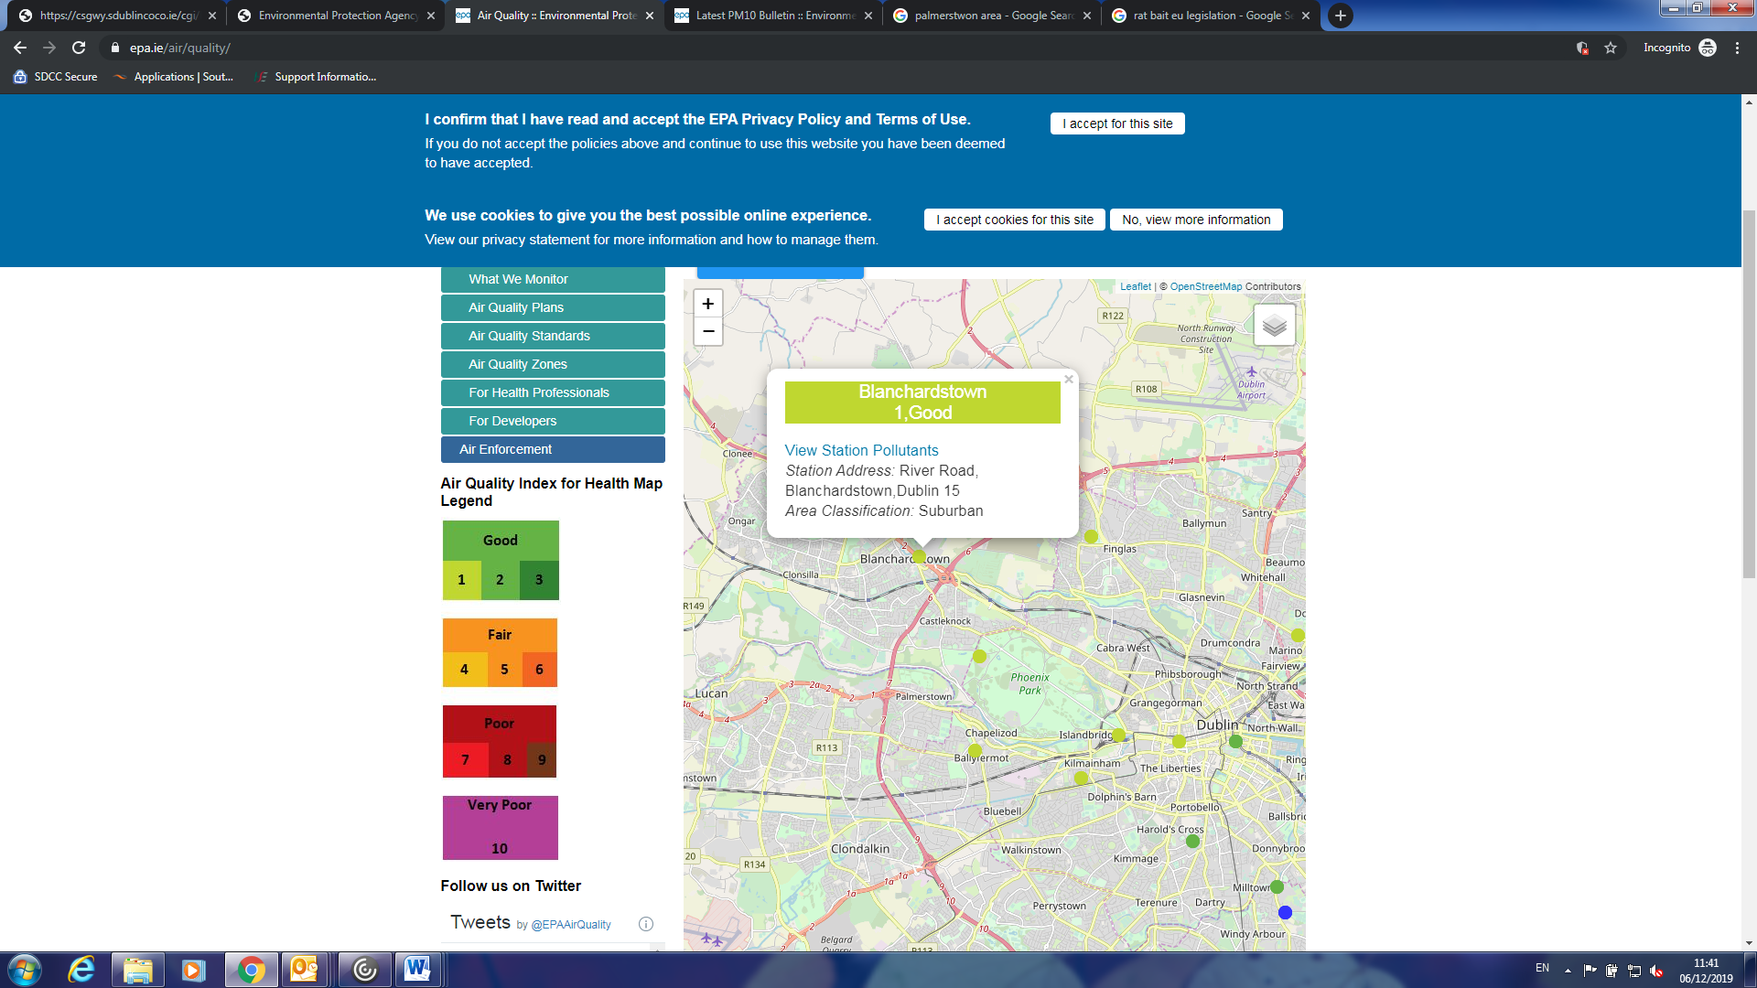

**At the Tallaght monitoring station located in Old Bawn there has been 3 exceedances of 50 ug/m3**of PM10. The monitoring station at Tallaght does not currently monitor NO2 (which is produced through traffic emissions) but it will monitor this parameter in the near future. It currently monitors PM10 and also SO2 and is more reflective of a residential location.

A further monitoring station is located in Ballyfermot. This is classed as a suburban background location. This Ballyfermot station monitors NO2, PM10 and PM2.5 . There have been **7 exceedances of 50 ug/m3**of PM10 at this location in 2019. Again the air quality index for health indicates the air quality as good as of the 06/12/2019.

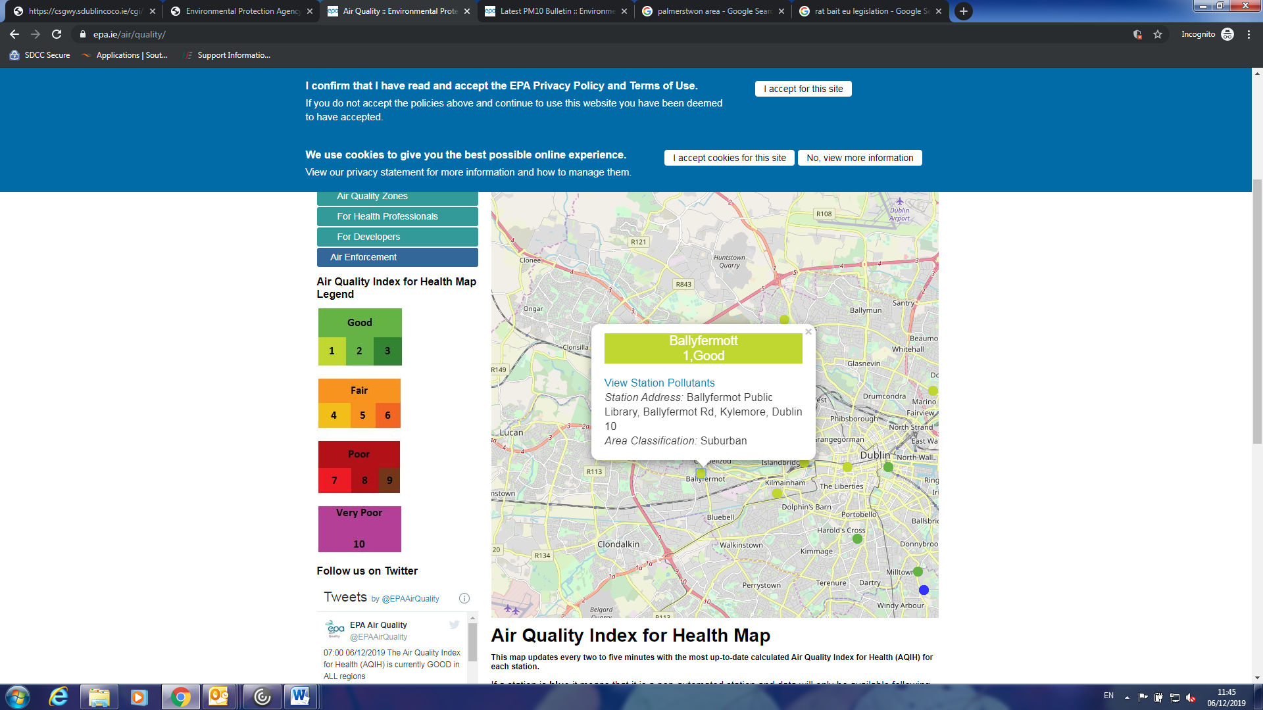

**Particulate Matter Limits**

The particulate matter PM10 daily limit of 50ug m-3 is deemed breached if more than 35 exceedances occur at a station in a calendar year. Therefore the Blanchardstown monitoring station, the Ballyfermot monitoring station and the Tallaght monitoring station to date this year have not breached EU limit values. Also in 2018 these stations did not breach EU limit values.

**Nitrogen Dioxide (NO2 )**

The **NO2**hourly limit of 200 ug m-3 is deemed breached if more than 18 exceedances have occurred. **There have not been any exceedances of NO2 at these locations this year to date or for all of 2018. The following tables show the NO2 levels recorded at Ballyfermot and Blanchardstown from November 24th to December 06th 2019.**

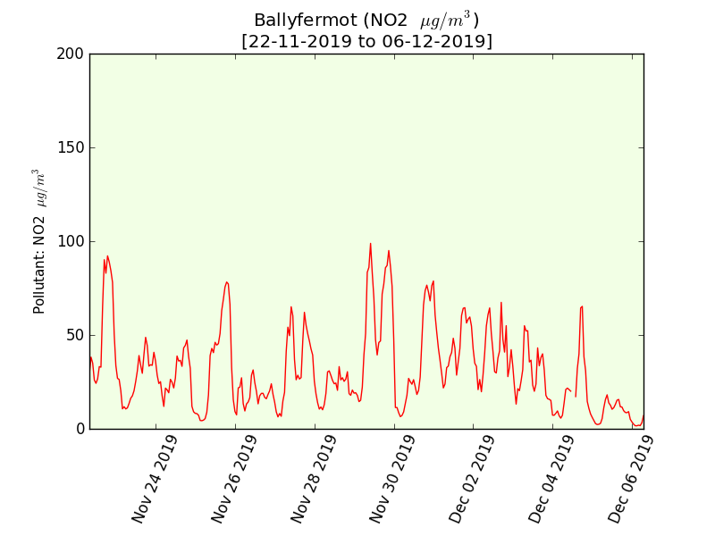

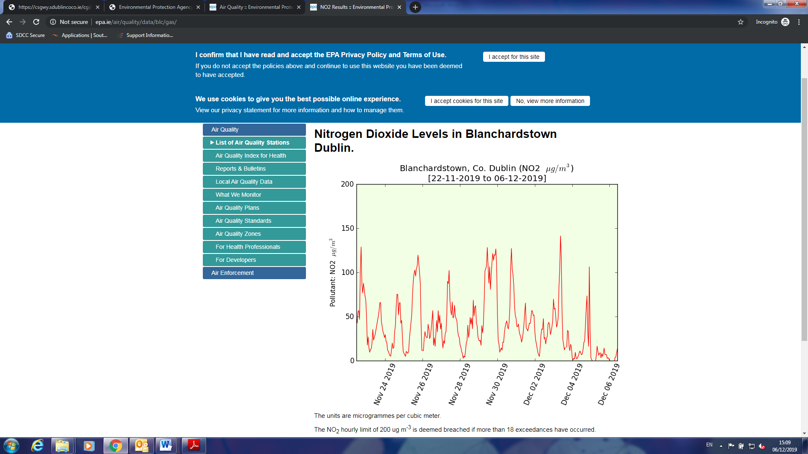

**The annual average EU limit value for NO2 is 40** ug m-3. There are a number of NO2 diffusion tube monitors along the M50 under the control of Transport Infrastructure Ireland (TII). The following table shows the 2018 NO2 levels against this annual emission limit value.

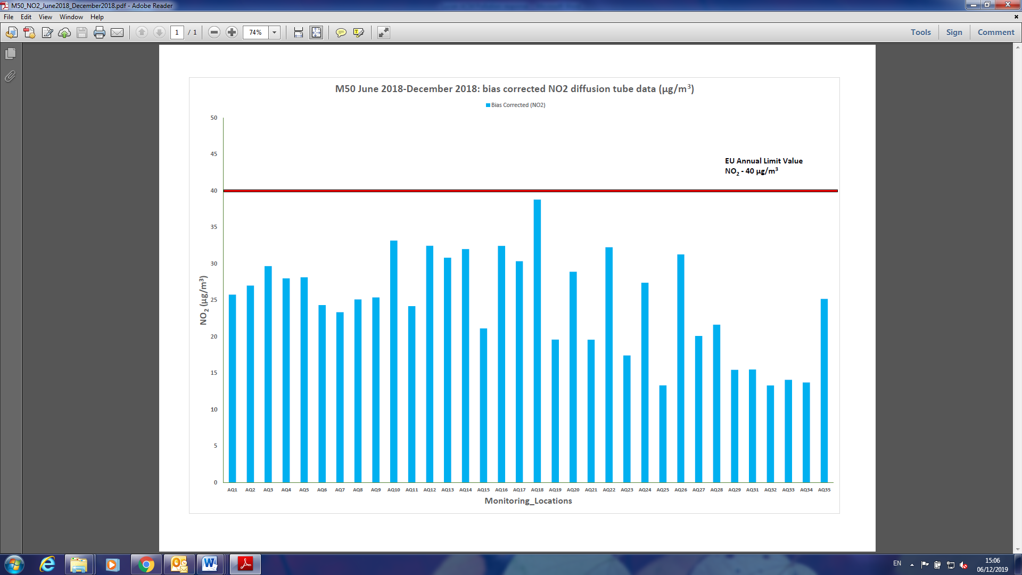

The locations are detailed along the bottom of the graph using AQ and a location number. AQ 16 is located at Woodfarm, AQ35 is located in Palmerstown, AQ13 is Chapelizod Bypass, AQ 17 is located at the Red Cow and AQ 18 is located at Cherry Orchard. The full list of locations is available on the TII website.

**Noise**

The following are the target values for undesirably high sound levels in the Noise Action Plan 2018-2023:

> 55 dB(A) Lnight

> 70 dB(A) Lday

The TII have a noise monitor located on the Old Lucan Road which would be indicative of noise at the roadside at this location. South Dublin County Council have a noise monitor located in Palmerstown Court indicating the noise levels in this residential area. Both sources of information are available online for the public.

The readings from the Palmerstown Court noise monitor for November are detailed below for the daytime period only. By clicking into these results online a full breakdown of the noise levels at various times of the day and night can be reviewed. Although set back from the M50 it gives a good indication of noise levels in nearby residential areas. Though not displayed on the following graph the night-time noise levels at this location are above the desired 55 dB(A) Lnight. This issue has been raised with the TII.

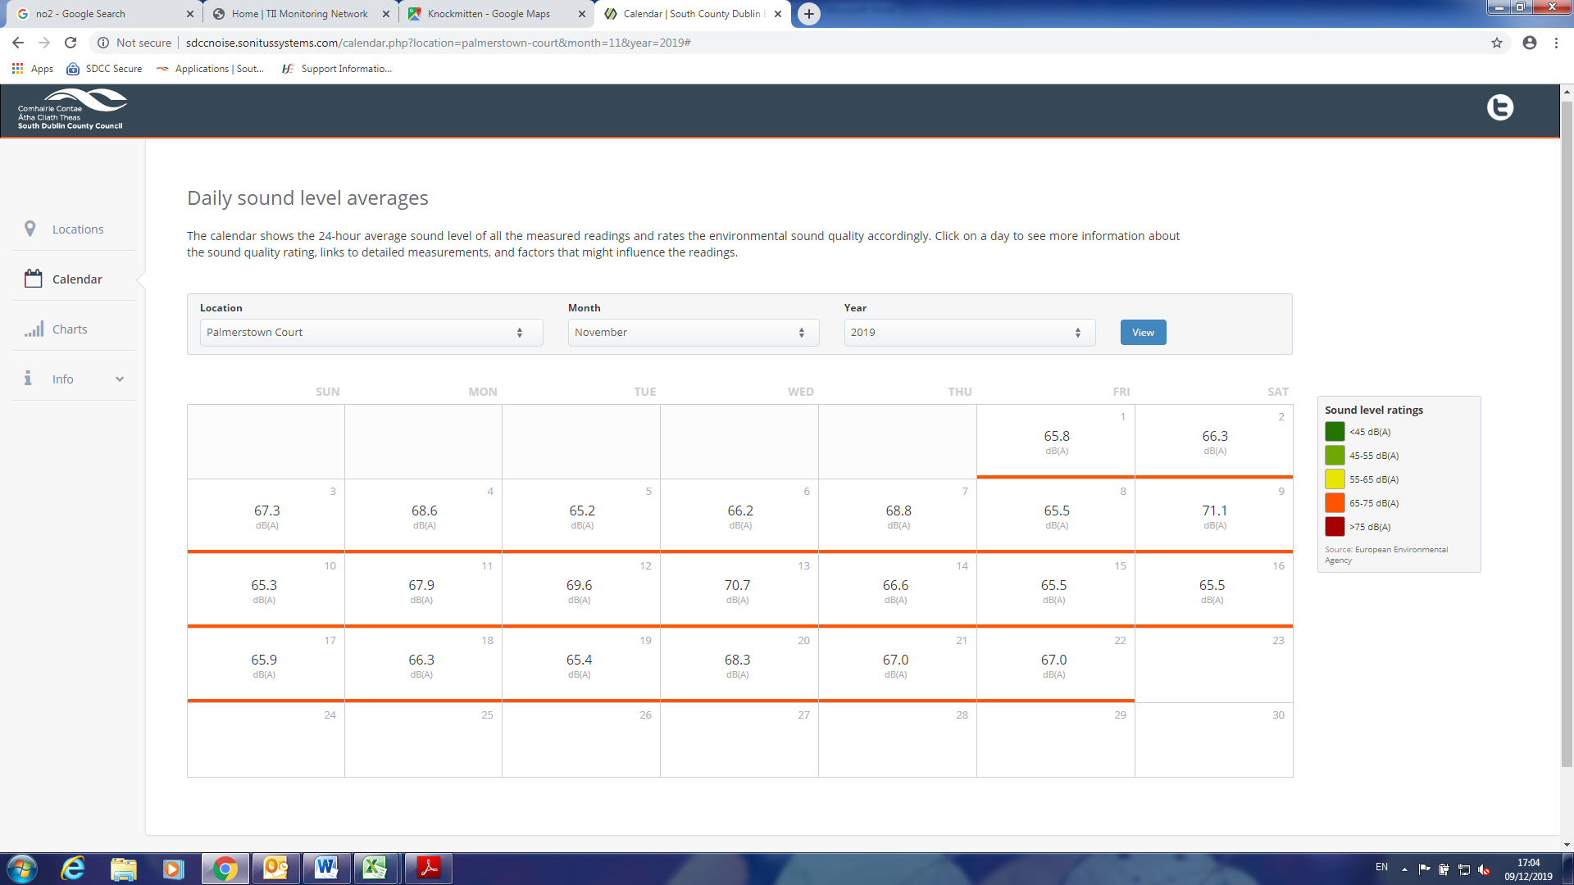

The TII noise monitor on the Old Lucan Road recorded the following data for the period of 01/12/2019 to the 06/12/2019.

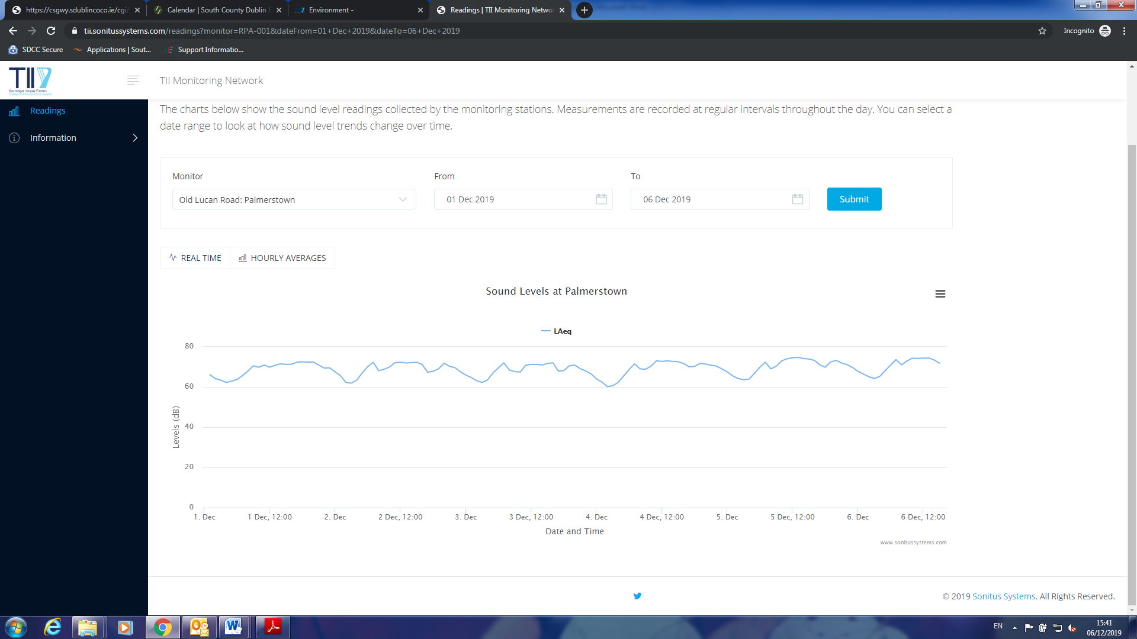

**In Summary**

The air pollution monitoring data indicates that the air quality rating for the Palmerstown area is good. That said we should always strive to have the least amount of pollutants in our atmosphere.

The best way to reduce PM in Ireland is to move to cleaner ways of heating our homes.  As we make our  homes more energy efficient, we will need less energy to heat our homes. If that energy comes in the form of solid fuel burning, then any reduction in that energy demand will lead to less production of PM and consequently less greenhouse gas formation. Improving our housing stocks energy efficiency and moving to clean home heating choices will have the twin benefit of lower emissions and improving air quality.

The main source of NO2 in Ireland is from road transport. Diesel engines produce more NO2 than petrol vehicles. Other sources of NO2 in Ireland include non-road machinery, industrial and construction activities and electrical and heat production equipment.

Actions needed to reduce air pollutants come in large part from Government strategies. Accelerating the incentives for electric car and van use, making economic growth less transport intensive and the conversion of public transport fleets to zero carbon alternatives are all initiatives which can make a big difference.

Noise levels in the area around Laburnum Walk, Cedar Drive, Glenpark Drive and Heather Grove are higher than the desired night-time noise level of 55 dB(A) Lnight. This has been communicated to the TII and we await a response from them in relation to assessing the noise barriers and additional controls in this area.