The Corkagh Grange PPP site is one of six sites in Bundle One of the Social Housing PPP Programme. On behalf of the Department of Housing, the National Development Finance Agency (NDFA) awarded the PPP Contract for this Bundle to Comhar Housing Limited on 19 March 2019. Under this PPP Contract John Sisk and Sons (Holdings) Ltd were appointed as Works Co. Part 8 Planning Permission for the development of 109 houses on the site was obtained by this Council in September 2017. However, the following conditions were approved by the Elected Members before becoming conditions of the Part 8.

1. In view of the widespread concerns indicated in the submissions received during the Part 8 process it was recommended that the project would address attenuation using Storm-tech type network and attenuation ponds would not be included in the project.
2. In addition, concerns about flooding risk resulting from incursion of the southernmost terrace proposed onto the area adjoining existing ponds will be addressed by repositioning this terrace in line with existing houses on Cherrywood Crescent.
3. A review of the access strategy to Corkagh Park has removed the need for vehicular access from Cherrywood Crescent to the housing site and the Park beyond therefore, Cherrywood Crescent will remain a cul-de-sac.

The Elected Members also noted the following requirements as conditions of the Part 8:

1. Prior to the commencement of any works the Council along with appropriate technical staff/contractors will meet with residents of Cherrywood Crescent to discuss the detail of the Stormtech type network to be provided in place of the attenuation ponds in order to alleviate resident’s concerns with respect to possible flooding at this location.
2. Prior to the commencement of any works on site the Council will establish a liaison meeting involving representatives from the Cherrywood, Kilcarberry and Oldchurch Residents Associations, the Council and the PPP consortium to ensure that issues such as boundary treatment, the Cherrywood Crescent cul-de-sac, and other relevant issues are implemented as agreed.

Before work commenced, South Dublin met with the residents and set out the process for engagement on the project and explained the Stormtech type network to be provided. This complied with A. & B. above. Since then, regular residents meetings are held with the NDFA and John Sisk and Sons (Holdings) Ltd. A community liaison was appointed and contact details provided. Newsletters are circulated to the residents with updates on the project. The next residents meeting is due to be held on the 12th December 2019.

The main concerns from the residents were in relation to flooding and the closing off of the vehicular access (only used by Parks Department) to Corkagh Park. Conditions Nos. 1 & 2. above deal with flooding and Condition No. 3. deals with the vehicular access to Corkagh Park.

**Repositioning of Houses – See Condition No. 2. Above***.*

*In addition, concerns about flooding risk resulting from incursion of the southernmost terrace proposed onto the area adjoining existing ponds will be addressed by repositioning this terrace in line with existing houses on Cherrywood Crescent.*

Background

There is a very low flooding risk on the development. However, to allay any residual concerns of the local residents this condition was included in the Part 8 planning permission. The proposal refers to the block of four terrace houses as highlighted on Figure 1 i.e. the southernmost terrace. There is no reference to the semi-detached houses on the right hand side of the terraced block of four.

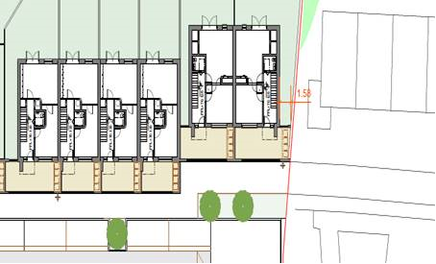

*Figure 1: location of southernmost terrace included in Part 8 Planning Application*

Design development

During the tender competition there was discussion between SDCC and the NDFA as to how this proposal might be satisfied in the design of the scheme. The solution demonstrated in Figure 2 below amends the line of the six houses in that section of the site to line up with the last house on Cherrywood Crescent cul-de-sac and makes these six houses a complete terrace i.e. there is no gap between the clusters of two and the previous southernmost terrace of four houses as there was previously. This design solution was considered to be acceptable by SDCC even though the planning approval did not require the moving of the first two houses adjacent to Cherrywood Crescent, nor did it stipulate an entire terrace be formed.

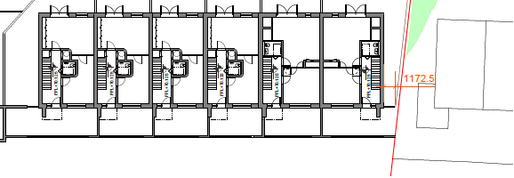

*Figure 2: potential solution identified during the tender competition*

Whilst SDCC confirmed that this preliminary proposal to respond to the planning condition would meet the requirements of the proposal included in the Chief Executive’s report requiring repositioning of the terrace it was not developed as a detailed design proposal when examined against planning and statutory requirements as outlined below.

Detailed Design

During the tender stage the design consultant commenced the development of this solution to a detail design There is a further consideration regarding the orientation of Cherrywood Crescent and Corkagh Grange. The wording of the planning condition is to ‘**reposition this terrace in line with existing houses on Cherrywood Crescent’**. The extract below from the master plan (Figure 3) clearly shows that Cherrywood Crescent and Corkagh Grange do not exist in parallel to each other therefore it is not possible to reposition ‘in line’ with Cherrywood Crescent. The respective roads are skewed and articulate at an angle to each other. Therefore, the planning proposal could only be interpreted as meaning that the terrace on Corkagh Grange needed to be realigned in the general context of the existing alignment of the Cherrywood Crescent housing.

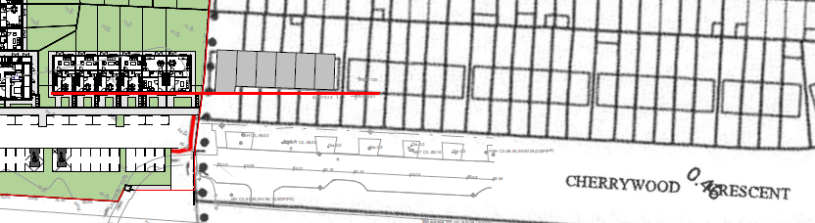

*Figure 3: Position of Corkagh Grange southernmost terrace relative to Cherrywood Crescent*

As shown in Figure 3 a straight line drawn from the Corkagh Grange terrace, as currently designed, intersects with the second block of terrace houses on Cherrywood Crescent. The Part 8 condition is not prescriptive about repositioning the terrace in line with the end house on Cherrywood Crescent (nor any other house). It is a general requirement to ‘reposition this terrace in line with existing houses on Cherrywood Crescent’.

The final design at this location has evolved through a detailed review of the statutory requirements including the proposal in respect of repositioning the southernmost terrace and the planning approval. The technical due diligence review and detailed analysis and consideration of all the requirements of the project brief including the planning permission and its conditions has resulted in the design proposal as set out in figure 3 above as the only compliant solution while repositioning the southernmost terrace as far north as possible.

The NDFA confirms that, as specifically requested in the planning conditions, the southernmost terrace of four houses as shown on the original planning drawing has been moved back in accordance with this condition of planning. These now line up with the adjacent semi-detached houses, the front of the existing houses in Cherrywood Crescent, are compliant with the South Dublin County Council’s Development plan and South Dublin County Council has confirmed it was satisfied with this.