COMHAIRLE CHONTAE ATHA CLIATH THEAS

SOUTH DUBLIN COUNTY COUNCIL
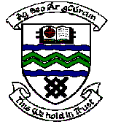

MEETING OF TALLAGHT AREA COMMITTEE MEETING (1)

Monday 20th March, 2006.

Question No. 6

Question: Councillor Joe Neville

"To ask the Manager for a detailed update on any grant applications submitted by Tymon Celtic and the current status of such an application and will the Manager make a statement on the matter?".

Reply

No Grant application has been received from Tymon Celtic to date.

