Interim report on **Orlagh Roundabout** Review

RT ACM

12 November 2019

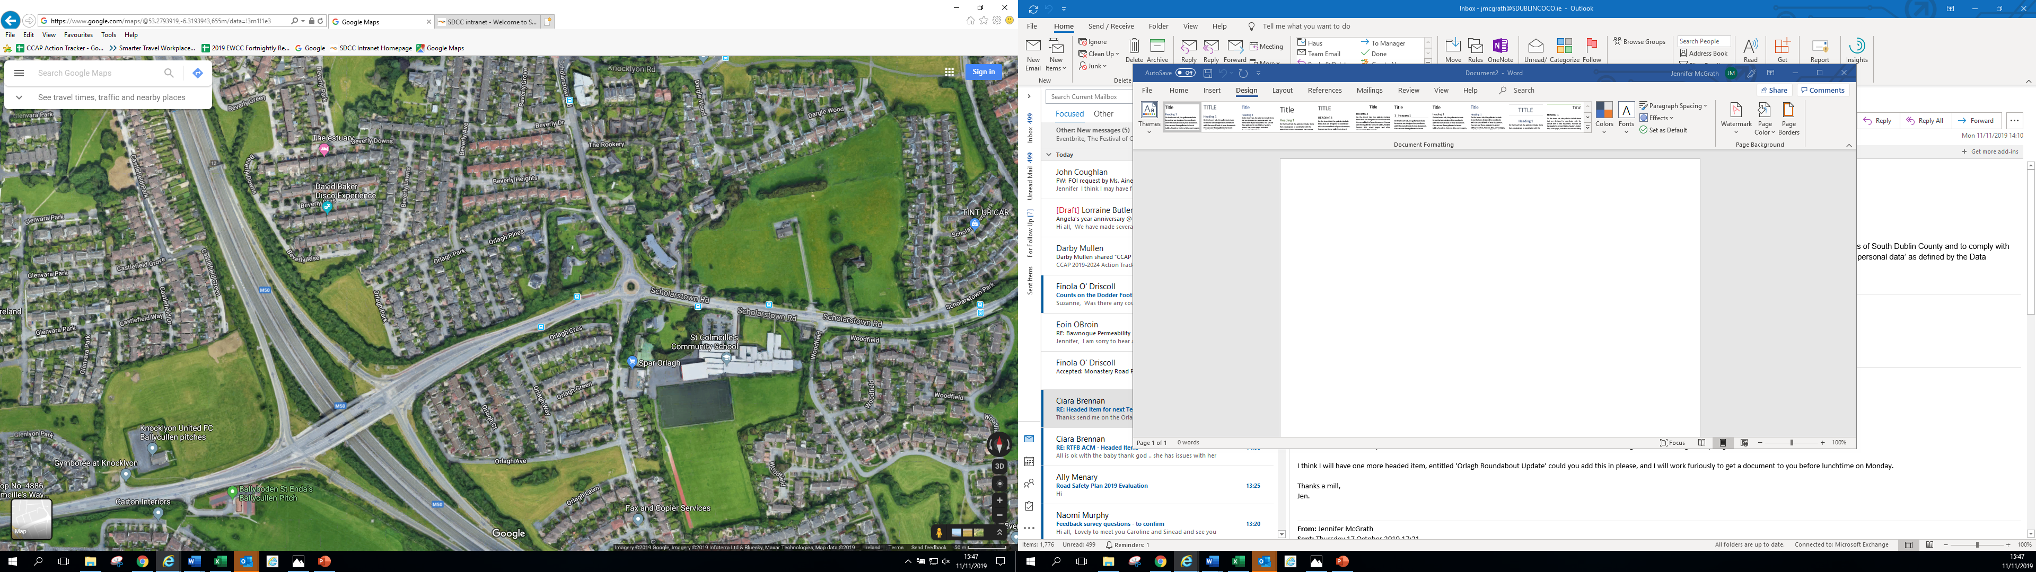

**Orlagh Roundabout Review**

* Objectives of the Scheme
* Safety
  + Review of the 2015 Options Report
  + Review of RSA 1/ 2/ 3/ 4
* Queuing
  + Review of pedestrian crossings signal timings
  + Before and after
* Counts
  + Pedestrians, cyclists, buses, vehicles
  + Before and after
* Traffic
  + Review of general traffic

Outcomes to date and interim changes:

* Counts, including queues will be carried out this week, signals will be tweaked, and counts will be carried out one week later