COMHAIRLE CHONTAE ATHA CLIATH THEAS

SOUTH DUBLIN COUNTY COUNCIL

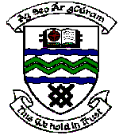

MEETING OF SOUTH DUBLIN COUNTY COUNCIL

Monday 13th March, 2006.

Headed Item No: 11

Application for a Countywide Grant.

Application for a grant under the Council’s Community Grants Scheme has been received from the organisation listed below. Payment of this grant to this organisation, in accordance with the conditions of the scheme, in the amount set out hereunder, is recommended for approval:-

Ref: | Group | Type of Application | Date of Application | Amount
SCRA | Dublin Community Games,  Carmichael House,  North Brunswick Street,  Dublin 7. | Countywide Community Activity Event with a Countywide Interest towards the annual Dublin Community Games including the development of Community Games in the Clondalkin & Tallaght Area. | 06/02/06 | €5,000

