**COMHAIRLE CONTAE ÁTHA CLIATH THEAS  
SOUTH DUBLIN COUNTY COUNCIL**

**MEETING OF LUCAN/PALMERSTOWN/FONTHILL AREA COMMITTEE**

**Tuesday, October 22, 2019**

**HEADED ITEM NO. 5**

**WATERSTOWN PARK**

This report sets out the current policy and practice in relation to the maintenance of Watertown Park as requested by the elected member following a suspensory/emergency motion at the Lucan/Palmerstown/Fonthill Area Committee Meeting in September 2019.

Management works in Waterstown Park are carried out based on the recommendations of the 2008 biodiversity study by Dr Mary Tubridy.  Much of this work continues from year to year such as managing the grasslands, general maintenance and encouraging community participation.

In 2010 a biodiversity action plan was formulated to ensure more of the long-term management objectives in the park were progressed.  Parks staff started a program of removing non-native trees near the Millrace.  This work was continued in 2011 but the main priorities for 2011 were further research into biodiversity in the park, removal of invasive species, hedgerow management and clearing of the Millrace.

A BioBlitz in May 2011 offered the opportunity for further research into biodiversity in the park.  This survey gave staff the opportunity to review the management practices and consider what effect they were having on biodiversity in the park.  687 species were recorded in the park during the BioBlitz which is equivalent to 10.60 species per hectare.  This far exceeded what was previously known to exist based on the 2-year study carried out from 2005-2007 and indicates that the park is becoming progressively more biologically diverse.

A recording and mapping exercise was also carried out on the extent of Japanese Knotweed in the park.  This is a highly invasive plant species which poses a threat to local biodiversity.  A programme of treatment is in place and the spread of this plant in the park has been halted and in places has been eliminated.

There are five key maintenance areas in the park.

1. Grassland
2. Woodland
3. Mill race
4. Vegetation
5. Hedgerow

**Grasslands:**

Grasslands have a long history at Waterstown Park. Historical maps (from 18th century) show that the principle land use was grassland. Lands were grazed and tilled where suitable. Intensification of farming use occurred between 1936 and 1960’s leading to the removal of hedgerows. In the 60’s and 70’s two fields in the park were used as a landfill site. New grasslands appeared after the landfill site was covered in a shallow layer of soil in the 1990’s.

The biodiversity value of dry grasslands is directly related to their species richness. These species rich grasslands are found above the landfill site and adjacent to it. The dry patch grass over the old landfill site is the most species rich grassland and previously had skylark, reed bunting and meadow pipits nesting in it. Apart from the Phoenix Park they are not found elsewhere nesting in parks so close to the city. While common in rural habitats these species are rare in urban situations. They were only present in the park as the height, nature, openness of the vegetation which had developed through natural colonisation of the bare stony ground provided the ideal habitat for nesting. It is only through the management of the grassland that the species richness can be maintained. Scrub encroachment and lack of grazing necessitate intervention to prevent habitat loss.

Grassland in other areas of the park comprise of deep meadow fields along the river Liffey and wetter ground to the west and north of the park.

The map attached to this report identifies Areas A, B & C which are considered to the most species rich wildflower areas. Ideally grass cutting in these areas should be twice per year with the first cut occurring before May and the second cut after August. The timing of these cuts coincides with the ground nesting bird season. The 3 areas should be cut on a rotational basis over a 3-year period. This approach facilitates the survival of insects who can migrate to uncut areas during the cutting season. While this approach commenced in the early years of grassland management, it was not possible to continue due to local resistance and a modified approach has been adopted. It would be preferable to reintroduce the bi-annual cutting regime. However, in the absence of being able to achieve this the following regime was introduced and undertaken in 2019.

February 2019 - Area A was flailed to cut back all scrub and growth with the intention to cut again in September 2019*.*

Areas B & C have not been cut to date, but it was intended that they would be cut in September along with area A and all arisings bailed and removed off site.

The treatment proposed is that the grass is cut, all cuttings are left for a few days to allow insects to migrate and to allow flower seeds to fall out onto the ground. The cuttings are then bailed by machine and taken off site. This will promote the growing of more wildflowers to appear in the coming summer.

Two orchid species, shown below, were identified in these meadows during the summer period.

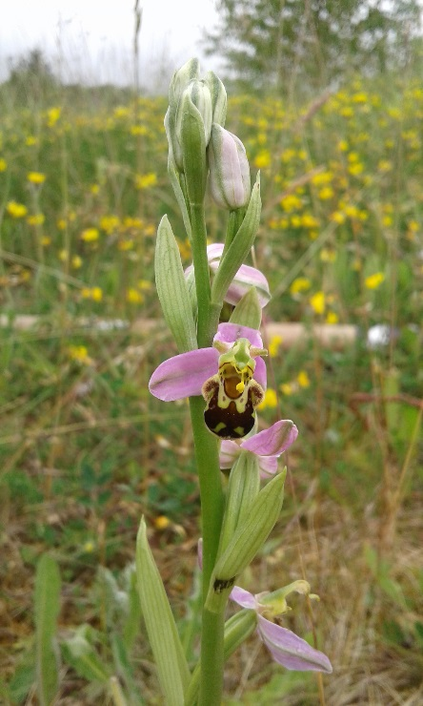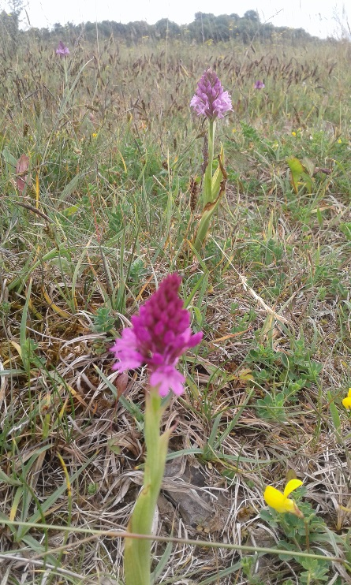*Bee Orchid – Ophyrs apifera Pyramidal Orchid – Anacamptis pyramidalis*

Grass cutting along all path is carried out on a regular 3-week cycle to allow for a set back from the paths and provide a welcoming and secure environment for park users.

Grass cutting on the fields between the Millrace and the Liffey have not been cut in years and have reverted to what is known as rank grassland with low species diversity. It was planned to cut these areas by flail in September/October to reinvigorate the areas however as a result of the suspensory/emergency motion this has been put on hold and is unlikely to happen as the ground is now too wet.

Grass cutting in the vicinity of slopes below Riversdale House and beside the dog run were to be flailed in September however this work was also put on hold. Generally, the treatment of large flat areas includes the bailing and removal of grass where suitable.

**Woodlands:**

The main focus is the management of semi-natural scrub areas and the removal non-native invasive species. This has started beside the mill race, where many Poplar trees were removed several years ago and again in 2019. Non-natives were also removed from the woodland near the zip-line (play item) as part of the Arboriculture Programme. Over time it is planned to remove all Poplar trees from the pNHA (proposed National Heritage Area). 31 native trees were planted in March 2019 in conjunction with the Palmerstown Tidy Town/ Meitheal group.

Informal paths have been introduced into the young woodlands to bring a human supervisory presence in there to offer another means of passive recreation and to prevent anti-social activity. It is proposed to use bark mulch to delineate some of these. The balance must be struck between allowing humans to walk everywhere for their personal enjoyment and protecting fauna, which is easily disturbed by human activity.

**Millrace:**

The Millrace is a walled canal which was used to divert water from the river Liffey to the Dunkirk Mill and other mills in the Palmerstown area. Several kilometres of the mill race is visible in Waterstown Park, though obscured behind overgrown vegetation and a section of the mill race is in fact underground.

Whereas the river Liffey is deep and fast-flowing, the mill race is slow-moving and supports fish, amphibians, birds and aquatic plants.

The major issue in managing the Millrace for biodiversity is to get the balance right between plant life and open water. It was identified that the Millrace has section that were overgrown, and not enough light was getting through thus decreasing biodiversity. In 2019 works commenced on addressing these issues with the aim of achieving a 40% open water and 60% semi-aquatic conditions in the mill race.

Initial works took place on land beside the millrace and included the removal of dead trees and fallen branches and a cleaup of areas of overgrown grass/nettles/weeds. Desilting works in the stream followed in line with Inland Fisheries Ireland requirements regarding fish spawning activity. Material removed during desilting was left on site near the millrace to allow invertebrates return to the water.

It would not be possible or desirable to attend to all areas of the mill race during the works period and therefore specific areas were targeted along the millrace where optimum results could be achieved. The Millrace will be assessed during the winter to determine the sequencing of further works in subsequent years.

**Vegetation:**

Works commenced in September on the cutting back of vegetation (briars, nettles and long grass), from paths and along the western boundary of the park.  On the western boundary, the vegetation had grown unchecked for a significant number of years and had enveloped trees that had been planted in the park in the past.  The vegetation was cut back to the park hedge boundary.  See image below.

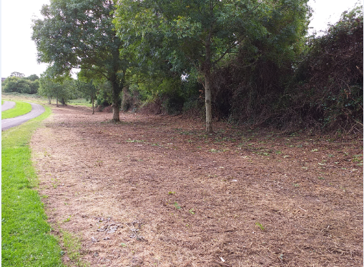

The vegetation along paths was starting to enclose these routes and reduce the mowing margin that was in existence.  This resulted in creating a sense of neglect and made the park less inviting and secure for users.  The 2 images below show where this vegetation was cut back from paths.

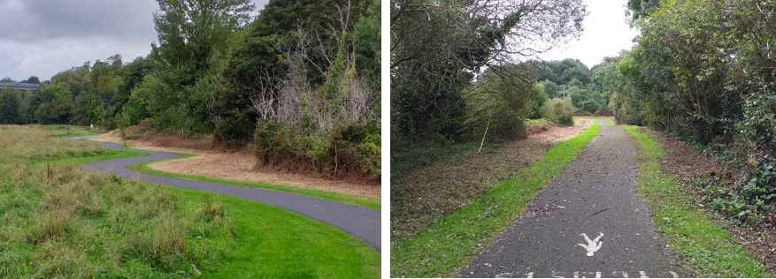

**Hedgerows:**

There are three good quality hedgerows in the west of the park, running north-south. It is proposed to work on these hedges over the coming years to rejuvenate them. Works commenced on the most westerly one in September 2019 and vegetation was cut back to allow access. The extent of works planned were largely completed and the hedge will be reassessed in 2020 to determine if additional pruning is necessary. The 2 hedges on either side of the dog run field also need to be cut back and this will form part of future works programmes in the forthcoming years. The hedges will be managed in separate years.

All vegetation pruning works were put on hold as requested following the emergency motion at the September LPF ACM meeting. It would be hoped to recommence these works this year however given the delay it might not be possible to complete all work targets as set out in the report.