COMHAIRLE CHONTAE ATHA CLIATH THEAS

SOUTH DUBLIN COUNTY COUNCIL

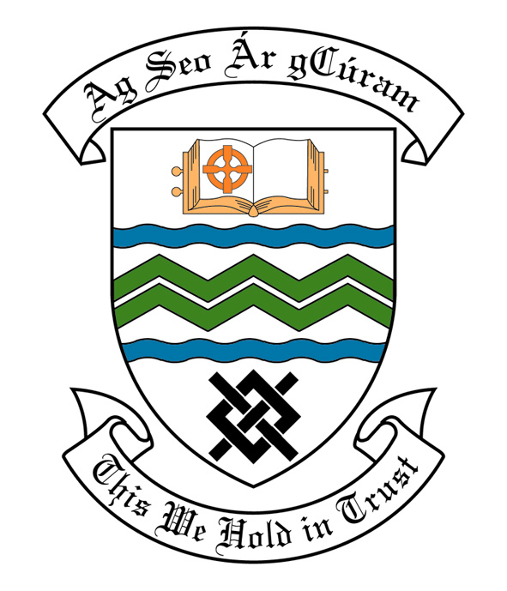

MEETING OF SOUTH DUBLIN COUNTY COUNCIL

Monday 13th March, 2006

MEETING OF THE LUCAN/ CLONDALKIN AREA COMMITTEE(2)

Wednesday 1st March, 2006.

HEADED ITEM NO: H- I (2) (g)

Application for Grants

Applications for grants under the Council’s Community Grants Scheme have been received from the organisations listed below. Payment of these grants to the organisations, in accordance with the conditions of the scheme and in the amounts set out hereunder, is recommended for approval:-

Ref: | Group | Type of Application | Date of Application | Amount
SCRA 1030/ GF 1382 | St. Ronan’s National School,  Deansrath,  Dublin 22. | Social Inclusion, Equality & Anti Poverty Grant. | 26/01/06 | €800
SCRA 907/ GF 1391 | Lucan St. Patrick’s Day Parade,  43 Doddsboro,  Lucan,  Co. Dublin. | Countywide Community Activity Event with a Countywide Interest | 17/02/06 | €3,000
SCRA 651  GF 1369 | Quarryvale Community & Leisure Centre  Clondalkin  Dublin 22 | Grant for Community Centre Based I.T.  Infrastructure | 5/12/05 | €4,000

Application for Grants (Arts Act 2003)

Application for a grant under the Council’s Arts Grants Scheme has been received from the organisation listed below. Payment of the grant to this organisation, in accordance with the conditions of the scheme and in the amount set out hereunder, is recommended for approval:-

Ref: | Group | Type of Application | Date of Application | Amount  €
SCRA 934  AGF 514 | Lucan Community College  Esker Drive  Lucan  Co Dublin | Arts Grant  towards the cost of arts workshops as part of arts festival. | 29/11/05 | 500

It was proposed by Councillor F. Mc Carthy, seconded by Councillor E. Tuffy and RESOLVED:

“That this Committee recommends that South Dublin County Council approve payment of the above grants recommended in the foregoing report”.

