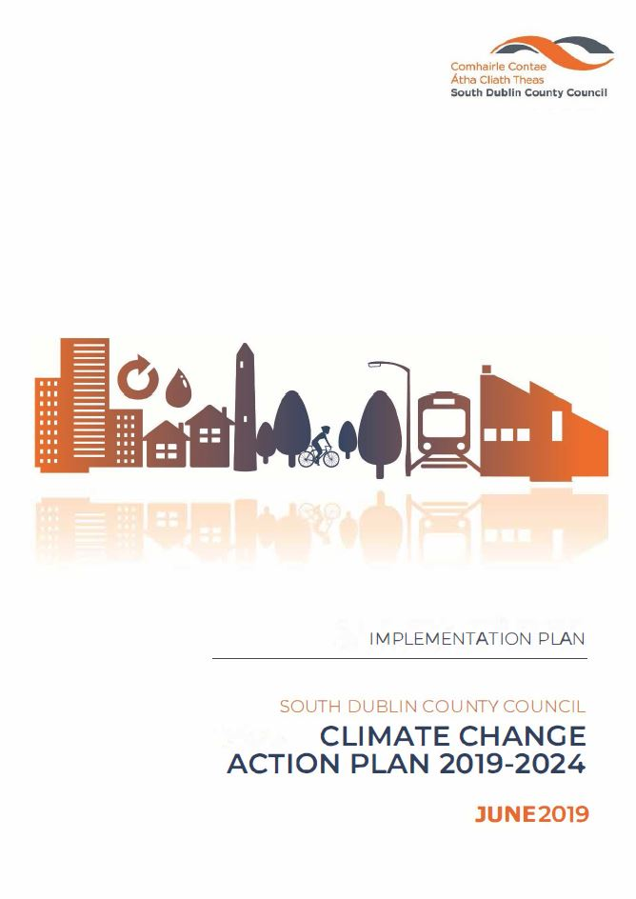

**August 2019**

**Implementation Plan for SDCC CCAP 2019-2024**

1. Background
2. Targets
3. Introduction
4. Delivery
   1. Administration of the CCAP
   2. Risk
   3. Budget
   4. Teams
   5. Meetings
   6. Reporting
5. Actions/Projects

APPENDIX 1: Actions

Document Control:

|  |  |  |  |
| --- | --- | --- | --- |
|  | Author | Approved | Date |
| Draft | JMcG/CG | TW | Jun ‘19 |
| Final | DM/CG | TW | Aug ‘19 |
|  |  |  |  |

1. **Background**

In 2013 the EU published the EU Adaptation Strategy which sets out a framework and mechanism for enhancing the preparedness of the EU for the current and future impacts of climate change, and in 2014 the EU Climate & Energy Framework was published, setting out policy objectives in the 2020-2030 period and mandatory EU wide targets.

The Paris Agreement (COP 21), December 2015, Ireland, as a party to this agreement, recognises both the right and responsibility of all parties to pursue low carbon, climate resilient development and its supporting initiatives.

Ireland responded with the publication of the National Climate Action and Low Carbon Development Act 2015 (commonly known as the Climate Act 2015) which provides the required policy context for a strategic national adaptation response to climate change. The aim, as a fundamental national objective, is to achieve a transition to a competitive, low carbon, climate resilient and environmentally sustainable economy by 2050.

As part of the Climate Act 2015 reductions in greenhouse gas emissions and adaptation to the impacts of climate change is being addressed through national plans, the National Low Carbon Roadmap, the National Mitigation Plan (NMP) and National Adaptation Framework (NAF).

Irelands NAF and NMP were developed by the DCCAE and provides for an all of government approach to adaptation and mitigation and requires the development of local and sectoral plans.

South Dublin County Council Climate Change Action Plan 2019-2024 (CCAP) is planned to be Launched in September 2019 and submitted to the Minister for Communications, Climate Action and Environment. This is in accordance with the requirements of the National Adaptation Framework (NAF) 2018, as local adaptation strategies are required to be submitted by 30th September 2019.

1. **Targets**

In Ireland, the public sector has mandatory energy efficiency targets. It is set in the context of Ireland’s EU and national commitments and wider climate change goals, whereby a target of 33% energy efficiency improvement is to be achieved by all Irish public bodies (as defined in Statutory Instrument 426 of 2014) by 2020.

* 33% energy efficiency improvement is to be achieved by all Irish public bodies by 2020

There is currently no statutory requirement to undertake sectoral mitigation plans, including revised sectoral, local authority emissions reductions targets.Being a signatory to the EU Covenant of Mayors for Climate & Energy since 2018, this Council has voluntarily committed to:

* 40% reduction in its greenhouse gas emissions by 2030 and become a more climate resilient region.

1. **Introduction**

The Climate Change Action Plan 2019-2024 (CCAP) sets out how the Council will improve energy efficiency and reduce greenhouse gas emissions in its own buildings and operations, while making its functional area more adaptive to the impacts of climate change.

The plan concentrates on the two approaches required to tackle climate change. The first, mitigation, consists of actions aimed at reducing current and future GHG emissions; examples of these include reductions in energy use, switching to renewable energy sources and carbon sinks.

The second approach, adaptation, consists of measures aimed at reducing the impacts that are currently being experienced through our changing climate and those that are projected to happen in the future. The measures include flood protection, increased resilience of infrastructure and emergency response planning. The approaches are interconnected and should be planned together.

There are four key targets;

1. 33% improvement in the Councils energy efficiency by 2020
2. 40% reduction in the Councils GHG emissions by 2030
3. To make Dublin a climate resilient region by reducing the impacts of future climate change related events
4. To actively engage and inform our citizens on climate change

The Plan includes a range of actions, organised across five key action areas;

1. Energy & Buildings
2. Transport
3. Flood Resilience
4. Nature Based Solutions and
5. Resource Management
6. **Delivery**
   1. **Administration of the CCAP**

The Management Team is key to driving the ownership of the actions to the managers within their departments, to ensure that climate change becomes part of the culture and day to day business of South Dublin County Council

There are five Action Areas in the Plan as identified above and delivery of the plan will be based around these five action areas. Action team will be tasked with delivery of the action in their area.

In order to satisfy the key target of actively engaging and informing our citizens on climate change, a further team will be created, this will be named;

Action Team 6; Citizen Engagement

* 1. **Teams**

Ownership and implementation of this Climate Change Action Plan resides with every department of South Dublin County Council. The Plan demands an inclusive approach by the full Council, as the 130 actions listed connect every department across multiple sections. The Management Team is key to driving the ownership of the actions to the managers within their departments, to ensure that climate change becomes part of the culture and day to day business of SDCC.

Given the complexity and long-term nature of climate change, it is essential that progress on the actions is continuously monitored and that the delivery of actions is subjected to periodic review, both in terms of the validity of the underlying scientific assumptions and the appropriateness of projects, policies and programmes. Lessons learned and good practices identified during the monitoring and evaluation of ongoing and completed projects, policies and programmes should inform future actions, creating an iterative and evolutionary process.

**SDCC Climate Action Steering Group (CASG)**

To ensure the 130 actions in the CCAP are delivered a dedicated Climate Action Steering Group (CASG) is being established, the CASG will take forward the governance of the CCAP in this county. This team will include Senior Management, the chairs of the five Action Teams as outlined in the CCAP and the chair of the additional Action Team entitled Citizen Engagement. The proposed members of the Steering Group is outlined in Appendix 1: Steering Group and Action Teams.

The objectives of this steering group are;

* To ensure alignment with National legislation
* To ensure alignment with the other Dublin Authorities and the CARO’s
* To meet the targets of the CCAP
* To ensure budgets are aligned with targets of the CCAP
* To ensure projects are completed and on budget
* To ensure the actions of the CCAP are being carried out by relevant sections
* To ensure reports are issued and deadlines met
* To remove and include new and revised actions at annual revisions and iterations
* To receive the required information in order to report on the Action Teams
* To ensure all reporting requirement are completed e.g. SPC’s Covenant of Mayors CARO etc.

The purpose of this group is to bring the findings and reports from the Six Action Teams to this group for regional and national reporting purposes.

**Action Teams**

There are six action teams;

Action Team 1; Energy and Buildings

Action Team 2; Transport

Action Team 3; Flood Resilience

Action Team 4; Nature Based Solutions

Action Team 5; Resource Management

Action Team 6; Citizen Engagement

The purpose of these teams is to manage and deliver the actions of the CCAP, to ensure new actions are included and all work streams that can be captured are recognised and included.

The inclusion of Action Team 6; Citizen Engagement, recognises our role in increasing citizen awareness and public participation in climate change solutions.

Action Team 6; Citizen Engagement

This team’s role is to fulfil the underlying theme of the CCAP which includes engagement with our citizens. The objective of this team is to ensure a unified approach of engagement is conducted by each of the Action Teams for all citizens, those who live and work in our functional area. The members of this team will include Community, LEO, Communications and Corporate Support.

Initial members of each action team are identified in Appendix 1, but membership will evolve as different action in the CCAP are being progressed.

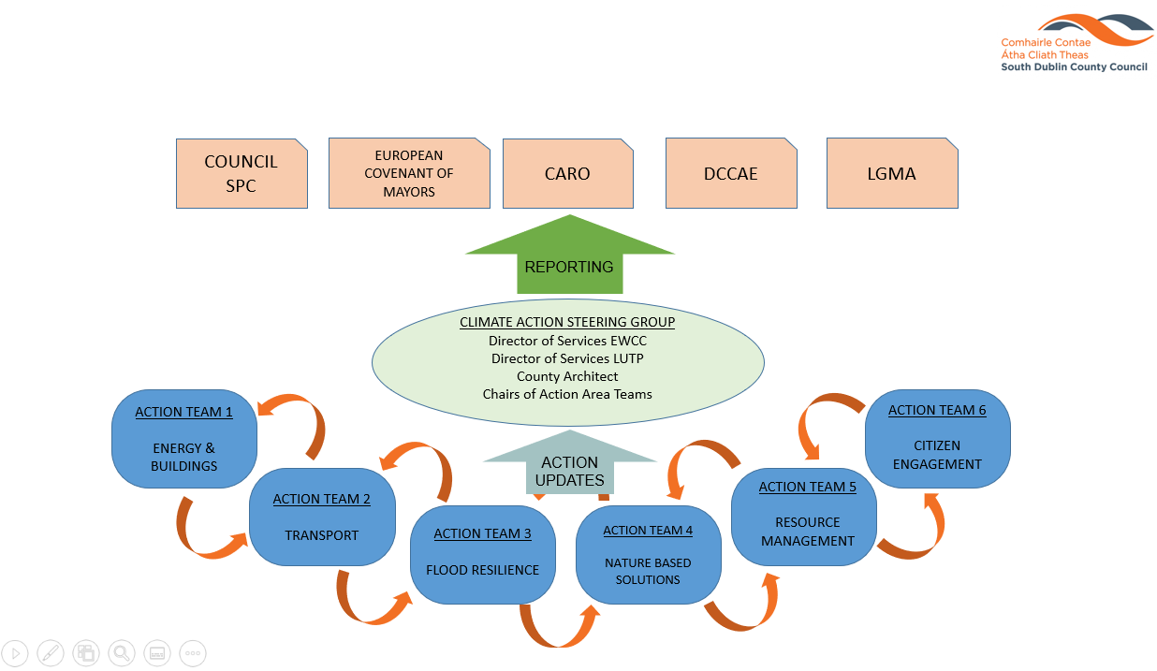

* 1. **Budget**

A review of the 130 actions listed, clearly shows that a lot of work is being carried out and budgets are already in place. For example, the upgrading of lights within County Hall to LEDs, upgrading of the public lighting stock to LED and flood alleviation schemes are all progressing and have been budgeted.

A Climate Action Budget of €250,000 has been provided for 2019. New and non-budgeted actions in the CCAP may avail of this Climate Action allocation.

It is proposed that projects or actions, once appraised and justified and confirmation that procurement criteria have been satisfied, they can be fully or partially funded from the Climate Action allocation.

Projects and actions that have been approved for the Climate Change Action Plan have been included on an action tracker to allow progress, budgets and actual costs to be monitored see Appendix 2.

The Climate Action budgeted items are recorded in Agresso. In order to monitor additional cost and spending pertaining to but external to the Climate Action budget, a separate operational code will be made available.

* 1. **Meetings**

**SDCC Climate Action Steering Group**

The inaugural meeting of this group was held on 27th June, 2019, subsequent meeting will occur every month for three months reducing to every quarterly meeting thereafter. Provisional dates and times agreed at the inaugural meeting are arranged through our administrative support team. These dates should align with the Environment, Public Realm & Climate Change SPC meetings.

**Action Teams**

It is proposed that each Action Team meet monthly for the first three months and revising to every second month thereafter. The dates and times agreed at the inaugural meeting are arranged through our administrative support team.

Actions should be reviewed by all team members prior to meetings. During the meeting team members will report on actions that are under their management.

* 1. **Reporting**

The following is the current list of bodies that the SDCC is responsible for reporting to, and from whom they take instruction regarding their reporting obligations;

* Environment, Public Realm and Climate Change SPC and Council
* Covenant of Mayors for Climate and Energy
* Dublin Metropolitan Climate Action Regional Office (CARO)
* DCCAE
* LGMA

To reduce the risks of omitting actions and significant items a top down and bottom up approach is required.

The Action Teams will be expected to report to the CASG through their Chairs. Reporting on the actions and their associated budgets. Introducing and revising actions on an annual basis.

The delivery of the CCAP will be a flexible process and subject to regular reviews in terms of the appropriateness of projects, policies and programmes, as well as climate projections.

**Environment, Public Realm and Climate Change SPC and Council**

The CASG will provide a report to the EPR & CC SPC at each of their meetings and in turn report to the full council.

This reporting system will be quarterly at each SPC meeting.

**Covenant of Mayors for Climate and Energy**

As the council is a signatory to the Covenant of Mayors for Climate and Energy, which is the world’s largest movement for local climate and energy actions, SDCC has pledged to support implementation of the EU 40% GHG reduction target by 2030 and to make SDCC a more resilient region. Accordingly, SDCC commits to submitting a Sustainable Energy and Climate Action Plan (SECAP), outlining the key actions it plans to undertake. The Plan will feature a Baseline Emission Inventory to track mitigation actions and a Climate Risks and Vulnerability Assessment. This commitment marks the beginning of a long-term process, a commitment has been made to submit a report on the implementation process every two years. The required information is provided to Codema, who compile and file the reports for all the Dublin LAs.

This reporting system is every two years.

**Climate Action Regional Office (CARO)**

Clearly climate change is a transboundary challenge. A Dublin regional approach has been adopted and will be overseen by the Dublin Metropolitan CARO. The task of the Dublin Metropolitan CARO is to liaise with the Dublin LA’s under their remit, the other three regional CAROs and respective central government departments to ensure alignment of actions. The CARO will also work with the University and Third Level section in relation to research and education on Climate Action.

Reporting to CARO by SDCC will be carried out formally on a quarterly basis, whilst informal reporting will occur weekly through associations.

Formal reporting procedures have yet to be fixed.

**DCCAE**

South Dublin County Council along with all public bodies, are required to report annual energy efficiency data to the Sustainable Energy Authority of Ireland (SEAI) which manages the reporting process on behalf of the Department of Communications, Climate Action and Environment (DCCAE). The required information is provided to Codema, who compile and file the reports for all the Dublin LAs.

This reporting system is annual.

**LGMA**

The LGMA circulated a research questionnaire to all LA’s in February 2019, the research was undertaken in partnership with the Climate Action Regional Offices (CAROs) on behalf of the County and City Management Association (CCMA) and the Environment Climate Change and Emergency Planning (ECCEP) Committee.

The questionnaire was devised to assist local authorities in developing a baseline assessment of local climate change actions. Nationally, local authorities are developing Climate Adaptation Strategies and Climate Change Action Plans throughout 2019, which indicate mitigation and adaptation responses. ECCEP indicated that emergency response (remediation) following extreme weather events should also form part of the baseline assessment to facilitate a thorough understanding of all climate change actions local authorities are currently engaged in. It is intended that the LGMA questionnaire will be circulated to all LA’s every January to report on the preceding year, tracking our progression over the forthcoming years.

This reporting system is annual.

Summary list of external bodies SDCC will be required to report to;

* CARO
* DCCAE through SEAI
* LGMA
* Covenant of Mayors for Climate and Energy through Codema
  1. **Risk**

A high-level risk assessment was carried out as part of the CCAP process, but as described on page 31 of the plan a more detail risk assessment must be carried out. The aim is to identify potential future climate impacts, vulnerabilities and risks that are of greatest relevance to the council according to the key operational areas. There will also be new opportunities and benefits that will emerge during this exercise, these will also be logged and reviewed.

The key tasks are:

* Further assessment of potential future climate impacts and vulnerabilities
* Development of a Risk Register for each Action Team
* To prioritise climate risks

1. **Actions/ Priority projects**

It should be noted that actions listed in the CCAP are in no particular order. Actions must be prioritised and revised as agreed by each of the Action Teams.

The following is a list of projects that are scheduled to commence in 2019. The initial cost of each project will be appraised, and spending will be monitored by the lead section. Funding shall be arranged through the relevant section and Government procurement guidelines will be adhered to.

Current projects in progress include;

* 1. Energy and Buildings
* Action E.3 - Prepare South Dublin Sustainable Energy and Climate Action Plan (SECAP), The plan is in development by CoDEMA with an expected delivered by the end of 2019.
* Action E.12 - Development of the Tallaght District heating Scheme.
* Action E.15 - Ongoing upgrading of lights in County Hall to LEDs
* Action E.17 - Replace existing SOX Public Lighting with LED lanterns.
  1. Transportation
* Action T.12 – Development of cycle/pedestrian greenways
* Action T.13 – Increase the number of public bike facilities
* Action T.21 - Expand availability of EV and other facilities for non-fossil fuel powers vehicle charging points in the County.
  1. Flood Resilience
* Action F.3 – Cross-boundary flood management with neighbouring local authorities
* Action F.17, F.18 & F.19 – Whitechurch, Poddle & Camac Flood Alleviation Schemes
  1. Nature Based Solutions
* Action N.14 – Increase tree canopy cover in the County through annual planting and maintenance
* Action N.17 Develop and promote establishment of tree trails in public parks across the County
* Action N.18 – Develop demonstration projects for successful planting and establishment of trees in urban hardscapes
* Action N25 - Manage and monitor identified ‘pollinator protection sites’
* Action N26 – Maintain and expand community gardens and allotments for local food production
  1. Resource Management
* Action R.2 – Introduce measures to reduce waste in Council Buildings
* Action R10 – Eliminate single-use plastics at Council organised events
* Action R.21 – Identify pilot locations for water access points (Single-use plastic elimination)
  1. Citizen Engagement
* SDCC Promotional Video

1. **Acronyms**

LAs Local Authorities

DLAs Dublin Local Authorities

NMP National Mitigation Plan

NAF National Climate Change Adaptation Framework

NEEAP National Energy Efficiency Action Plan

CARO Climate Action Regional Office

CCAP Climate Change Action Plans

LAPs Local Area Plans

SDZ Strategic Development Zone

GHG Greenhouse Gases

ETS Emissions Trading Scheme

CAT Climate Action Team

CASG Climate Action Steering Group

LGMA Local Government Management Agency

SEAI Sustainable Energy Ireland

ECCEP Environment Climate Change and Emergency Planning committee, part of

CCMA County and City Management Association

SECAP Sustainable Energy and Climate Action Plan

Codema City of Dublin Energy Management Agency

**APPENDIX 1 - ACTIONS**

