COMHAIRLE CHONTAE ÁTHA CLIATH THEAS

SOUTH DUBLIN COUNTY COUNCIL



MEETING OF SOUTH DUBLIN COUNTY COUNCIL

Monday, 13th March 2006

Question NO. 37

Question:- Councillor E Tuffy

“To ask the Manager for an updated report on works being implemented or planned by the Parks Department to enhance bio-diversity in the County's parks and open spaces?”

REPLY:
Biodiversity or biological diversity as defined by The Convention on Biological Diversity is the variability among living organisms from all sources including, inter alia, terrestrial, marine and other aquatic ecosystems and the ecological complexes of which they are part; this includes diversity within species, between species and of ecosystems. Biodiversity therefore is considered at three levels as follows; ecosystems, species and within species of plants and animals.

In terms of habitats (ecosystems), the following are the main types within parks, i.e. grasslands (high maintenance and low maintenance, sometimes described as wastelands), woodland (including scrubland and hedgerows) and wetlands (including lakes, streams, marshes etc.). The policy has been to aim for a diverse range of habitats for visual interest and biodiversity. The greater the range of habitats, the greater will be the number of species.

In order to establish a baseline for the habitat type and variety of species, a flora and fauna study was carried out with funding from The Heritage Council, on five regional parks in 1999 and fifteen neighbourhood parks in 2000. The range of flora species included in the survey were Vascular Plants, lichens and fungi and the fauna species included birds, mammals and insects. Biodiversity was calculated for all of the parks by determining the total number of native and alien species present divided by a logarithm of the area of the park and a similar exercise was undertaken for each habitat. Thus for example, Tymon Park was recorded as having 339 species and when divided by a log of the area (130 hectares), the index of 160 was determined.

Figure 1 below includes a summary of the study in regard to biodiversity scores. It was found that the Waterstown Park (Liffey Valley) and the Dodder Valley had the highest diversity scores, which highlights the importance of these parks as the most diverse area of parkland surveyed in the South Dublin area.

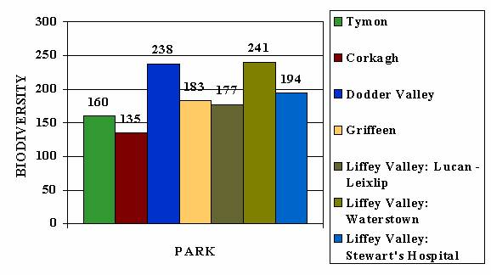

Fig.1 Biodiversity Scores for Regional Parks (1999)
In the 200 study, the comparison of the levels of biodiversity within the neighbourhood parks and the regional parks showed some expected patterns. Figure 2 shows a graph of the parks and their associated biodiversity values in ascending order.
Evidence from Figure 2 indicates that many of the neighbourhood parks are on a par with the Regional Parks with regards to their level of biodiversity. The older demesnes of Rathfarnham Castle and Willsbrook Park have a higher diversity than several of the Regional Parks. The recently developed parks of Rathcoole, Seán Walsh and Ballymount have an encouragingly high diversity index, indicative of the careful consideration given to the establishment of these parks with respect to their wildlife composition.
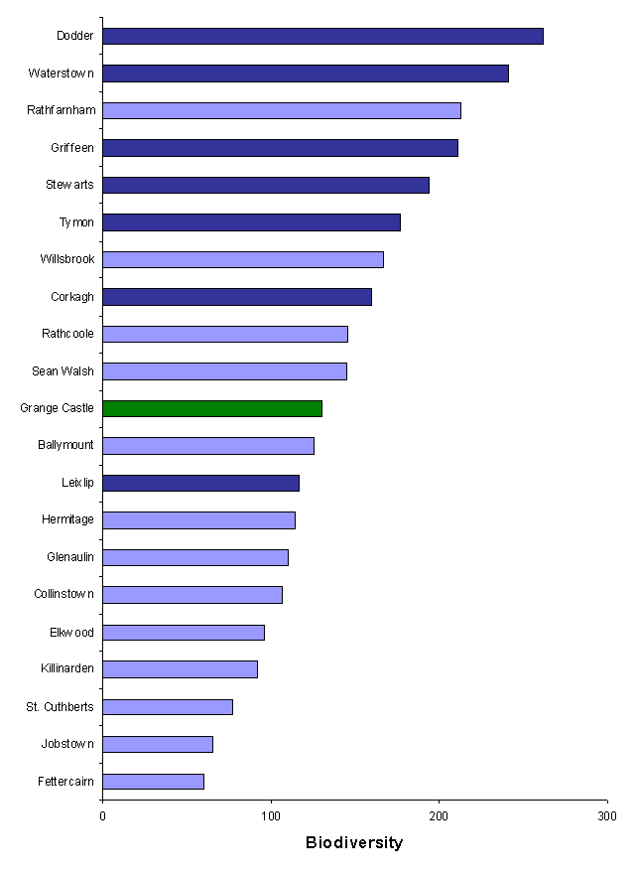Fig 1: Biodiversity scores for the Regional and Neighbourhood parks, and the Golf Course, arranged in ascending order.

The survey indicated that the Council’s policy in aiming for a diversity of habitats within parks is in keeping with national aims and objectives. This policy is continuing and the new parks developed in recent years are establishing well and the flora and fauna are continuing to diversify.

With the aim of conserving and enhancing the biodiversity of Waterstown Park, the Council engaged a consultant ecologist, to advise on how the park development can be undertaken in a way that is sensitive to its ecological potential and the designation of part of the site as a pNHA and in a manner that allows for sensitive public access. The National Parks and Wildlife Service were also involved in the discussions. A management plan is to be developed with the ecologist to allow for the management of the site in accordance with its ecological importance and its position as a link in the plans for a larger Liffey Valley Park.

Rivers and their associated riparian zones are important habitats that support a number of Annex 1 (Brook lamprey, Freshwater Pearl Mussel, Freshwater Crayfish under the Habitats Directive and Kingfisher under the Birds Directive) and Annex 11 species such as the Otter. Rivers are also important wildlife corridors for many species and are an important feeding ground for a number of bat species. However to be an appealing habitat for these species the river water needs to be clean and the surrounding habitats be diverse enough to attract species to feed and breed in the area. Therefore, the rivers within the County and especially in parks should be enhanced to ensure biodiversity is sustained and increased. For these reasons a general enhancement of the rivers by removing items dumped and creating wild seed areas and erecting bat, insect and bird boxes as well as signs to describe the wildlife is planned for the rivers, commencing with the Griffeen Valley Park. It is anticipated that the construction of reed beds and wetlands further upstream at Griffeen Park will lead to cleaner water.

For the past number of years, areas within parks that are not required for active recreation have been allowed to develop into wildflower meadows and signs placed adjacent to these meadows, indicating the species that may be seen at various times of the year.

