**AL90208A.RPT**

|  |  |  |  |
| --- | --- | --- | --- |
| logo | **South Dublin County**  **Joint Policing Committee** | |  |
| **Date:**  **26th April 2019** | | **Report:**  **LPF Reports** | |

1. **Introduction**

1.1 There are four Local Policing Forums in South Dublin County:

* Clondalkin Local Policing Forum covering Clondalkin Garda Sub Division
* D12 Local Policing Forum covering a small part of Crumlin Garda Sub Division around Greenhills
* North Clondalkin Policing Forum covering Ronanstown Garda Sub Division
* Tallaght Local Policing Forum covering the West Tallaght area of Tallaght Garda Sub Division

1.2 Each LPF has a management committee comprising:

* An Garda Síochána Superintendent
* South Dublin County Council
* One elected representative
* Community representatives
* Drug Task Force representative

1.3 The following table sets out the meetings of the JPC and LPFs diary for 2019:

**2018**

|  |  |  |  |  |  |  |  |  |  |  |  |  |  |
| --- | --- | --- | --- | --- | --- | --- | --- | --- | --- | --- | --- | --- | --- |
|  | | Jan | Feb | Mar | Apr | May | Jun | Jul | Aug | Sep | Oct | Nov | Dec |
| **JPC** | |  | **01** |  | **26** |  |  |  |  | **20** |  | **22** |  |
| Steering Group | | 18 |  |  | 18 |  |  |  |  | 06 |  | 08 |  |
| JPC Drug Sub | | 16 | 19 |  |  |  |  |  |  |  |  |  |  |
| **Clondalkin LPF MC** | |  |  |  |  |  |  |  |  |  |  |  |  |
| **Clondalkin LPF PM** | |  |  |  |  |  |  |  |  |  |  |  |  |
| **D12 LPF MC** | |  | **07** |  | **30** |  |  |  |  |  |  |  |  |
| **D12 LPF PM** | |  | **07** |  | **30** |  |  |  |  |  |  |  |  |
| **N Clondalkin LPF MC** | | **10** | **14** | **14** | **11** | **09** | **13** | **11** |  | **12** | **10** | **14** | **12** |
| **N Clondalkin LPF PM** | |  |  |  |  |  |  |  |  |  |  |  |  |
| **W Tallaght LPF MC** | | **15** |  |  | **30** |  |  |  |  |  |  |  |  |
| **W Tallaght LPF PM** | |  |  |  |  |  |  |  |  |  |  |  |  |
| **Total** |  |  |  |  |  |  |  |  |  |  |  |  |  |

**MC: Management Committee**

**PM: Public Meeting**

1.4 Each LPF is given the opportunity of submitting a report to be included in the LPF Report to be considered at each JPC meeting. This report can contain recommendations from the LPF to be considered by the JPC. It also provides a short summary of issues covered by the LPF at its most recent meetings. Appendix 1 sets out the functions of the JPC and the role of local policing fora to discuss and make recommendations to the committee concerning matters that it is to keep under review.

**2 Issues for consideration by the JPC**

2.1 None identified

**3 LPF Reports**

# 3.1 Clondalkin Local Policing Forum

3.1.1The Management Committee need to meet.

## 3.1.2 Public meetings

The last Public meeting in Clondalkin was held on Thursday 12th April 2018.

**3.2 D12 Local Policing Forum**

3.2.1The Management Committee meet regularly to plan the Public Meetings. The last Management Committee meeting was held on the 7th February 2019. The next Management Committee meeting is on the 30th April 2019

3.2.2 Public meetings

The last Public meeting in D12 was held on the 7th February 2019 at the St John Bosco Centre. Issues raised at this meeting included the following:

* Parking enforcement and clamping those parking on footpaths
* ASB setting fire to bins. Powers of DCC in dealing with ASB, reporting ASB to the Gardaí and reporting on Pulse system
* Task force for the D12 area
* Gangs particularly bike gangs 30/40 at a time, crossing the whole area and moving into Ballyfermot and other districts, need for better coordination between Gardaí districts
* Dealing with under 12s need to refer to Tusla
* Brickfield park fires
* CCTV and body cameras for the Gardaí
* Bru Garda Diversion programme employing an outreach worker, only seven youth workers in the D12 area
* Crime figures don’t show the problem areas, would be good to have some indication of the number of calls made to the Gardaí
* Quad bikes seems to have been addressed
* Jumping red lights if locations are identified to be referred to the Traffic Unit
* Gardaí Awards night in Tallaght stadium on the 28th February 2019
* Extra funding has been put into CCTV cameras by DCC

3.2.3 The next Public Meeting is TBC.

3.2.4 The D12 LPF has been funded by DCC and SDCC to produce a Crimestoppers campaign:

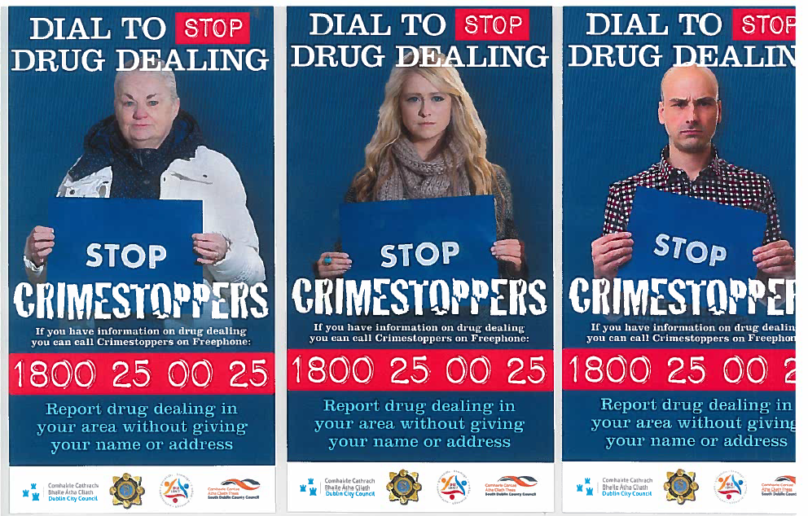

**3.3 North Clondalkin, Lucan & Palmerstown Local Policing Forum**

3.3.1 There have been 3 LPF and 2 CSF meetings over the last 3 months, community representatives have raised the following issues which are impacting on their quality of life and the community in general.

3.3.2 **Issues**

* Local playground and play area covered in broken glass - ongoing problem – needs regular clean ups - SDCC
* Path alongside this play ground needs public lighting installed - SDCC
* Path or steps to be constructed which would give access to Thomas Omer Road for children from Balgaddy who are attending Kisheogue College – Actioned SDCC through part 8/new housing development.
* Local tenants acknowledged the respectful approach of the Gardaí in relation to the recent shooting. Gardaí in turn acknowledged the very positive response from the community in their door to door enquiries. Concerns were also expressed regarding children who have been affected by this crime. Gardaí gave reassurance that they will give support / advice to anyone affected by this. They also recommended, that this information be passed on to the families of children that have been affected.
* Double yellow lines - Reinstatement of double yellow lines on newly surfaced road – Will be actioned by SDCC and Gardaí.
* Local Crèche: Yellow lines painted on both sides of the road. This is creating a major problem, highly dangerous for parents leaving children off at the crèche. Local Cllr will follow up on this (SDCC).
* Taxis have been targeted for the purposes of robbery - Garda will check this out.
* The homes of elderly people being targeted by bogus waste collection people and roof repair men. Gardaí advised that elderly people are informed through church/parish priest to not engage with such callers and to contact Gardaí.
* Increase in burglaries and unusual activity involving individual and a van – details were passed on to Gardaí for follow up action.
* Cars been broken into, this activity was caught on cctv and led to a successful arrest
* Problems with cars parking on the tarmacadam area adjacent to the footpaths. Could SDCC arrange to position some street furniture at these locations to prevent such parking, other courses of action will be explored to address this problem with other motorists who are parking cars in the vicinity.
* Public lighting – impact of lighting reduced because of overgrown trees; it has been suggested to replace existing bulbs with LED bulbs – elected representatives have been working on this.
* Ongoing drug dealing and ASB at a local shopping centre, Gardaí meet regularly with local business owners to agree specific actions to deal with this problem and Gardaí will continue to commit resources to tackling this problem.
* Drug dealing and ASB at the location a very high wall where this activity can take place out of view and often difficult to detect. There was a suggestion that the planting of thorny bushes might deter young people from hanging out at this location. Residents have been asked to get in touch with the Gardaí to discuss this issue further.
* Attempted access to cars, this activity has been caught on CCTV and will be passed on to Gardaí.
* Boundary wall between 2 housing estates has been vandalised and is the site of ASB and other issues. Local residents’ group have tried to find out who owns the land and the wall, so far their efforts have been unsuccessful. The wall needs to be repaired asap to eliminate the problem – Local Cllr will follow up on this.
* Rubbish being dumped and burned on the “*black path*”, rubbish bins need to be placed across the community of North Clondalkin, needs to actioned by SDCC
* Double/hazardous parking at local shops, public house/off-licence – ongoing monitoring by Gardaí.
* M50 Concession – Any update on the filling in of the gap between the boundary wall and the M50 fence?

**3.4 Tallaght Local Policing Forum**

3.4.1 The LPF Management Committee meet in County Hall and the last meeting was held on 15th January 2019 with the next meeting is set for the 30th April 2019. Issues discussed at the last meeting included:

* **Scramblers:** Still a major issue in the West Tallaght area and it was noted that the Gardaí in Fingal had carried out an operation on Christmas Day to address scramblers and had succeeded in apprehending a number of scrambler bikes.
* **Sheehy Skeffington Meadows Estate:** problems of intimidation of new families and other anti-social behaviour in the area.
* **Drug related Intimidation:** Drug related intimidation is becoming more frequent now and is a growing issue for frontline workers.
* **Killinarden Park:** pitches have been destroyed, dumping of rubbish is also a major problem.
* **Cushlawn Parade:** drug dealing a problem with dealers using bikes that nobody is able to catch.

3.4.2 Public meetings

The last public meeting was held on Tuesday 8th May 2018 at 7.00pm in the Maldron Hotel Tallaght. 58 people were present. The date for the next Public Meeting is TBC.