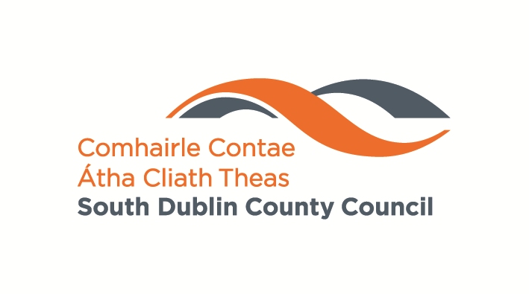

South Dublin County Council

Road Traffic
(Periodic Special Speed Limit) Amendment Bye-Law
2019

R.S.L. 1 of 2019

South Dublin County Council, in exercise of the powers conferred on it by Section 9 of the Road Traffic Act 2004 (no 44 of 2004), hereby make the following bye-law for a periodic special speed limit of 30km/h in the following locations:

Road Name | Location
Kiltipper Way (L3043) | From a point 15 metres south of public lighting pole no. 16 in northerly direction for 185 metres.
Castletymon Road (L3036) | From a point 28 metres east of the centre of the junction with Tymonville Road in an easterly direction for 210 metres.
Limekiln Road (L4013) | From a point 25 metres east of public lighting pole no. 18 in an easterly direction for 475 metres.
Collinstown Road (L1007) | From a point adjacent to public lighting pole no. 39 in a southerly direction for 195 metres.
Bawnogue Road (L1002) | From a point adjacent to public lighting pole no. 14 in a northerly direction for 175 metres.
Brookfield Road (L3003) | From a point 10 metres south west of public lighting pole no. 18 in north easterly direction for 185 metres.

- This bye-law may be cited as the Road Traffic (Periodic Special Speed Limit) Amendment Bye-Law, 2019 (R.S.L. No 1 of 2019).

- This bye-law shall come into operation on the 1st May, 2019 and shall be effective from 8.00am to 9.30am and from 1.00pm to 4.00pm on dates which are in accordance with the Department of Education & Skills school year, the Standardisation of the School Year document and at times specified locally.

- 30 kilometres per hour shall be the periodic special speed limit for mechanically propelled vehicles on the road specified in the schedule to this bye-law.

SCHEDULE

- Section 10.1. Thirteenth Schedule (Periodic Special Speed Limits) of Bye Law R.S.L. 1 of 2017 is hereby amended by Bye Law R.S.L. No 1 of 2019 as follows:-

10.1.14 Kiltipper Way (L3043)
From a point 15 metres south of public lighting pole no. 16 in northerly direction for 185 metres.

10.1.15 Castletymon Road (L3036)
From a point 28 metres east of the centre of the junction with Tymonville Road in an easterly direction for 210 metres.

10.1.16 Limekiln Road (L4013)
From a point 25 metres east of public lighting pole no. 18 in an easterly direction for 475 metres.

10.1.17 Collinstown Road (L1007)
From a point adjacent to public lighting pole no. 39 in a southerly direction for 195 metres.

10.1.18 Bawnogue Road (L1002)
From a point adjacent to public lighting pole no. 14 in a northerly direction for 175 metres.

10.1.19 Brookfield Road (L3003)
From a point 10 metres south west of public lighting pole no. 18 in north easterly direction for 185 metres.

EXPLANATORY NOTE

(This note is not part of the bye-law and does not purport to be a legal interpretation).

This bye-law amends the Road Traffic (Speed Limits) Bye Laws, 2017 to have a 30 km/h periodic special speed limit on the public roads listed.

Ambulances, fire brigade and Garda Síochána vehicles while being used in the course of duty are exempt from the speed limit.

Made Under the Official Seal
of
South Dublin County Council

Dated this day of 2019

Present when the official seal of South Dublin County Council was affixed hereto:

_______________________________
Director of Services,
Land Use, Planning & Transportation

This Bye-Law shall come into effect on the 1st day of June, 2019.

