|  |  |  |  |
| --- | --- | --- | --- |
|  | | | |
| **Briefing Note** | | | |
| **Date:** | 21/02/2019 | File Ref: | NRO234-M002-A |
| **Subject:** | M4 Maynooth to Leixlip – Overview & Progress | | |

# **Scheme Location**

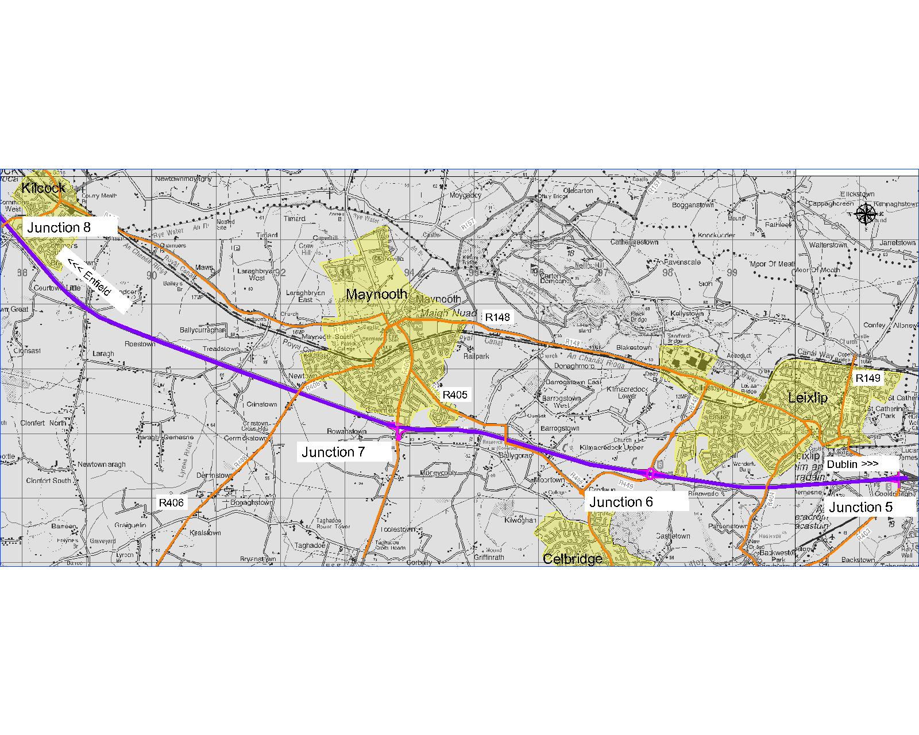

# Project Description

The aim of the project is to assess the needs of the M4 mainline corridor and junctions from Maynooth to Junction 5 Leixlip in terms of catering for future demand from a capacity, safety and operational perspective.

The M4 Maynooth to Leixlip is listed as a major road development to be prioritised for delivery under the National Development Plan 2018–2027 and forms part of the Trans-European Transport Network (TEN-T) comprehensive network.

The project is approximately 10km in length with 1.5km in South Dublin County Council and the rest in Kildare County Council.

Transport Infrastructure Ireland is the Sanctioning Authority for the project.

# Need for Consideration

The need for consideration of an intervention in the corridor has been based upon a number of factors examined within a project pre-appraisal, which are summarised as follows:

* **Delivery of Project Ireland 2040:** The ‘M4 Maynooth to Leixlip’ is listed as a major road development to be progressed through pre-appraisal and early planning and prioritised for delivery under the National Development Plan 2018–2027.
* **Congestion:** The corridor experiences congestion and as a result has a low Level of Service.
* **Poor Journey Time Reliability**: the corridor experience low journey time reliability at peak times.

# **Current Phase of Project**

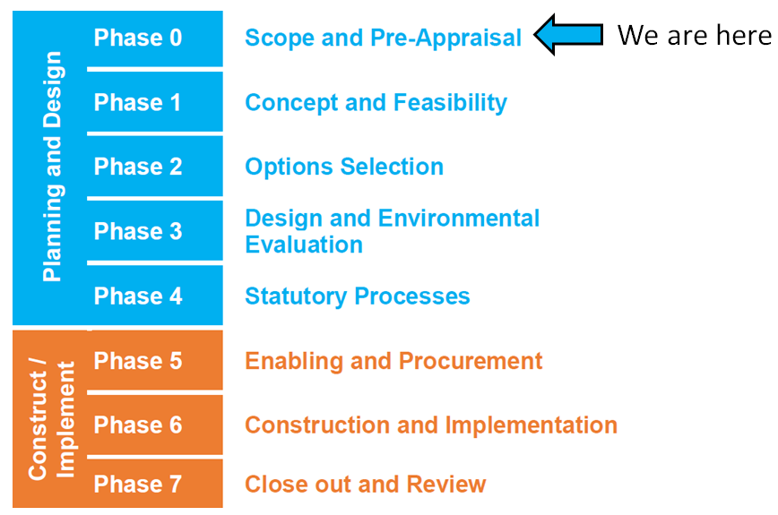

Transport Infrastructure Ireland Project Phases

The project is in the early Scope and Pre-appraisal Phase. A pre-appraisal was completed on the project, which was approved by DTTaS in January 2019 meaning the project can progress to the next phases of development.

The pre-appraisal confirms that there is a need to examine the corridor in greater detail in Phase 1 and to determine if an intervention is required and if an intervention is feasible.

Phase 2 would examine options that could address the aims of project.

Phase 3 would develop a design of an emerging preferred option from Phase 2 for further assessment.

Phase 4 would include undertaking of Statutory Processes.

The project must pass various assessments and gateway approvals through each Phase and may be terminated at any Phase as a result.

# Next Steps and Phases of the Project

A Section 85 will facilitate progress through the next stage of project development, Phase 1 to 4, which are as follows:

* Phase 1: Concept & Feasibility;
* Phase 2: Option Selection;
* Phase 3: Design and Environmental Evaluation; and
* Phase 4: Statutory Process.

The Mayor and Members will be kept informed throughout the development of the project.