COMHAIRLE CHONTAE ÁTHA CLIATH THEAS
SOUTH DUBLIN COUNTY COUNCIL

MEETING OF TERENURE-RATHFARNHAM AREA COMMITTEE (1)
Tuesday, 7th March, 2006
H-I (3)
St. Catherine’s, Augustinian Site, Ballyboden -
Report Of Conservation Officer
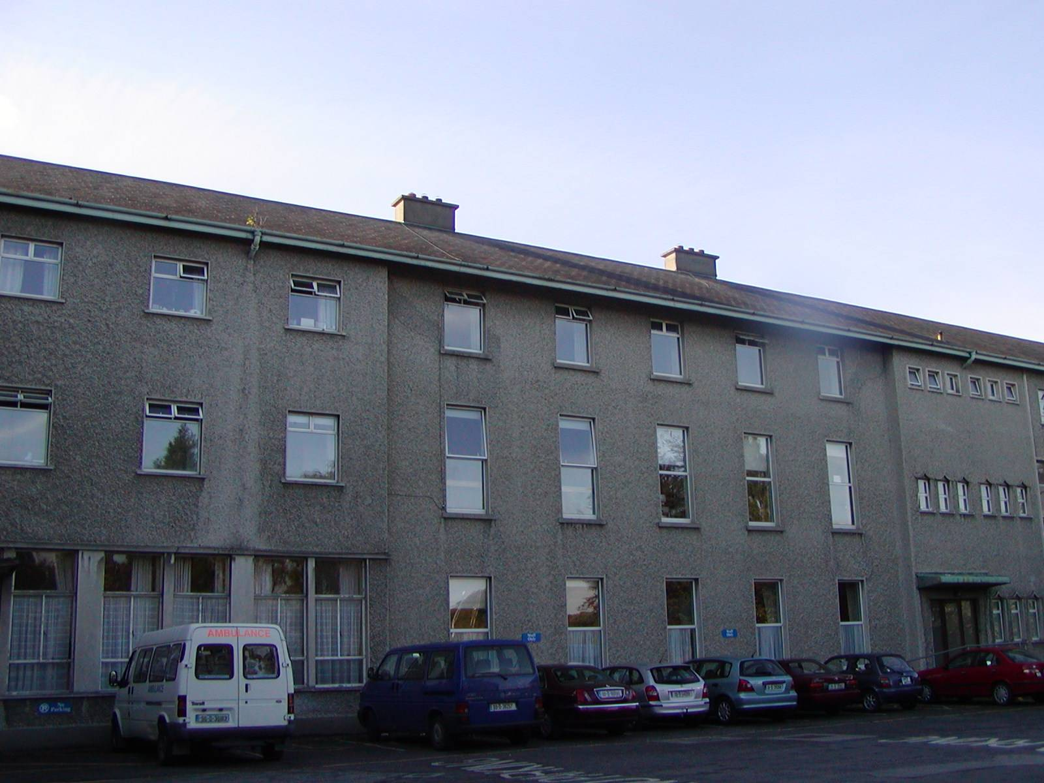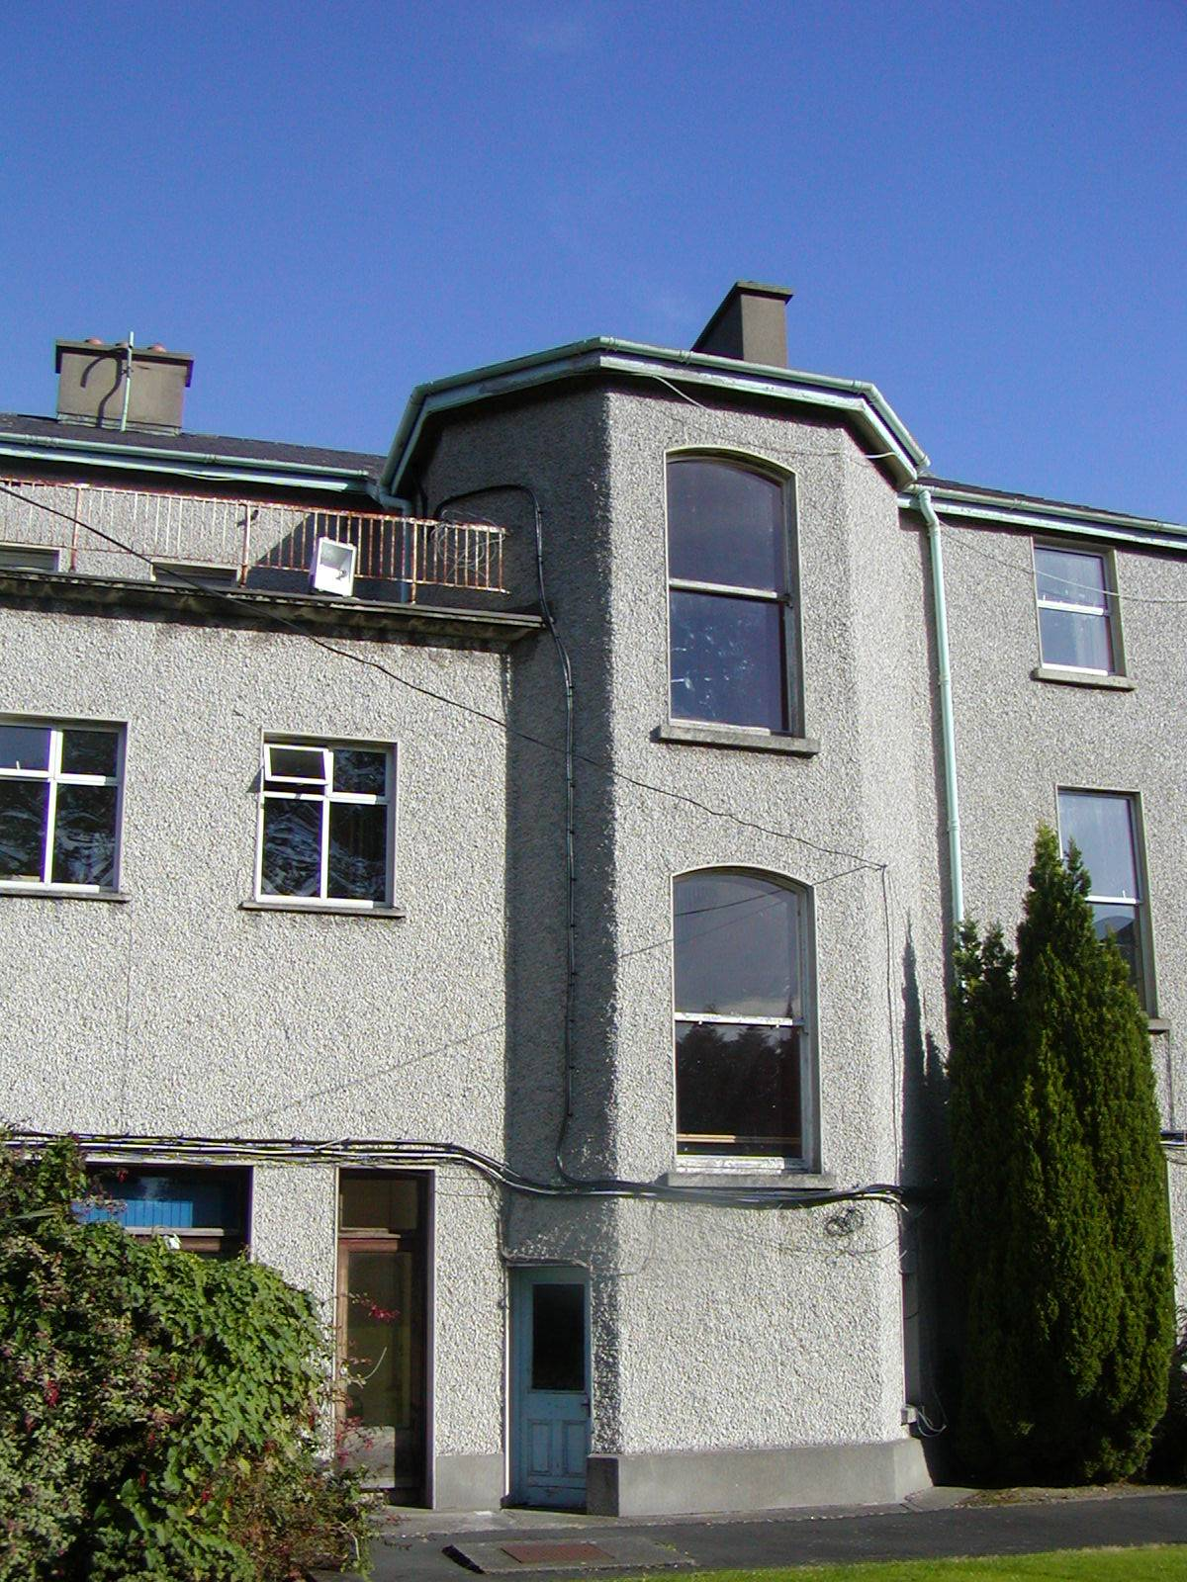
Front Elevation - Former St. Catherine’s House Rear Elevation – Former St. Catherine’s House

INTRODUCTION

The (former) St. Catherine’s House is located within the grounds of the Augustinian site, Taylors Lane, Ballyboden. A number of submissions have been received requesting that the former St. Catherine’s be included on the Record of Protected Structures. Submissions/recommendations have been received from The Glendoher and District Residents Association, Ballyboden Road Cottages Residents Association and An Taisce. The structure in question is an early to mid 19th century former house. It should be noted that the former St. Catherine’s was not identified under the National Inventory of Architectural Heritage, which was carried out for South Dublin County during 2002. Presently the buildings are being used by the health authorities as a care facility

The structure was dramatically altered and extended to accommodate its new use as a seminary in the c.1950s. The entire exterior of the original structure has been completely altered to match the 1950s wings making it difficult to identify.

A visual inspection of both the exterior and interior of the site was carried out. It was evident from the inspection that many, what appear to be, original internal features are intact although the original layout of the former house has been totally altered due to subdivision of areas relating to its change of use. Some of the internal features include a very fine staircase with a very decorative newel post and trend ends. Original plasterwork exists along the stairs and landings and in some of the rooms located in the first floors. There would also appear to be original fireplaces in some of the front and rear rooms on the ground floor (access was not possible throughout the whole building). Original window boxes and shutters also remain intact although the original windows have been replaced with inappropriate aluminium windows. There are however single pane timber sliding sash windows remaining on each half landing of the original staircase.

A number of archival searches were carried out in order to ascertain a full understanding of the historical development of the structure/site. The searches proved ineffective as no such information could be found.

CONCLUSION:

St. Catherine’s has been substantially altered externally and internally. The original structure is unrecognisable today due to the addition of the 1950s wings and external render used to marry the old building with the later additions.

Under Section 2 of the Planning and Development Act 2000, the term ‘structure’ means “any building, structure, excavation, or other thing constructed or made on, in, or under any land, or any part of a structure so defined, (a) where the context so admits, includes the land on, in or under which the structure is situate, and (b) in relation to a protected structure or proposed protected structure, includes (i) the interior of the structure, (ii) the land lying within the curtilage of the structure, (iii) any other structures lying within that curtilage and their interiors, and (iv) all fixtures and features which form part of the interior or exterior of any structure or structures”.

The placing of a structure on the Record of Protected Structures means that the entire site is a protected structure. This would include all existing buildings on site - their exteriors, interiors, fixtures and fittings. The protection also extends to the lands of the site and as such come under the provisions of the Planning and Development Act 2000. To include the former St. Catherine’s on the Record of Protected Structure solely for the protection of some internal features would give protection to the site as a whole. In this case it is difficult to justify the inclusion of the entire site on the Record of Protected Structures.

It is recommended under the Architectural Heritage Protection Guidelines that “a planning authority must decide whether a structure is worthy of inclusion in the Record of Protected Structures (RPS) by identifying the characteristics of special interest, which would merit its inclusion”. Part 2 of the Guidelines indicates features, which may contribute to the character and special interest of a structure. The Planning Act requires that a protected structure be of special interest under one or more of the following categories: Architectural, Historical, Archaeological, Artistic, Cultural, Scientific, Technical and social.

Architectural interest is the most common category associated with structures on the Record of Protected Structures. “Architectural interest refers to the characteristics of architectural interest which may be attributed to a structure or part of a structure with such qualities e.g. a structure with an interior that is well designed rich in decoration, complex or spatially pleasing”.

It is considered that although the interior of the former St. Catherine’s has some existing features of interest it is not entirely rich in decoration, therefore justification can not be made that the structure is of architectural interest on internal features alone.

RECOMMENDATION:

It is considered that the former St. Catherine’s House does not merit inclusion on the Record of Protected Structures. It is considered that the site as a whole provides some level of architectural and social interest. It is therefore considered that a provision or policy be included in the proposed Ballyboden Village Plan for the safeguarding of the original architectural features of the house.

