**REPORT ON INTERIM INTERNAL REVIEW**

**OF TREE MANAGEMENT POLICY 2015-2020 ‘LIVING WITH TREES’**

The Council's Tree Management Policy 2015-2020 'Living With Trees' was adopted at a meeting of the Council on July 13, 2015.

The policy was developed by the Council’s Public Realm section having regard to best practice within the wider local authority and arboricultural sectors on both national and international levels. The process involved the support and active input of a dedicated working group comprising members of the Environment, Water & Climate Change Strategic Policy Committee. A draft policy document was published to coincide with a period of public consultation enabling the public to submit comments and observations which were considered by the working group and addressed in the adopted policy.

The Tree Management Policy provides a framework to inform and support decisions made by the Council on the management and development of a sustainable tree population in the County. The Policy acts as a point of reference for the public, Councillors, Council staff and professionally interested people to enable informed discussion and to establish a clearer, consistent and a structured approach to the issues affecting trees.

The objectives of the policy are:

* Improve tree management and create a safer, healthier tree population
* Implement a proactive, planned programme of cyclical tree maintenance
* Maximise the use of the Council’s resources to provide a better service and give better value for money.

**Interim Review**

This is a 5-Year management policy. An interim internal review of the policy commenced during 2018 in accordance with the relevant specific action listed in the Action Plan which accompanies and supports the Tree Management Policy.

The aim of the review is to:

* Review and assess progress to date on the implementation of the Action Plan
* Confirm whether the vision established by the policy is the right focus
* Provide an updated snapshot of our current tree stock and how the Council manages them
* Reassess aspects of the policy on particular issues that continue to generate ambiguity
* Look at emerging issues
* Assess consistency of relevant policies and actions of the Tree Management Policy with the Council’s Climate Change Action Plan
* Make new policy recommendations as necessary from review process

The review has primarily focussed on updating policies and actions to ensure current and future challenges are met, taking account of emerging issues and providing further direction and clarity for management of trees in the county.

The specific policy issues reviewed as part of the interim internal review are as follows:

* Trees in conflict with built structures
* Tree root pruning
* Trees in proximity to public lighting columns
* Trees and utilities
* Nesting birds
* Unauthorised removal of trees
* Tree planting
* Update list of recommended tree species
* Management of trees located along private boundaries within parks and open spaces
* Trees located within the gardens of Council-owned housing
* Monetary valuation of amenity trees
* Planning controls for residential extensions or annex developments in close proximity to established trees
* Removal of trees to facilitate widening of residential driveway access
* Climate Change

Arising from discussion of a report on the ongoing review of the Council’s Tree Management Policy to the meeting of the Environment, Public Realm and Climate Change SPC Meeting on November 6th last, it was proposed to convene a working group to progress the detail of the review process.  The working group was to comprise members of the SPC with an expressed interest in participating in the review process and former SPC members who were involved in the initial development of the Tree Management Policy with an expressed interest in participating in the review process also. Meetings of the working group took place on January 9 and January 22, 2019.

**Review Recommendations**

The review recommendations are detailed as follows:

**Trees In Conflict With Built Structures**

***Review Objective:***

1. ***Provide a clear, corporate protocol for resolving issues where tree roots are in conflict with the built environment. Specific locations include public footpaths, private boundary walls and driveways***
2. ***Review and agree with relevant internal departments guidelines and options for implementation of alternative engineering solutions in order to minimise removal of healthy trees***

***Current Policy Statements***

**6.5 Trees in Conflict with the Built Environment**

Trees in an urban environment will inevitably conflict with people and infrastructure which creates pressures for trees to be pruned or felled. The Council recognises that trees under its ownership/management may be implicated in causing damage to nearby built structures but is also aware that this is not always the case and that nearby trees often get blamed for damage before a thorough investigation is carried out. Some other reasons for structural failure are inadequate foundation design, general structural failure, poor quality construction, nearby excavations or major works to adjacent properties.

Property owners will be expected to provide evidence that a particular tree is causing damage to the property and that all reasonable engineering alternatives have been explored before felling will be considered.

Although the level of evidence required may differ on a case by case basis, the Council, as a minimum, will normally require an engineer’s report including an accurate survey, a history of the damage to a built structure and a plan and profile of foundations where relevant.

If this evidence is not sufficient to demonstrate that the tree is responsible for the damage, the Council may require further information including an arborist’s report, crack monitoring, soil analysis and root analysis to be submitted.

Where necessary, the Council will obtain expert specialist advice to verify submitted evidence and where it demonstrates that the tree is an influencing cause, permission to remove the tree will not unreasonably be withheld, provided that there is no other recourse available.

**6.4 Trip Hazard**

**Policy: The Council will undertake measures to make safe an unacceptable trip hazard on a public footpath or road caused by the growth of a Council owned/managed tree.**

The roots of trees exploit the soil in various ways dependent on species, local conditions and history of site disturbance. Pressure exerted by the radial growth of roots can deform the surfaces of footpaths, roads or other light structures, especially in the close confines of the urban setting. Damage occurs most commonly close to the tree and will diminish rapidly with distance. To constitute a trip hazard the deformation will be assessed by the Council. Where a hazard exists and is attributable to tree roots engineering options will be explored before root pruning or tree removal is undertaken.

It is often possible to repair paths to take account of adjacent trees and tree roots. Where roots protrude they can be root pruned, or the path can be re-laid around the tree with flexible material such as asphalt to provide a smooth surface or using reinforced concrete or other engineering solutions.

Where trees are considered to be causing damage to paths or footpaths, the Council will not normally consider tree removal except where there is a risk to public health which cannot otherwise be mitigated. Removal of the tree will usually be the last resort, accepting that in some circumstances where the tree is of low value or easily replaced removal may be the most appropriate solution. The Council will seek to explore engineering options through internal consultation between the Public Realm and Roads Maintenance sections to reduce trip hazards before root pruning or tree removal. The Council will develop a protocol for resolving issues where tree roots are in conflict with public areas under hard surfacing.

***Review Discussion***

The Council receives very significant numbers of requests for tree removal through its customer contact system. Chief among the reasons cited in requests received by the Council for removal of a particular tree, or trees, are where they are perceived to be the cause of damage to a built structure, most frequently public footpaths, private boundary walls or private driveways.

Unfortunately, due to inaccurate and frequently misguided conceptions and reports linking trees with damage to built structures, it has become established in the public’s mind and in many professional and technical circles, that trees are always the cause of damage to the built environment even before adequate site investigations have been conducted. It is accepted amongst tree professionals that trees are on many occasions are a contributing factor in structural damage. However, it is also true that they are not the causative agent in the damage, although frequently cited as the prime cause. The issue is far more complex than this and requires consideration of appropriate professionally verified evidence along with options for remedial actions that don’t automatically presume the removal of the particular tree or trees. The culture whereby the balance of probabilities argument has been used to identify trees as the culprits of structural damage needs to be replaced with one of accurate assessment of the relevant facts. This facilitates a more balanced and proportionate approach to tree management.

Considerations of this issue also need to take account of the evolving context whereby the role of trees in addressing climate change resilience is becoming ever more widely understood. South Dublin County Council has identified actions in its Draft Climate Change Action Plan that seek to prevent loss of tree cover and ensure high standards of tree protection, planting and management

***Review Recommendation***

Amend Policy Statement 6.5 Trees in Conflict with the Built Environment as follows:

**Policy: The Council will not normally consider removal of a tree where structural damage can be repaired or reasonably resolved by appropriate engineering solutions.**

Trees in an urban environment will inevitably conflict with people and infrastructure which creates pressures for trees to be pruned or felled. The perceived threat of damage by tree roots is sometimes a worry people have about trees near to buildings or built structures. Much of this concern is unwarranted as most trees growing near buildings cause no damage.  Tree roots are unlikely to directly penetrate sound footings. Lightly loaded structures, if they have inadequate foundations, may be affected by pressure exerted by tree roots or trunks but in such cases trees are not the primary cause of damage.

The Council recognises that trees under its ownership/management may be implicated in damage to nearby built structures but is also aware that trees are not always the causative agent and that nearby trees often get blamed for damage before a thorough investigation is carried out. Some other reasons for structural failure are inadequate foundation design, general structural failure, poor quality construction, nearby excavations or major works to adjacent properties.

In circumstances where structural damage can be repaired or reasonably resolved by appropriate engineering solutions, the Council will not normally consider removal of a tree, except where the tree is considered to be of poor structural or physiological condition.

Property owners will, at their own expense, be expected to provide evidence from an appropriately qualified professional that a particular tree is or has caused damage to their property and that all reasonable engineering alternatives have been explored before felling will be considered.  Where evidence is provided which demonstrates a Council owned tree is the cause of damage, the Council will take appropriate action on a case by case basis.

**Tree Root Pruning**

***Review Objective:***

* ***Provide a policy statement on tree root pruning***

***Review Recommendation***

*Proposed policy statement:*

***Tree Root Pruning***

**Policy: The Council will carry out root pruning only when viable alternatives to severing the roots cannot be found and where an obvious and positive outcome can be achieved without any long-term damage to the tree.**

Tree roots keep a tree healthy and upright. Most roots are found in the top 600mm of soil and often grow out further than the tree’s height. If roots are damaged the tree may become unstable or may suffer irreversible harm and eventually die.

Root pruning is generally discouraged as a method of alleviating damage to adjoining property, such as infrastructure uplift or service-line disturbance. This is because the long term implications of sustained and heavy root pruning are unpredictable. The Council will perform root pruning on any tree wherever practicable before removal is considered. Approval of the Council’s Tree Officer or Parks Supervisor is required before any tree root over 25mm in diameter is pruned.

Any construction, excavation or installation works being carried out in proximity to trees must be in accordance with British Standard (2012): Trees in relation to Design, Demolition and Construction – Recommendations and with the current NJUG (UK National Joint Utilities Group) Guidelines for the Planning, Installation and Maintenance of Utility Apparatus in Proximity to Trees.

**Trees In Proximity To Public Lighting Columns**

***Review Objective:***

* ***Review policy on removal of trees in proximity to public lighting columns in order to minimise loss of healthy trees and address public resistance to implementation of current policy***

***Current Policy Statements***

**6.1 Obstruction of Street Light**

**Policy: The Council will undertake work to a tree in Council ownership/management to ensure that trees do not unduly obstruct the streetlight.**

Tree pruning will be undertaken where reasonably feasible to address obstruction of a street light where a tree is within 5m of the lighting column. Where the trunk of a tree is within 2m of a lighting column, the removal of the tree is considered to be the most appropriate long-term option.

Where a tree is removed from a roadside verge, due to proximity to a public lighting column, a replacement tree will not be planted back into the same verge.

**4.3.4 Removal of Trees (extract from section)**

Trees are removed only when necessary as a last resort. The criteria for tree removal are:

* The trunk of the tree is within 2m of a public lighting column and the long term viability of the tree if retained in its location would be compromised by a requirement for ongoing maintenance in order to maintain the effectiveness of the adjoining street light.

***Review Discussion***

The current policy on removal of trees in proximity to public lighting columns was reviewed in order to minimise loss of healthy trees and address public resistance to current practice of removing trees within 2m of a lighting column.

***Review Recommendation***

Amend Policy Statement 6.1 Obstruction of Street Light as follows:

**Policy: The Council will undertake work to a tree in Council ownership/management to ensure that trees do not unduly obstruct the streetlight.**

Tree pruning will be undertaken where reasonably feasible to address obstruction of a street light.

In circumstances where the long term viability of the tree if retained in its location would be compromised by a requirement for ongoing maintenance in order to maintain the effectiveness of the adjoining street light, the tree may be removed. Alternative public lighting solutions should also be explored for areas of existing mature and established trees. Where a tree is removed from a roadside verge, due to proximity to a public lighting column, a replacement tree will not normally be planted back into the same verge. The Design Manual for Urban Roads and Streets (2013) recommends that new lights should be positioned away from trees, which in time may grow to envelop the lanterns or cast shadows which will render the lighting less effective.

Amend Policy Statement 4.3.4 Removal of Trees as follows:

Trees are removed only when necessary as a last resort. The criteria for tree removal are:

* **Where a tree is located in close proximity to a public lighting column and** the long term viability of the tree if retained in its location would be compromised by a requirement for ongoing maintenance in order to maintain the effectiveness of the adjoining street light.

**Trees and Utilities**

***Review Objective:***

* ***Enhance protection of trees and their growing environment from threats, such as loss of and damage to verges, and the activities of statutory agencies and others excavating near trees or carrying out tree pruning***
* ***Update current policy statement reference to Council’s licensing system for openings in public roads, public realm and green areas.***
* ***Incorporate as an Appendix to the policy the current NJUG (UK National Joint Utilities Group) Guidelines for The Planning, Installation and Maintenance of Utility Apparatus in Proximity to Trees***

***Current Policy Statement***

**6.8 Trees and Utilities**

Utility companies have certain legal rights to carry out works to public or privately owned trees to address health and safety problems and to maintain a clearance between trees and their apparatus. This may sometimes involve the loss of trees or removal of large parts of a tree leaving a misshapen and unbalanced crown and reducing the amenity value of the tree. Excavation works near to street trees brings considerable potential disturbance within the root zone of trees, often reducing their stability and long-term viability.

Where works to trees are necessary as a result of proximity or conflict, the Council will encourage utility operators to adopt the most appropriate long term solution, giving consideration to tree health, local tree cover and visual amenity.

Utility companies must consult with the Public Realm section of South Dublin County Council in advance of any pruning, trenching or other works likely to affect Council owned trees, and will refer to the procedures and conditions of the Council’s Roadmap system. Guidelines for Managing Openings in Public Roads

The Council will develop protocols for dealing with trees and utilities in consultation with the main utility providers and adhere to the recommendations of the current NJUG (UK National Joint Utilities Group) Guidelines for The Planning, Installation and Maintenance of Utility Apparatus in Proximity to Trees.

***Review* *Recommendation***

Amend Policy Statement 6.8 Trees and Utilities as follows:

…….. Utility companies must consult with the Public Realm section of South Dublin County Council in advance of any pruning, trenching or other works likely to affect Council owned trees, **and will adhere to the procedures and conditions of the Council’s MapRoad licensing system and the associated Guidelines for Managing Openings in Public Roads (2017).**

The Council will develop protocols for dealing with trees and utilities in consultation with the main utility providers **and utility companies are required to adhere to the best practice recommendations of the current NJUG (UK National Joint Utilities Group) Guidelines for The Planning, Installation and Maintenance of Utility Apparatus in Proximity to Trees. (See Appendix)**

New Appendix

Incorporate as an Appendix to the policy the current NJUG (UK National Joint Utilities Group) Guidelines for The Planning, Installation and Maintenance of Utility Apparatus in Proximity to Trees.

**APPENDIX: National Joint Utilities Group (UK) Guidelines for the Planning, Installation and Maintenance of Utility Apparatus in Proximity to Trees**

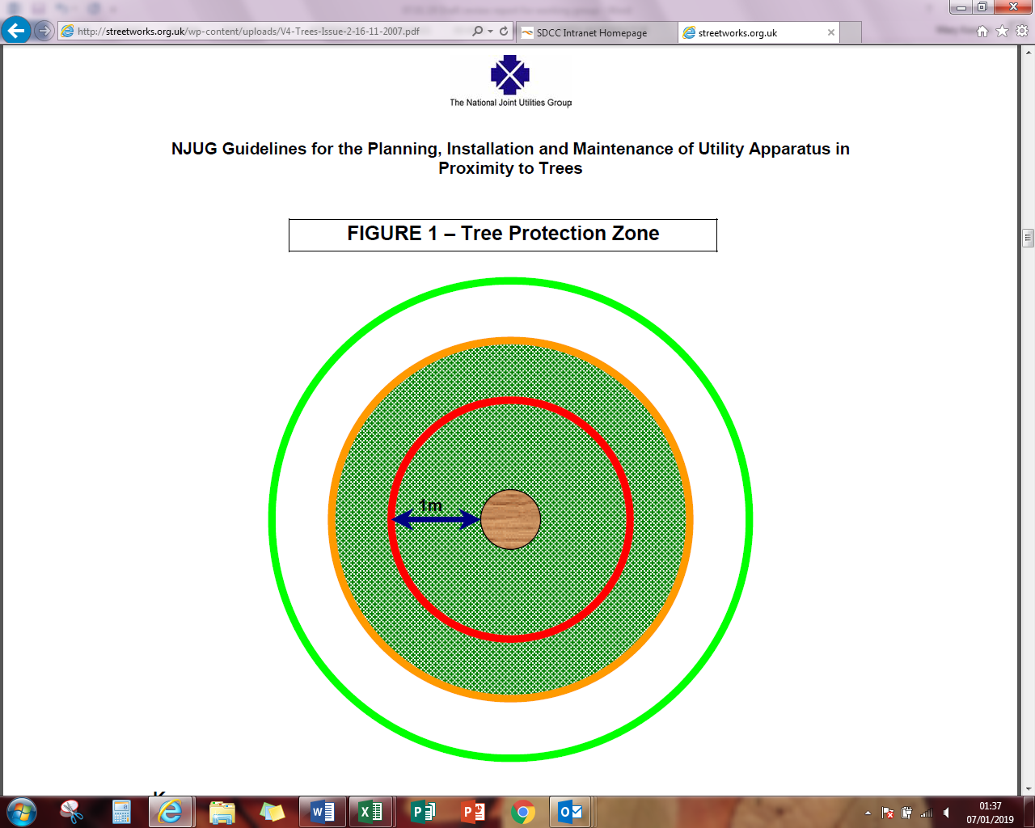

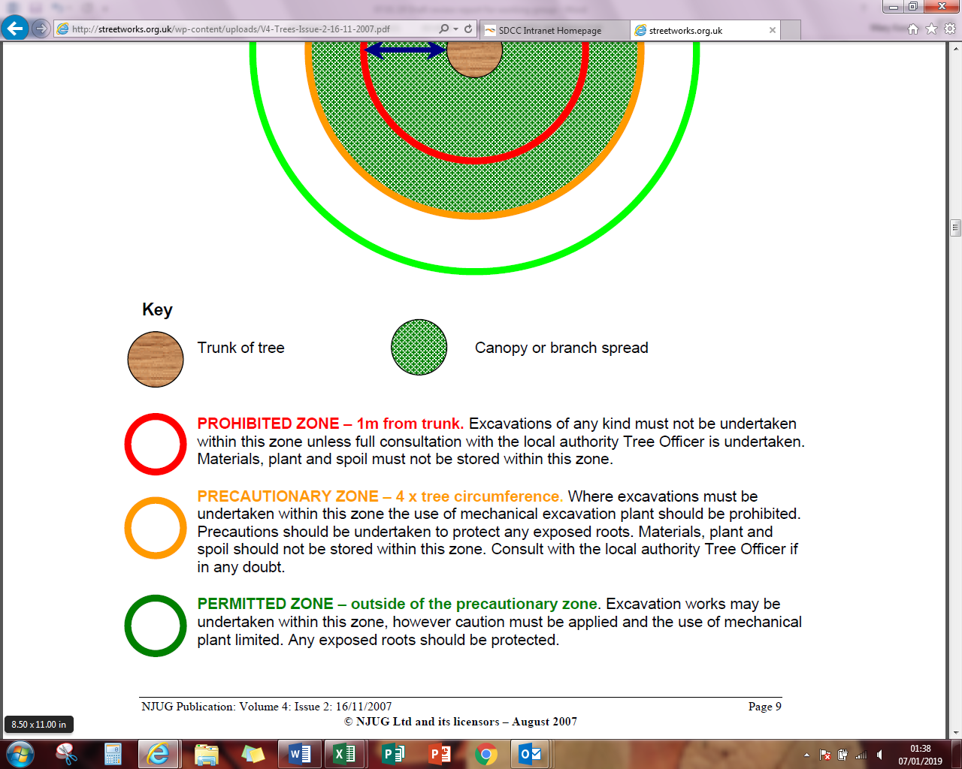

**PROTECTING ROOTS - DO’S and DON’TS**

There are three designated zones around a tree each of which has its own criteria for working practices.

**THE PROHIBITED ZONE**

**Don’t** excavate within this zone.

**Don’t** use any form of mechanical plant within this zone

**Don’t** store materials, plant or equipment within this zone.

**Don’t** move plant or vehicles within this zone.

**Don’t** lean materials against, or chain plant to, the trunk.

**Do** contact the local authority tree officer or owner of the tree if excavation within this zone is unavoidable.

**Do** protect any exposed roots uncovered within this zone with dry sacking.

**Do** backfill with a suitable inert granular and top soil material mix as soon as possible on completion of works.

**Do** notify the local authority tree officer or the tree’s owner of any damage.

**THE PRECAUTIONARY ZONE**

**Don’t** excavate with machinery. Where excavation is unavoidable within this zone excavate only by hand or use trenchless techniques.

**Don’t** cut roots over 25mm in diameter, unless advice has been sought from the local authority tree officer.

**Don’t** repeatedly move / use heavy mechanical plant except on hard standing.

**Don’t** store spoil or building material, including chemicals and fuels, within this zone.

**Do** prune roots which have to be removed using a sharp tool (e.g. secateurs or handsaw). Make a clean cut and leave as small a wound as possible.

**Do** backfill the trench with an inert granular material and top soil mix. Compact the backfill with care around the retained roots. On non-highway sites backfill only with excavated soil.

**Do** protect any exposed roots with dry sacking ensuring this is removed before backfilling.

**Do** notify the local authority tree officer or the tree’s owner of any damage.

**THE PERMITTED ZONE**

**Don’t** cut roots over 25mm in diameter, unless advice has been sought from the local authority tree officer.

**Do** use caution if it is absolutely necessary to operate mechanical plant within this zone.

**Do** prune roots which have to be removed using a sharp tool (e.g. secateurs or handsaw). Make a clean cut and leave as small a wound as possible.

**Do** protect any exposed roots with dry sacking ensuring this is removed before backfilling.

**Do** notify the local authority tree officer or the tree’s owner of any damage.

.**Nesting Birds**

***Review Objective:***

* ***Provide a code of practice for pre works inspections of trees for wildlife and nesting birds***

***Current Policy Statement***

**4.8 Nesting Birds**

**Policy: The Council will carry out inspections of trees prior to tree works for bird nests during the nesting period of March 1 – August 31 and comply with the relevant legislation and seek expert advice from relevant organisations where necessary.**

The Wildlife Act 1976 (as amended 2000) is the principle legislation protecting nesting birds in Ireland. The Act makes it an offence to kill, injure or take any wild bird and to take, damage or destroy any nest that is either in use or being built. Section 40 of the Act prohibits cutting of vegetation on uncultivated land between March 1st and August 31st. However, it is accepted in practice that street trees are cultivated and as such, this allows for tree maintenance works to be carried out during the closed period subject to compliance with best practice protocols in regard to pre-works assessment of trees for active nests or nesting birds. Where an active nest or nesting birds are observed, no tree works should be carried out.

The primary reason for a year round programme of street tree maintenance is to ensure public safety and minimise tree hazards. Phenological and biological research also indicates that a number of tree species including cherry and walnut are best pruned in mid-summer to avoid introduction of disease while maple and horse chestnut will bleed sap extensively if pruned during early season growth.

To comply with the Act, the Council will draft a best practice protocol to ensure minimal impact on wildlife and nesting birds. The Council’s tree maintenance crews or contractors engaged by the Council, will be required to thoroughly check trees for nesting birds during the nesting period (March 1 – August 31) and take appropriate measures to prevent disturbance prior to the commencement of routine works. Advice from external experts will be sought where necessary. These measures may mean delaying the works until young birds have flown.

***Review Discussion***

The Council’s tree maintenance crews and contractors operating on behalf of the Council are required to carry out pre works inspections of trees for wildlife and nesting birds in line with best practice recommendations. This procedure is now documented and a draft Code of Practice has been prepared for consideration. It is recommended that the approved Code of Practice is incorporated as an Appendix to the Tree Management Policy.

***Review Recommendation***

Incorporate new Appendix into policy:

**Appendix: Code of Practice for Pre Works Inspections of Trees for Nesting Birds**

**Appendix: Code of Practice For Pre Works Inspections of Trees for Nesting Birds**

The Wildlife Act 1976 (as amended 2000) is the principle legislation protecting nesting birds in Ireland. The Act makes it an offence to kill, injure or take any wild bird and to take, damage or destroy any nest that is either in use or being built. In general terms, bird nesting in Ireland can be expected to take place between March 1 and August 31.

South Dublin County Council’s tree maintenance crews and contractors operating on behalf of the Council are required to carry out pre works inspections of trees for wildlife and nesting birds in line with best practice recommendations. Appendix 1 provides a checklist for pre works inspections for nesting birds.

During the bird nesting season, the following general procedures should be observed:

* Work within dense vegetation should shall be prohibited (unless directed by An Garda Síochána).
* Trees and shrubs being worked upon shall be single individuals that can be observed in full.
* Carry out the checklist “What to do before tree works” see Appendix 1.
* Complete site inspection form see Appendix 2.
* If the selected tree/shrub is part of a group or immediately adjacent to tree/shrubs, these too should also be inspected for nests. For example felling one tree could expose a nest to a change in micro-climates or predators.
* If at any time, an active nest or a nest that is being built is observed, the tree/shrub must not be worked upon.
* If a nest is observed that it is quite clearly an old or abandoned nest (not maintained/falling apart or clearly not being used – time of year will be a consideration), the tree/shrub may be felled.
* In regard to larger mature trees it should be our aim to work on these trees out of the regular nesting season. However if for health and safety reasons or perhaps responding to wind damage, work should continue with caution. The tree should be continually observed for nests and bird activities.
* Holes in the trunk/branches should be viewed with suspicion and all available measures (eg binoculars, hoist) should be employed to investigate such features further. If a tree is found in a dangerous condition that contains a nest, where possible the work should continue without disturbance to the nest and within the shortest possible time. Where there is possibility the nest may be physically disturbed advice should be taken from The National Parks and Wildlife Services (NPWS).
* Fallen trees and trailing branches in water bodies present nesting opportunities for waterfowl such as Coots and Grebes. Water side trees and vegetation should not be generally worked upon during the nesting season. If there is a necessity to work upon such trees or vegetation (e.g. health and safety issues) then first view the tree/branch/vegetation from as many aspects as possible to identify any nests, including under any waterside branching/vegetation.
* In case of shrubs particularly evergreen species such as Laurel (a favourite with blackbirds) as necessary separate the branches and look in the central areas of the shrub looking for nests.
* At times where formally grown shrubs or hedges are being clipped of current season’s growth, an inspection that includes physically moving and separating and visually inspecting the areas to be cut should take place. Operations in such areas should only proceed with caution, with operators prepared to stop if they see anything that concerns them regarding bird movement or activity.

**Appendix 1: Pre Works Inspection Checklist for Bird Nesting Activities**

|  |  |
| --- | --- |
| **Assessment for Bird Nesting Activities**  **Checklist of What To Do Before Tree Work** | |
| **Action** | **Tick when completed** |
| 1. Look at the tree from a distance, looking up and down the tree for indications of nesting. |  |
| 1. Slowly circle the tree, again inspecting for indications of nesting |  |
| 1. Move underneath the tree, again slowly circle looking for nests. |  |
| 1. Look on the ground for concentrations of white-coloured droppings, then check the vegetation above again. |  |
| 1. Holes in the trunk/branches should be viewed with suspicion and all available measures (e.g. binoculars, hoist) should be employed to investigate such features further. |  |
| 1. As you walk through an area, look for birds flying out of vegetation close to you and intensely scolding you; they may have a nest nearby. |  |
| 1. Sit quietly and watch for birds that may be bringing nest material or food repeatedly to one place. Birds tend to place their nests just on the undersides of the tree canopy and where branches join together. |  |
| When an Active Nest is Found – Reschedule! | |

**Appendix 2: Site inspection form for documenting searches for bird nesting activity associated with tree and shrub work undertaken in the bird nesting season (March 1 – August 31)**

|  |  |  |  |  |  |  |  |  |
| --- | --- | --- | --- | --- | --- | --- | --- | --- |
|  | **Assessment for Bird Nesting Activities** | | | | | | | |
| Date |  | | | Time | | |  | |
| Inspectors name |  | | | | | | | |
| Location |  | | | | | | | |
| Tree/shrub description |  | | | | | | | |
| Site Description |  | | | | | | | |
| Description of inspection technique | Ground Inspection | | | | Hoist Inspection | | | |
|  |  | | | |  | | | |
| Visual evidence of bird nesting activity | Phyiscal  Observation |  | Physical Nests | | |  | Foodstuffs |  |
| Nest Materials |  | Droppings | | |  | Cavities |  |
| Final Comments |  | | | | | | | |
| Signed |  | | | | | | | |

Appendix 3. If you find a baby bird out of its nest on site. – What to Do

No

Yes

*If clearly injured or known to be orphaned, you may take it to the Dublin Society for Prevention of Cruelty to Animals, Mount Venus Rd, Rathfarnham, Dublin 16. 01 4935502

No

Yes

Yes

No

**Unauthorised Removal of Trees**

***Review Objective:***

* ***Update policy statement to reflect recommended actions***

***Current Policy Statement***

**4.4 Unauthorised Pruning, Removal or Damage to Council Owned Trees**

**Policy: The Council may seek to prosecute anyone found to be carrying out unauthorised work or causing damage to its trees without permission and where appropriate apply the maximum penalty.**

The unauthorised removal of trees affects the amenity of an area and destroys the many positive benefits of trees in a locality.

All Council staff operate from vehicles displaying the Council’s logo and tree contractors operating on behalf of the Council are required to erect signage which refers specifically to South Dublin County Council. If someone is observed pruning, removing or causing damage to a Council owned tree who may be without consent (person not associated with a relevant sign or vehicle and / or without clothing that clearly identifies who they are) the Gardai should be called and the Council notified. Unauthorised damage, pruning or removal of a Council owned/managed tree may be prosecuted by an Garda Siochana under the Criminal Damage Act 1991.

Unauthorised works or damage to Council-owned trees may result in a charge being levied. This charge will reflect the amount of damage sustained and where the life/safety of the trees is undermined, it will include the cost of total tree replacement and compensation for loss of tree value. These charges will be drawn up by professional parks staff and each case will be assessed on an individual basis using a recognised tree valuation system (eg. CAVAT or Helliwell)

***Review Discussion***

The Council occasionally receives reports of unauthorised removal of tree under the ownership or management of the Council. The number of reports received is increasing.

The current policy states that the Council may seek to prosecute anyone found to be carrying out unauthorised work or causing damage to trees. However, in practical terms, the power to prosecute rests with An Gárda Síochána and the securing of a successful prosecution is very limited in the absence of a witness. The Council’s Law Department has advised that witnesses who report incidences of unauthorised removal should be advised to make direct contact and provide a statement to the Gardai in order to enable an action. The current policy statement requires to be revised accordingly.

***Review Recommendation***

Amend wording of Policy Statement 4.4 Unauthorised Pruning, Removal of Damage to Councl Owned Trees as follows:

…….**If a person is observed pruning, removing or causing damage to a Council owned tree and it is suspected that the action is being carried out without the Council’s consent, the matter must be reported by the observer to An Garda Siochana in the first instance and the Council notified.** Unauthorised damage, pruning or removal of a Council owned/managed tree may be prosecuted by An Garda Siochana under the Criminal Damage Act 1991.

**Tree Planting**

***Review Objective:***

1. ***Provide better public notification of tree planting***
2. ***Strengthen promotion of the positive benefits of tree planting***
3. ***Encourage community involvement in maintenance of newly planted trees***

***Review Recommendation***

Under the Tree Management Policy’s Action Plan insert new action under Objective 3 – Prepare and implement a public awareness and education tree programme

Develop a simple promotional flier for distribution into residences where new trees are to be planted to provide advance notification of planting, to promote awareness and appreciation of the positive benefits of tree planting in the neighbourhood and invite and encourage assistance from residents with watering newly planted trees, especially during periods of drought.

**Update Lists of Recommended Tree Species**

***Review Objective***

* ***Review new research, newly emerging species and updated best practice recommendations. List of recommended tree species to be updated to include new broadleaf deciduous cultivars for street tree planting and a select list of large canopy and specimen broadleaf and coniferous trees for planting on green open space areas.***

***Review Recommendation***

Revise and update Appendix 2: Sample List of Tree Species Suitable for Street Planting

Add new lists of Specimen Trees Suitable for Open Space Planting and Trees Suitable for Urban Gardens

**Tree Suitable for Street Planting**

|  |  |
| --- | --- |
| **Latin Name** | **Common name** |
| Acer campestre ‘Elsrijk’ | Field maple |
| Acer campestre ‘Streetwise’ | Field maple |
| Acer platanoides ‘Globosum’ | Maple |
| Amelanchier arborea 'Robin Hill' | Serviceberry |
| Betula albosinensis 'Fascination' | Chinese Birch |
| Betula pendula | Silver Birch |
| Betula pubescens | Downy Birch |
| Betula utilis ‘Jacquemontii’ | Himalayan Birch |
| Carpinus betulus ‘Frans Fontaine’ | Hornbeam |
| Corylus colurna | Turkish hazel |
| Crataegus laevigata ‘Paul’s Scarlet’ | Hawthorn |
| Malus ‘Royalty’ | Crab Apple |
| Malus trilobata | Crab Apple |
| Malus tschonoskii | Crab Apple |
| Prunus cerasifera ‘Nigra’ | Black cherry plum |
| Prunus padus ‘Watereri’ | Bird cherry |
| Prunus sargentii ‘Rancho’ | Sargent’s cherry |
| Prunus subhirtella ‘Autumnalis Rosea’ | Autumn flowering cherry |
| Prunus ‘Pandora’ | Cherry |
| Pyrus calleryana 'Chanticleer' | Ornamental Pear |
| Quercus robur ‘Fastigiata’ | Fastigiate oak |
| Sorbus aria 'Lutescens' | Whitebeam |
| Sorbus aria Majestica’ | Whitebeam |
| Sorbus intermedia 'Brouwers' | Swedish Whitebeam |
| Tilia cordata 'Greenspire' | Small leaved Lime |

**Specimen Trees Suitable for Open Space Planting**

|  |  |
| --- | --- |
| **Latin Name** | **Common name** |
| Acer pseudoplatanus ‘Spaethii’ | Maple |
| Aesculus hippocastanum | Horse chestnut |
| Alnus cordata | Italian alder |
| Betula ermanii | Erman’s Birch |
| Castanea sativa | Spanish chestnut |
| Cedrus atlantica ‘Glauca’ | Blue Atlas cedar |
| Cedrus libani | Cedar of Lebanon |
| Fagus sylvatica | Beech |
| Fagus sylvatica ‘Atropurpurea’ | Copper beech |
| Juglans regia | Walnut |
| Pinus sylvestris | Scot’s pine |
| Platanus x acerifolia | London plane |
| Prunus ‘Shirotae’ | Mount Fuji cherry |
| Prunus ‘Yedoensis’ | Yoshino cherry |
| Pterocarya fraxinifolia | Caucasian wingnut |
| Quercus ilex | Holm oak |
| Quercus robur | English Oak |
| Robinia pseudoacacia | False acacia |
| Tilia x euchlora | Lime |
| Ulmus ‘Lobel | Elm |

**Trees Suitable for Urban Gardens**

|  |  |
| --- | --- |
| **Latin Name** | **Common name** |
| Arbutus unedo | Strawberry tree |
| Acer palmatum ‘Atropurpureum’ | Japanese maple |
| Acer davidii | Snake bark maple |
| Acer griseum | Paperbark maple |
| Amelanchier lamarckii | Snowy mespilus |
| Crataegus orientalis | Eastern thorn |
| Cercis canadensis 'Forest Pansy' | Redbud |
| Malus ‘Golden Hornet’ | Crab apple |
| Malus ‘Royalty’ | Crab apple |
| Prunus 'Amanogawa' | Cherry |
| Sorbus vilmorinii | Rowan |

**Management of Trees Located along Private Boundaries within Parks and Open Spaces**

***Review Objective:***

* ***Provide clarification in regard to responsibility for maintenance of trees within gardens of Council-owned housing***

***Review Recommendation***

Proposed Policy Statement**:**

**Trees Located Along Private Boundaries Within Parks & Open Spaces**

**Policy: The Council will seek to develop long term management plans for trees in parks and open spaces in order to enhance the quality of the environment, maintain a succession of viable and healthy trees and minimise risk to people and structures.**

In general, the Council will cut back trees located within adjacent parks and open space areas to provide 3m clearance from property boundaries. In some circumstances it may be more appropriate to fell trees.

**Trees Located Within Gardens Of Council-Owned Housing**

***Review Objective:***

* ***Provide clarification in regard to responsibility for maintenance of trees within gardens of Council-owned housing***

***Review Recommendation***

Proposed Policy Statement:

**Trees Located Within Gardens of Council-Owned Housing**

**Policy: Trees located within the residential gardens of Council-owned housing are to be maintained by tenants as part of their tenancy agreement, except in cases subject to the Housing Department’s discretion.**

**Monetary Valuation of Amenity Trees**

***Review Objective:***

* ***Update current policy statement to delete reference to a specific amenity tree valuation system***

***Review Discussion:***

A review and evaluation is ongoing of standard methodologies and practices in common use for monetary valuation of trees. Monetary valuation seeks to provide a method for managing and recognising trees as public assets rather than liabilities. It provides a mechanism to measure value and compensate for tree loss and replacement. A recommendation is in development. The current policy statement indicates that the Council will use the CAVAT system to value all Council trees. However, the Council is likely to also use alternative systems as appropriate. The policy statement therefore requires to be amended to reflect the practice.

***Current Policy Statement***

**6.9 Valuing Trees and Compensating for Tree Damage**

**Policy: The Council will initiate use of the CAVAT system to value all Council street trees and use this information to assist in the management of the tree stock.**

In recent years there has been increased interest in quantifying the benefits of trees and translating them into financial terms. A system known as CAVAT (Capital Asset Value for Amenity Trees) has been developed by The London Tree Officers Association to allow authorities to prepare a valuation of their tree stock which can then be used to justify managing the trees as if it were a financial asset of the community. The CAVAT system takes into account: tree size, longevity and condition, site suitability and other attributes to give a monetary value used to help guide management decisions. This is a major step forward as traditionally, the management of trees and woodlands by local authorities has been seen solely as a cost, with no acknowledgement of the financial benefits that trees bring.

It is important to place a monetary value on South Dublin County Council’s trees because of the contribution trees make to the economic, social and environmental landscape of the county. Assessing the value of each tree will enable a more effective and efficient level of understanding to be applied to a given tree or group of trees when deciding their future management or removal.

The Council will also use the CAVAT tree valuation system or other industry standard valuation system as necessary to provide the basis in calculating the replacement value of any trees that have been significantly damaged or removed and the Council will seek this level of compensation from organisations found to be responsible for such damage.

***Review Recommendation***

Revise Policy Statement 6.9 Valuing Trees and Compensating for Damage as follows:

**Policy: The Council will use a standard Amenity Tree Valuation formula to value all Council street trees and use this information to assist in the management of the tree stock.**

In recent years there has been increased interest in quantifying the benefits of trees and translating them into financial terms. Several recognised formulae such as the CAVAT (Capital Asset Value for Amenity Trees) and Helliwell systems have been developed to allow authorities to prepare a valuation of their tree stock which can then be used to justify managing the trees as if it were a financial asset of the community. An amenity tree valuation system takes into account: tree size, longevity and condition, site suitability and other attributes to give a monetary value used to help guide management decisions. This is a major step forward as traditionally, the management of trees and woodlands by local authorities has been seen solely as a cost, with no acknowledgement of the financial benefits that trees bring.

It is important to place a monetary value on South Dublin County Council’s trees because of the contribution trees make to the economic, social and environmental landscape of the county. Assessing the value of each tree will enable a more effective and efficient level of understanding to be applied to a given tree or group of trees when deciding their future management or removal.

The Council will also use a standard amenity tree valuation system to provide the basis for calculating the replacement value of any trees that have been significantly damaged or removed and the Council will seek this level of compensation from organisations found to be responsible for such damage.

**Planning Controls for Residential Extensions or Annex Developments in Close Proximity to Established Trees**

***Review Objective:***

* ***Clarify planning controls for residential extensions or annex developments in close proximity to established trees in order to minimise issues arising post development installation.***

***Review Discussion***

This issue is increasingly emerging as a burden on the Council’s Tree Management Section to implement remedial action where previously existing and established Council-owned trees become an issue of conflict with new residential extensions post development or are damaged by the development installation or construction works. The compatibility and impact of such proposed new developments on existing trees should be identified and any necessary remedial actions addressed as part of the planning process. This will help to protect trees from damage arising from development and alleviate an avoidable burden on the Council’s tree maintenance resources.

***Review Recommendation***

Proposed Policy Statement as follows:

**Development of the Built Environment (including Residential Extensions or Annex Developments) in Close Proximity to Established Trees**

**Policy: Where there are trees within a proposed planning application site or on land adjacent to it that could influence or be affected by proposed development, including street trees in the ownership or management of the Council, the planning application must include a detailed submission prepared by a suitably qualified Arboriculturist in accordance with British Standard 5837: 2012 ‘Trees in Relation to Design, Demolition and Construction – Recommendations’.**

South Dublin County Council will consider the protection of existing trees when granting planning permission for minor and major developments and will seek to ensure the maximum retention, preservation and management of trees, groups of trees and hedges.

Where development is proposed it is essential that existing trees are considered from the very earliest stages of design and prior to an application for planning permission being submitted. Root systems, stems and canopies, with allowance for future movement and growth, need to be taken into account in all projects.

For all minor and major development applications where trees might be affected, the application must be accompanied by the information below prepared by a suitably qualified Arboriculturist (who through relevant education, training and experience, has expertise in the field of trees in relation to construction) in accordance with British Standard 5837: 2012 ‘Trees in Relation to Design, Demolition and Construction – Recommendations’:

* Tree survey
* Arboricultural impact assessment
* Arboricultural method statement
* Tree retention/removal plan
* Tree protection plan
* Details of retained trees and Root Protection Areas shown on the proposed layout to include those of trees located within the proposed planning application site or on land or a street or roadside adjacent to an application site that could influence or be affected by the proposed development.

As part of the application assessment, the Council will apply a standard Amenity Tree Valuation formula to fully determine the costs associated with the removal, retention or replacement of specific trees associated with the development activity. If the condition of a tree is declining and its life expectancy is short, tree removal may be considered to allow for the new development. Removal and replacement of trees will be at the cost of the applicant and a new tree or trees will be replanted as close as possible to the original tree.

Any tree works that are required prior, during or post completion will be completed by a suitably qualified arborist. The cost of any tree works shall be borne by the applicant. Any proposed works shall be agreed with the Council’s Public Realm Section prior to the commencement of development.

**Removal of Trees to Facilitate Widening of Residential Driveway Access and Vehicle Crossover**

***Review Objective:***

* ***Provide clarification on procedure for widening of residential driveway and crossover in proximity to street trees.***

***Current Policy Statement***

**6.19 Driveways and New Entrances**

**Policy: Removal of Council owned/managed trees will be managed by protocol through the Planning Application process. No action will be undertaken until such time as driveway widening or the creation of a new entrance has been subject to the planning process.**

***Review Recommendation***

Revise Policy Statement as follows:

**6.19 Driveways and New Entrances**

**Policy: The Council will not normally support either the removal of a tree or cutting of a tree’s roots for the construction of vehicle crossovers and/or alterations to residential driveway access, unless the tree is of limited life expectancy or is small enough to be relocated elsewhere. Exceptional circumstances will be considered by the Council on a case by case basis.**

Planning permission is required if a property owner wishes to widen an existing access or create a new access to the public road. The Council’s Environment Department should be consulted if the grass verge or any roadside trees are affected in order to get advice on the acceptability of a specific proposal and other technical requirements before any planning application is made. A minimum clearance of 3 metres or 10 times the diameter of the tree trunk at its base (whichever is greater) must be provided between the trunk of any street tree and the edge of the crossover unless the Council determines otherwise. The Council’s Roads Department should also be consulted if the roadside kerb is to be dished and a roadside concrete apron laid to provide vehicle access to car parking spaces in front of a house.

As part of the application assessment, the Council will apply a standard Tree Amenity Valuation formula to fully determine the costs associated with the removal and or retention of specific trees associated with the development activity. If the condition of the street tree is declining and its life expectancy is short, tree removal may be considered to allow for the installation of a new driveway crossover. Removal and replacement of trees will be at the cost of the applicant and a new tree will be replanted as close as possible to the original tree.

**SDCC Climate Change Action Plan**

***Review Objective***

* ***To update commentary on climate change within the current policy to align with actions included in the Council’s Draft Climate Change Action Plan. Updated commentary to include reference to the findings of the Dublin Tree Canopy Study published in March 2017 and its implications for tree management in South Dublin.***

***Current Policy Statement***

**1.3 Impact of Climate Change and Trees**

**Policy: The Council will protect and increase the county’s overall canopy cover to mitigate the effects of climate change.**

As climate change increasingly becomes a reality, planting and caring for trees in our towns and cities will become even more important. The effects of climate change are predicted to result in warmer wetter winters with an increased risk of flooding and hotter drier summers. This policy has previously highlighted the importance of trees in cooling the urban environment and the health, social and economic benefits that trees provide to the public space environment of South Dublin. Trees also have the ability to maintain and recycle vast amounts of water and, while flooding is not currently a major climate mitigation issue for South Dublin, the part that trees play in flood mitigation may become increasingly significant in the future.

While trees may play a part in mitigating climate change, they are also directly affected by it and unfortunately the effects of changing climate will threaten the health and survival of trees. One of the greatest challenges facing the local and national tree population is the control and containment of new pests and diseases from outside Ireland. New pests and diseases are a threat to Ireland due to the increased international trade in plants, timber and general goods, and the more favourable conditions for new pests and diseases associated with climate change. Recent examples include ash dieback and bacterial canker of horse chestnuts. The spread of new species-specific diseases to Ireland emphasises the importance of species diversity. It is important to ensure the future continuity of tree cover across the county by, where practical, managing the age range of trees and by replanting with a more diverse range of species in order to mitigate the risks that monoculture and climate change present for tree management.

***Review Recommendation:***

*Addendum to policy statement 1.3 Impact of Climate Change and Trees*

The ‘Dublin Tree Canopy Study’ undertaken by the School of Geography, University College Dublin and published in March 2017 provides an analysis of data from an aerial survey of the tree cover for the Greater Dublin Region within the lands managed by the four Dublin local authorities and the Office of Public Works. The survey data is analysed in terms of the environmental services (biodiversity, air quality, water management) provided by the tree cover across the county.

The report indicates that “A tree canopy cover of 15% would make Dublin comparable to other European cities. Currently cover across the county is 10% but there are large variations between local authorities.”

In regard to the South Dublin Administrative Area the report finds “South Dublin County Council (SDCC) displays a strong urban/rural divide in terms of canopy cover. Rural areas contain approximately double the canopy cover per unit area compared to its urban areas, due in part to the presence of forested areas in the south Dublin Mountains and areas adjacent to the river Liffey. SDCC’s urban areas are impoverished in terms of tree canopy compared to neighbouring DLR, with approximately two thirds of urban SDCC having less than 10% canopy cover. As with Fingal, most urban areas of SDCC would benefit from increased plantings, though in contrast to Fingal SDCC has a relative abundance of rural canopy. Areas of particular need of tree planting are Adamstown, City West, Firhouse, Jobstown, Tallaght, Palmerstown, Perrystown and Walkinstown.”



Figure 4. Estimated tree canopy cover across SDCC, which is 42% urbanised.

(Brennan, M., Mills, G, and Ningal, T. 2017: The Dublin Tree Canopy Study. University College Dublin.)

South Dublin County Council’s Climate Change Action Plan promotes the use of trees and vegetation as adaptive measures to manage air pollution, drainage and flood mitigation etc. Actions aim to develop, agree and embed principles of sustainable and best practice tree planting and management in South Dublin. The residents of South Dublin are also encouraged to support the Council’s actions to increase tree canopy cover by planting trees in private gardens.

**Conclusion**

In general, it is widely acknowledged that the South Dublin County Council’s Tree Management Policy 2015-2020 ‘Living With Trees’ has led to the Council continuously improving management of its existing trees, progressively bringing all of it trees into an active programme of management and enabling provision for new and replacement tree planting with over 2,500 trees planted since its adoption.

This interim internal review has sought to reassess and update aspects of the policy to provide further direction and clarity for management of trees in the county. It is now proposed to implement these updated policies for the remaining duration of the Tree Management Policy 2015-2020.