
Architectural Services Department

COUNTY ARCHITECT’S REPORT FOR PART VIII DISPLAY October 2018

Project Title | Energy Centre and Distribution Network for the South Dublin District heating Pilot Project
County Architect: | Eddie Conroy FRIAI
Part VIII Process
Brief  explanation of  Part 8 Process  carried out  under Part 8 of  the Planning  and  Development  Regulations  2001 | Part 8 (Public Consultation Schemes)  Developments by a Local Authority are subject to a public consultation process as set out in the Planning & Development Regulations, 2001 - 2015. This procedure requires that notice of the proposed development be given in the public press and that a site notice be erected. On completion of the display period and if any submissions or observations are received, a report is presented to the members of the Council. This report contains a list of the submissions along with a summary of the points made by them and the Local Authority's response.  Arising from consideration of the representations, the report sets out whether or not it is proposed to proceed as originally planned or to proceed with a modified proposal.  Development by a Local Authority: 'Part VIII Process'  From time to time the Local Authority may carry out development within its  Administrative area, such as the construction of houses, roads, swimming pools, public toilets etc.  Development carried out by a Local Authority is often referred to as a 'Part 8’: - this is reference to Part VIII of the Planning and Development Regulations 2001 which sets out the procedure for carrying out such developments.  Public consultation is an intrinsic part of the 'Part 8' process. This is achieved by public notices, public display of the proposal, observations by members of the public, reportage on observations received and a recommendation that considers all internal and public observations. The consultation may extend to advisory consultation meetings with local community and interest groups dependant on the particular circumstances and impact of the proposal, though such meetings are not proscribed under the legislation. The primary purpose of the process is to notify the public of the proposal and incorporate any observations validly submitted into a report to inform the Council on its decision to recommend the proposal.  Comments and observations on Proposed Developments by a Local Authority can only be received in writing between certain dates. The public notices should be referred to in this regard to ascertain the final date of receipt for observations.  Part VIII of the Planning and Development Act 2000 refers to requirements in respect of specified development by, on behalf of, or in partnership with Local Authorities. Part 8 applications are generally lodged by the proposing department within the Council. Article 80 of the Planning and Development Regulations 2001 sets out a list of the types of development prescribed for the purposes of the act.  The process is as follows:  Public Notices of the proposed development must be placed in an approved newspaper. A site notice (or notices) must be erected on the land on which the proposed development is situated – Article 81(1)(a)(b) of the Planning and Development Regulations 2001 provides guidance on the requirements.  The application, which must be submitted on the same date as the Newspaper notice, must include a cover letter / report, a copy of the newspaper and site notice and public display of the proposal in a designated public area accessible to the public during normal office hours – normally County Hall. Drawings can be made available to the public on request.  There is no fee payable on a Part 8 application.  The application is referred to internal works Departments in the County Council – (Roads, Water, Drainage).  In the case of protected structures, the application is referred to the Conservation Section, An Taisce, DEHLG and the Heritage Council.  The timeframe for third party Observations/Submissions on the Part 8 application is eight weeks from the date of lodgement. This date is specified in the public notices.  There is no fee charged for observations/submissions on a Part 8.  The proposing Department completes a report for the attention of the Executive Manager of the Planning Department. The Executive Manager will make a recommendation to the proposing department on foot of this report.  A report will then be compiled for a meeting of the Council. Following consideration of this report by the Council, the proposed development may be recommended, unless the local authority, by resolution, decides to vary or modify the development, otherwise than as recommended in the report, or decides not to proceed with the development’ – as per Section 179(4)(b) of the Planning and Development Act 2000.  For a Part 8 application the period for observations/submissions is 8 weeks.  There are 5 weeks allowed for a planning application submitted by private Individuals / companies under the standard planning process.  The making of a decision on a Part 8 application is a reserved function of Council, while a standard planning application is determined by the Planning Department as an executive function.  The above is a summary of the Part 8 requirement for consultation. It is intended for guidance only. The Planning Acts set out the requirements in full.

Wording of Site Notice/Public Notice | SOUTH DUBLIN COUNTY COUNCIL  SITE NOTICE/PUBLIC NOTICE  Notice Under Planning and Development Act 2000 to 2016  Public Consultation Procedure & under Part VIII of the Planning and Development Regulations 2001 - 2016  Pursuant to the requirements of the above, Notice is hereby given of the proposal to construct the following scheme by South Dublin County Council:  A new Energy Centre on a site at the junction of Airton Road and Belgard Road to provide for a future district heating distribution network for the South Dublin District Heating scheme Tallaght, Dublin 24.  The development will consist of:  A new two storey Energy Centre building containing plant-rooms, office and welfare facilities, comprising an internal floor area of c.491sq² incorporating an ESB substation. The site will be accessed using the existing vehicular entrance off Airton Road. The works also include 2Nº cylinder water tanks located to the west of the main centre both of which extend to c.5m diameter, and c.8m above FFL and 2Nº parking spaces for service vehicles along with general landscaping and site works. The preferred routes for Phase 1 of the underground distribution network of the South Dublin District Heating scheme is also set out in this proposal.  Plans and particulars of the proposed scheme will be available for inspection or purchase at a fee not exceeding the reasonable cost of making a copy during the period from 19th October to 30th November at: South Dublin County Council, County Hall, Tallaght, Dublin 24 (between the hours of 9:00am – 5:00pm Monday to Thursday and 9.00am - 4.30pm on Friday) The plans and particulars can be viewed on South Dublin County Council’s website – www.sdcc.ie and the Public Consultation Portal http://consult.sdublincoco.ie. Written submissions or observations with respect to the proposed development, dealing with the proper planning and sustainable development of the area in which the developments would be situated, may be made in writing to arrive no later than 4.30pm on 30th November 2018 to:  Senior Executive Officer of Land use Planning and Transportation,  South Dublin County Council  County Hall  Tallaght  Dublin 24  Or  Online at https://consult.sdublincoco.ie up to midnight on November 30th, 2018  It should be noted that the Freedom of Information Act applies to all records held by South Dublin County Council.  All advertised information, maps and drawings in relation to South Dublin County Council is available on our website 24 hours a day seven day a week.  Visit www.southdublin.ie for all your information needs

Context and Project Description | Ireland has legal obligations and binding targets in terms of limiting Greenhouse Gas emissions and expanding the development of renewable energy as part of the EU’s energy and climate package to 2020 and 2030. South Dublin County Council is fully committed to meeting its target of 30% reduction by 2020. The Council has a Sustainable Energy Action Plan, and Energy masterplans in position for Clonburris and Grange Castle Business Park. The County Development Plan has clear policies on renewable energy and use of waste heat.  Growing penetration of Wind-powered energy has meant that the majority of problematic emissions now arise from agriculture, transport and buildings. For large urban authorities like South Dublin, decarbonising transport and buildings has become the focus. For buildings, the vast majority of energy consumption and associated emissions comes from the provision of space heating and hot water.  District-heating is an important potential response to integrating renewable sources, lowering carbon and reducing heat costs. New-generation district-heating systems allow the integration of different sources of heat- co-generation, renewable and waste-heat into flexible smart-energy systems which link energy production and consumption creating resilience and value while reducing emissions. This enables urban areas to make better use of low-cost, low-carbon resources, increases security of supply, lowers heating costs transitions to a sustainable energy system.  In pursuing these objectives SDCC is a partner in the Inter-Reg NWE “Heatnet” project as one of 5 municipalities funded to develop a pilot 4G (fourth generation) district-heating network. A large scale source of waste-heat may be available from a new data-centre to be developed on Belgard Road (subject to Planning and all other statutory approvals).  The viability of the project is dependent on the waste-heat component being made available at no charge by the Data-company, a critical mass of end users being signed up and sufficient grant aid being made available to mitigate the start-up costs.  The location of the proposed Energy Centre is on the junction of Belgard Road and Airton Road, on the site of the old Jacobs Social Centre. As part of the agreement with the Data Centre, the site for the Energy Centre will be leased to SDCC.  Heat-mapping already carried out by SDCC under the South Dublin Spatial Energy Demand Analysis has identified Tallaght as having heat-demand densities that will support the viable development of District-heating.  Although the proposed project is an energy supply project, the benefits go far beyond the energy sector. Most of the benefits are direct and quantitative, like energy and GHG reductions, reduced energy costs and increased local employment, but many are in-direct and qualitative like increased comfort and knowledge.  - It will be the first 4G district heating network in Ireland contracting low-cost, low-carbon heat based on a renewable energy source.  - It will enable the first data-centre in Ireland to collect its waste-heat, improve its environmental efficiency and footprint and input to a DH network.  - It will be an important tool in helping SDCC achieve its 2020 and 2030 international targets. ( 55% reduction in carbon created in County Hall complex)  - It will consolidate the growing brand of South Dublin and Tallaght as centres of innovation in Smart-energy and sustainable community development attracting more business investment and job-creation.  The proposed Energy centre will in due course result in the provision of heating to a wide range of public and private buildings and facilities in the surrounding area. The preferred routes for Phase 01 of these works are indicated on the attached Part 8 Sheets. Set out below is potential future connections to the proposed Heating System.  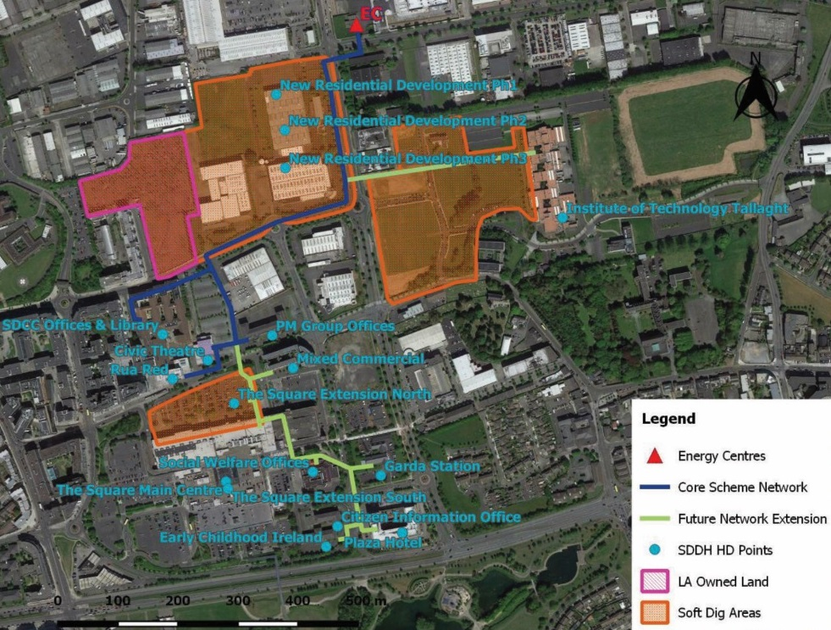

History | The site was greenfield up to the 1930s when development began. See historical map attached. With the development of the adjoining site as a Jacobs Biscuit facory, the subject site accomodated the Jacobs social club. In more recent times, the site has formed part of the ADSIL site, and currently the out of use social club sits on the subject site. A recently permited Planning Application for the ADSIL site, included the subject site, and established permission to remove the social club building, and relocate the existing culvert Tymon Poddle stream with traverses the site.  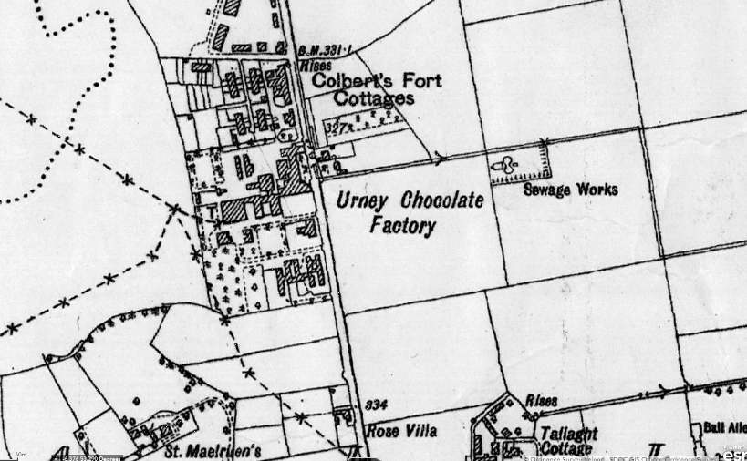  Extract from 4th Edition six inch maps (1938)
Development Plan | The SDCC Development Plan 2016-2022 in its Energy chapter promotes the use of waste industrial heat, local energy partnerships and prioritises the development of low-carbon District-heating.  ENERGY (E) Policy 5 Waste Heat Recovery & Utilisation  It is the policy of the Council to promote the development of waste heat technologies and the utilisation and sharing of waste heat in new or extended industrial and commercial developments, where the processes associated with the primary operation on site generates waste heat.  E5 Objective 1:  To promote the development of waste heat technologies and the utilisation and sharing of waste heat, in new or extended industrial and commercial developments, where the processes associated with the primary operation on site generates waste heat.  E5 Objective 2:  To promote the development of local energy partnerships among businesses in the County.  E5 Objective 3:  To promote increased energy self-sufficiency across business sectors.  ENERGY (E) Policy 6 Low Carbon District Heating Networks  (a) It is the policy of the Council to support the development of low carbon district heating networks across the County based on technologies such as combined heat and power (CHP), large scale heat pumps, and renewable energy opportunities including geothermal energy, energy from waste, biomass and bio-gas.  (b) It is the policy of the Council to support the development of both deep and shallow geothermal energy sources throughout the County. Deep geothermal projects are particularly suited to areas demonstrating high heat densities.  E6 Objective 1:  To prioritise the development of low carbon district heating networks in Low Carbon District Heating Areas of Potential.  E6 Objective 2:  To future proof the built environment in Low Carbon District Heating Areas of Potential to aid the future realisation of local energy networks and a move towards de-centralised energy systems.  E6 Objective 3:  To ensure that all development proposals in Low Carbon District Heating Areas of Potential carry out an Energy Analysis and explore the potential for the development of low carbon district heating networks.  E6 Objective 4:  To support deep and shallow geothermal projects at appropriate locations across South Dublin County and in accordance with the South Dublin Spatial Energy Demand Analysis (SEDA).  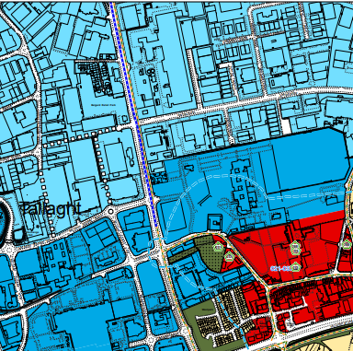  Extract from the Development Plan 2016-2022  Shows the land zoned as: REGEN  To facilitate enterprise and/or residential led regeneration  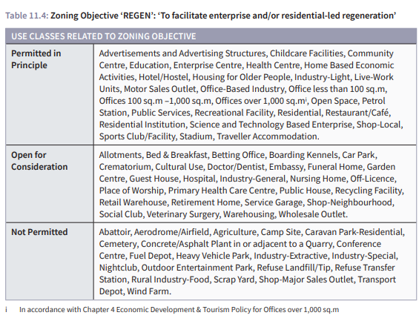
Adjoining uses | The site next door is used as a Data Centre for Amazon. It is proposed that the waste heat from this data centre will provide the energy for the district heating network. There is a large vacant site across the Belgard Road, which is identified in the SDCC for large scale new residential use.
Site Conditions | The site is a brownfield site, containing the old Jacobs factory social centre. This is a single story building which is a state of poor repair. It is proposed to demolish the building to make room for the new energy centre.  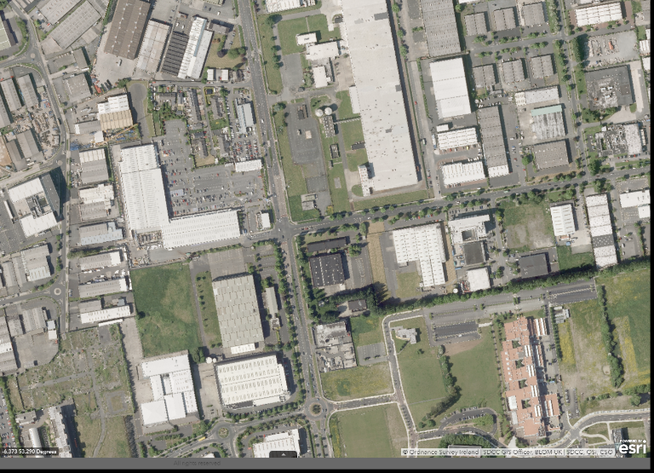  Aerial view showing brownfield site
Constraints and Utilities | There are a large number of services in the Belgard Road and Airton Road, including Water, Mains Drainage ESB, Fibre Optic data and Gas.  A substantial 1050mm pipe which culverts the Tymon Poddle stream traverses the site. Permitted development for a new data centre, and associated works on lands to the north, includes for the relocation of the culvert pipe through the subject site.  The permitted culverted route is set out on Sheet 01 of the Part 8.
Access and Parking | Access to the site will be by means of the existing vehicular entrance off the Airton Road.
Proposed Design | 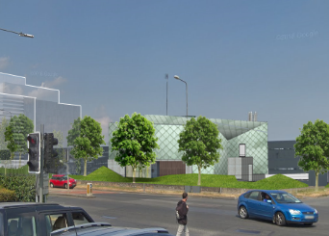  The proposed Energy Centre is primarily a Plant facility, which will house the equipment to consolidate, store and distribute heating and cooling to the neighbouring areas. The centre also includes support facilities such as a small meeting room/ office and staff toilets.  The building has been designed to ensure future expansion of the heating scheme can be facilitated from this new energy centre. The architectural design comprises a coloured sheet metal box, which sits on a concrete plinth. The use of green metal shingles (or similar) will provide a distinctive quality to the building. The nature of the facility as a public amenity, has created the opportunity to create a feature building on this high profile corner- at the Belgard Road/ Airton Road junction. The centre extends to 491m². The robust concrete finish to the plinth block, with more delicate sheet metal above, will provide durable and suitable finishes for the maintenance and upkeep of this facility. The overall height of the facility will vary between 6m and 9m.  This first phase of the District Heating Scheme will also include an underground pipe connection between the Energy-Centre and the County Hall. This will form a trunk- main with potential for connections to upcoming residential developments, the Institute of Technology Tallaght and other public/ commercial buildings over time. The pipe will comprise 225mm- 300mm diameter insulated pipework, and be located at a minimum depth of 600mm below ground level.  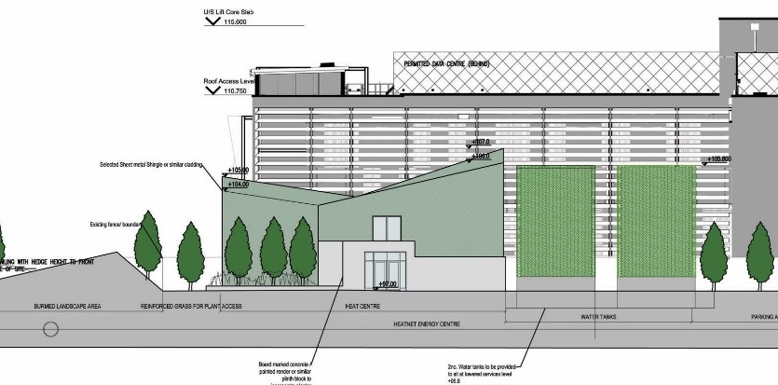  To the East of the site- 2N^{o.} Water tanks of c. 5m diameter x 10m height are proposed. These have been provided at plenum level (1.2m below Ground Floor FFL) resulting in a height of 8.8m above FFL. A steel frame is proposed around the tanks, which will act as a trellis, to provide screen planting to the 2N^{o.} Tanks.  The preferred route for the distribution pipes to Phase 01 are indicated below- along with a number of potential variations are also indicated.  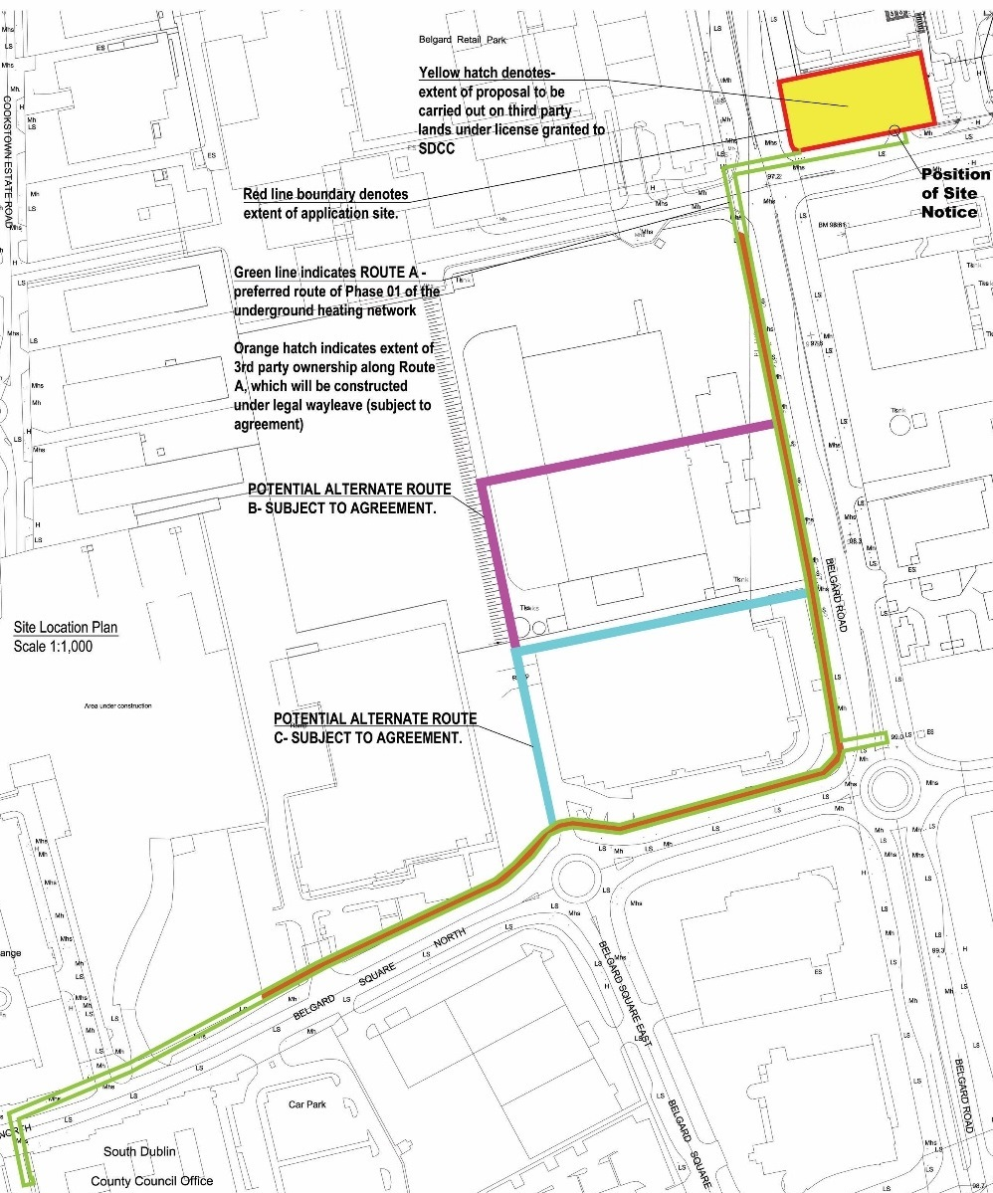
Materials | The Proposed building will be a simple pallette of concrete plinth and sheet metal cladding. Trellis planters will be provided to the water tanks and high quality landscaping to be provided to tanks.  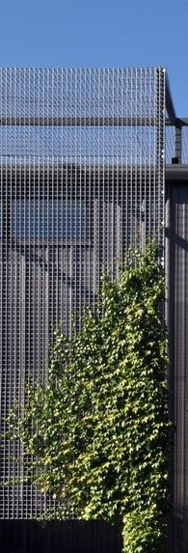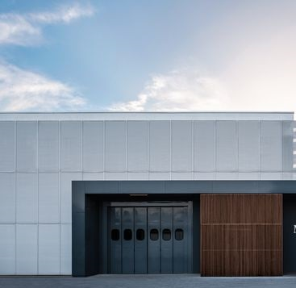  Dark grey steel grille/ frame to act as planted trellis.  Plinth to wrap around Steel doors and picture window to Belgard road.  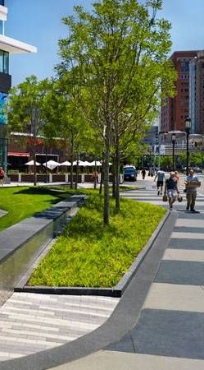  Burmed landscaping to perimeter of Energy Centre- Boundary walls in keeping with new adjoining data centre  Shingle sheet metal, with punctured openings to Belgard road.

Environmental Screening | The preliminary process of environmental screening has been completed and the reports are submitted with this document. The raising of the temperature of the waste-heat to levels suitable for distribution will be carried out using electric heat-pumps so no emissions will be involved. The use of the heat-pumps to raise the water-temperature defines the waste-heat as a renewable source for EU categorisation definitions. Industrial Waste-heat treated in this way is categorised as a renewable energy source.  Please refer to the Appropriate and Environmental Screening Assessments by Minogue Associates as well SDCC signed determinations, which are submitted with this Report.
Part 8 Submissions  & Commentary | Council Departments  All comments received from other Council Sections incorporated in design process prior to display- no comments received during consultation process.  Public Submissions  Only one public submission was made by Tallaght Community Council . They offered a general welcome to the project but recommended that it be subject to an international design competition . Due to timetable issues with EU Inter-reg, the data-centre programme, cost implications and the essential nature of this building as a plant room for heat-pumps this recommendation cannot be acceded to.  Screening Reports  Appropriate Assessment (AA) Screening and  EIAR Screenings carried out and results incorporated into design.  Appropriate Assessment (AA) Screening  Following an examination, analysis and evaluation of the objective information provided in the “Screening Statement in support of Appropriate Assessment of District Heating Centre and associated works” prepared by Doherty Environmental, South Dublin County Council, as the Competent Authority determines that the proposed South Dublin District Heating Pilot Project, will not have a significant negative effect on European Sites and will not negatively affect their conservation objectives or integrity. The principal reasons supporting this determination include:  - During the Screening of the proposed project it was found that eleven European Sites occur within a 15km radius of the project site. The nearest European Site to the project site, Glenasmole Valley SAC, is located at a remote distance from the project site, approximately 3.4km to the south.  - All of these European Sites (and their associated qualifying features of interest/special conservation interests) are not connected to the project area via impact pathways and are located outside the zone of influence of all activities associated with the proposed project. No impact pathways were identified linking the wider project area to these surrounding European Sites.  Therefore a Stage 2: Appropriate Assessment will not be required to inform the project either alone or in combination with other plans & projects, with respect to any Natura 2000 site and its conservation objectives.  EIAR Screenings;  On the basis of the objective information provided in the “Environmental Impact Assessment Screening report for the proposed District Heating Centre and associated works” (the Screening Report) prepared by Minogue and Associates, South Dublin County Council as the Competent Authority determines that the proposed, individually, and in combination with other plans and projects, does not require an EIA.  It is considered that the Screening Report, has been carried out giving full consideration to the EIA Directive and in particular to Annex I, II and III of that Directive, which sets out requirements for mandatory and sub-threshold EIA.  It is further considered that the Screening Report contains a fair and reasonable assessment of the likelihood of significant effects of the development on the environment. Having regard to the foregoing and in particular the characteristics of the proposed development are considered potentially not significant due to the size, scale and location of the development, the characteristics and sensitivities of the receiving environmental and design and mitigation measures including:  - A detailed Best Practice Construction Approach;  - Measures to avoid discharges to the River Poddle watercourse; and  - A Demolition Waste Management Plan.  It is considered that the environmental effects arising from the project will generally be temporary, localised, and minor in nature.  That South Dublin County Council as the Competent Authority, having considered the EIA Screening Report, prepared by Minogue and Associates, makes a determination that the proposed South Dublin District Heating Pilot Project would not be likely to have significant effects on the environment and that the project does not require an Environmental Impact Assessment as recommended by the foregoing report by the County Architect.  County Architect  Recommend that in light of the above, Part 8 be approved as presented.
Drawings. | Sheet 01- Site Location Map and Site Plan showing Constraints ,  Sheet 02- Proposed GA Plans and Sections  Sheet 03- Proposed Elevations, materials and artists impression.

_____Eddie Conroy FRIAI, County Architect_________________________________

Date_3rd December, 2018______________

