Qu (7) Clondalkin ACM November 21st 2018

**Over the past year Clondalkin Library has comprehensively marked the occasion of the ending of World War 1, 100 years ago.**

The programme of events is listed below:

**Author visit for world book day by Carmel Ui Cheallaigh.**

Carmel has written the children’s nonfiction book “Man of the people, Fr William Doyle SJ” *“Willie Doyle lived a life of great generosity kindness and courage. One hundred years on, his example and values are more relevant than ever. How did this young boy from Dublin become a World War 1 hero?”*

3rd class from Scoil Aine attended.

To link in with Carmel’s visit we hosted part of the exhibition detailed below. We were unable to take the whole exhibition due to space restrictions. This was initially advertised as being on display from 1st of March – 14th of March but this was extended in April 2018.

“**Jesuits Chaplains and Rathfarnham Castle in the First World War” curated by Damien Burke archivist from the Irish Jesuit Archives**

This exhibition tells the story of the Jesuits chaplains in the First World War.  In 1913, the Jesuits purchased Rathfarnham Castle. During the war, it housed Jesuits who were attending university and missionaries, including Frs Willie Doyle, Joseph Flinn, Henry Gill and Patrick O’ Mara, who were all missionaries based at Rathfarnham Castle, prior to their serving as chaplains in the First World War.  Jesuit chaplains served at the frontline with the soldiers.  In the circumstances of war, some chaplains underwent transformative experiences, while others who survived the conflict never recovered from the trauma they had experienced and witnessed.

The exhibition, curated by Damien Burke, and featured the award-winning graphic short, “A Perfect Trust”, by Alan Dunne, along with photographs of the First World War by Fr Henry Gill SJ.

In relation to remembering and honouring the men from South Dublin and Clondalkin who died in the Great War, Historian David Power presented a talk on the stories of men from Clondalkin and South Dublin killed at Messines and the Third Battle of Ypres, also known as   
Passchendaele in Clondalkin Library on April 18th 2018.

As part of our WWI exhibition which was displayed in the County Library, Dave Power also created individual panels with images and biographical details for some of the war dead from south Dublin County area. There were at least two from Clondalkin included and attached here is an image of one of those panels.

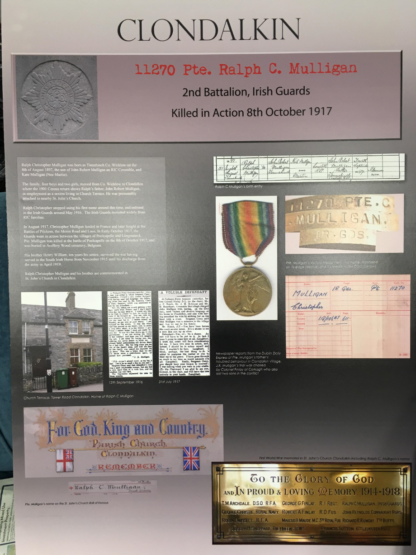

A copy of the roll of honour listing the men who died from Clondalkin is also on permanent display in Clondalkin Library.