Motion (9) Clondalkin ACM November 21st 2018

Over the course of 2018, Clondalkin Library has hosted a very comprehensive programme of events marking the significance of two very important historical events:

* Historian David Power delivered a lecture on 100 years since the ending of WWI with specific attention drawn to men from South Dublin and Clondalkin who were killed at Messines and the Third battle of Ypres.
* The women’s’ suffragette movement was marked In July in Clondalkin Library by the “Great Women of Ireland show”. This is an interactive show detailing the lives of great Irish women with particular emphasis on Countess Markievicz. It also incorporated aspects of the Suffragette Movement and the granting of votes to women.

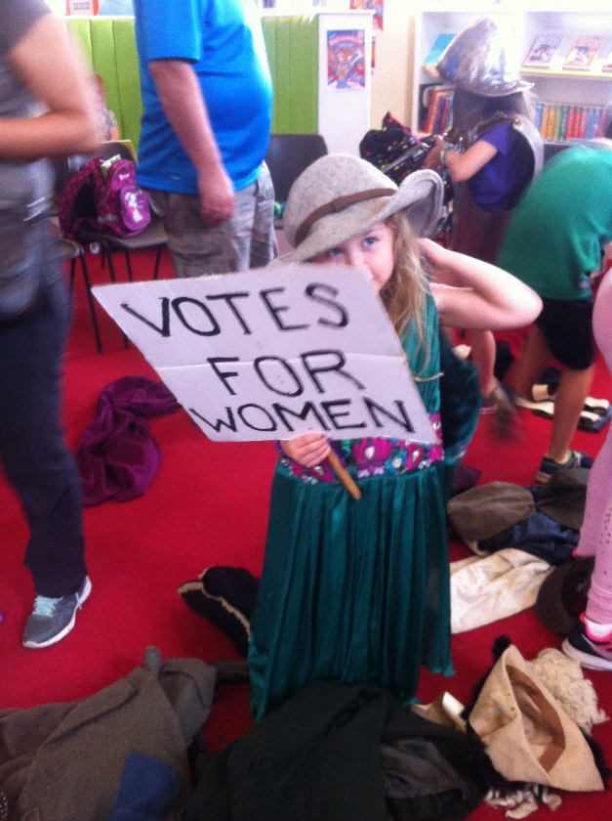

* 10 September 2018 – Launch of exhibition “Changed utterly’: 1918 and the path to war’ at County Library, Tallaght. This exhibition consisted of seven stand-alone panels produced in duplicate and mounted simultaneously in the respective public libraries. One of these panels was dedicated to the Suffrage movement as a critical piece of history, and will be displayed again in Clondalkin Library in December 2018.

The Suffrage panel is available here:

[\\10.128.32.43\share\WWI\1918EndOfWar\1918Panels\SuffrageMovement](file:///\\10.128.32.43\share\WWI\1918EndOfWar\1918Panels\SuffrageMovement)

Clondalkin Library may also host ‘The Irish Women’s Suffrage Movement’ a lecture by Historian Liz Gillis, previously delivered at Ballyroan Library at a future date depending on resources.