## COMHAIRLE CONTAE ATHA CLIATH THEAS

## SOUTH DUBLIN COUNTY COUNCIL

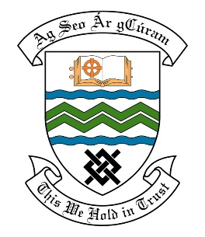

### MEETING OF THE TERENURE RATHFARNHAM TEMPLEOUGE AREA COMMITTEE MEETING

## 13th November, 2018

## HEADED ITEM NO. 18

**Deputations meeting – 24th October, 2018 @ 2pm.**

**Orwell Park Residents Association**

**Deputation** **attendees** – Stephen Willoughby, Donnachadh Lehane, Ciaran Boylan and Joseph Kiernan

**Elected Members** – Cllr. Conor McMahon, Cllr. Charlie O’Connor, Cllr. Rob Russell, Cllr. Paul Foley & Cllr. Pamela Kearns.

**Council Officials** –Máire Ni Dhomhnaill, Eamon Harnett, Oliver Hoey & Vincent Heywood.

Cllr. Paul Foley presided.

**Items discussed**:

1. Roundabout – Orwell.
2. Road Signage – Orwell.
3. Development Plan – Orwell Park Green.
4. Commitments given at Deputation meeting.

**Commitments given**:

1. Ongoing maintenance of the roundabout – Máire Ní Dhomhnaill.
2. Site meeting to walk the area with Residents and discuss signage – Vincent Heywood.
3. Three month review to be carried out on signage – Vincent Heywood.
4. Works program for Orwell Park Green to include some, if not all, proposals from the Residents Association. List provided. - Máire Ní Dhomhnaill.