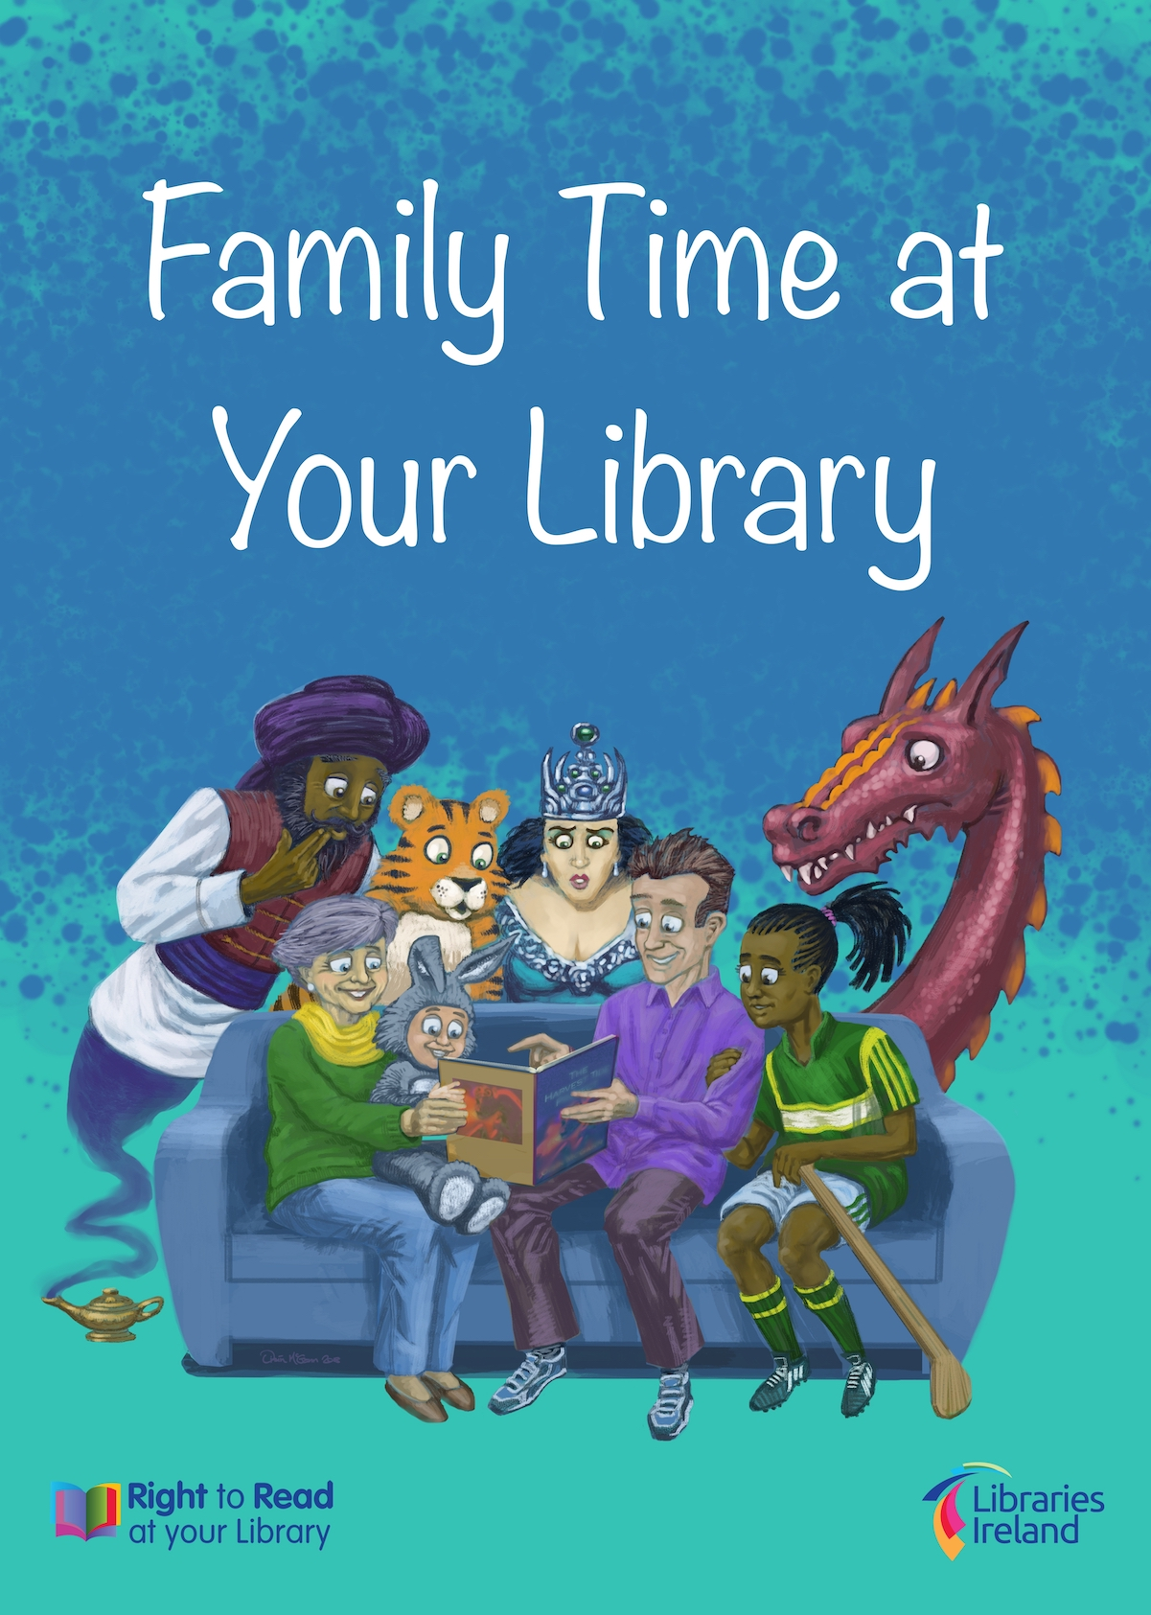



**Right to Read: Family Time at your Library 2018**

Family Time at your Library in December is a new initiative under the Right to Read national programme. The Right to Read programme itself is a nationally coordinated framework for literacy support and development utilising libraries as a key resource in local communities.

Family Time at your Library is the most recent initiative to be added to the other national components which currently are:

* Spring into Storytime
* Summer Stars
* Children’s Book Festival
* Service to schools

The aim of this new initiative is to support family focused approaches to reading with children, and to increase awareness among parents and families of services and resources for children in libraries.

The focus is to provide an event branded **Family Time at Your Library** in each branch library in the country during December 2018, by offering fun activities for children with their families. It also offers an opportunity to share reading recommendations with families and provide tips on reading with children and selecting books.

All south Dublin Libraries including the mobile service will be offering a family focused children’s reading event during the month of December.

These include:

* **Play a Family Board Game** in the County Library Tallaght. Choose from a selection of traditional board games to see if you can beat your family
* **Record a Story**. The opportunity to have yourself recorded reading a story to your child, creating a new family memory at the library. Each family will receive a digital file and a CD of their Storytime. County Library, Tallaght.
* **Family Time in the Library** with storyteller Steve Lally. A magical storyteller with some science magic thrown in. Clondalkin and Ballyroan libraries.
* **Polar Express** family evening in Clondalkin library, with Polar Express themed story time and arts and crafts for all ages.

The family unit is the primary learning environment, and Increasing awareness of the benefits of reading, and promoting and providing reading as a fun recreational activity which can be enjoyed through family participation, is a key role of our library service.