## COMHAIRLE CONTAE ATHA CLIATH THEAS

## SOUTH DUBLIN COUNTY COUNCIL

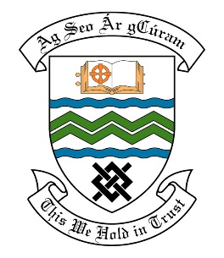

### MEETING OF THE TALLAGHT AREA COMMITTEE MEETING

## 22nd October, 2018

## HEADED ITEM NO. 2

**Deputations meeting – 26th September, 2018 @ 3pm.**

**St. Martins Residents Association**

**Deputation** **attendees** – Tara de Buitlear, Dave Power, Karl Tipping, Denise Delappe, Adrienne Dunleavy.

**Elected Members** – Cllr. Charlie O’Connor.

**Council Officials** – Mary Maguire, Máire Ni Dhomhnaill, Eamon Harnett, Oisin Egan & Mary Keenan.

Cllr. Charlie O’Connor presided.

**Items discussed**:

1. Request to plant copper beech hedge at Heather Close, Heatherview Drive & Carraigmore Road.
2. New trees & path maintenance at Aylesbury Park.
3. Litter management & enforcement in Aylesbury.
4. Public Lighting in Aylesbury.
5. Commitments given at Deputation meeting.

**Commitments given**:

1. Meeting on site to be arranged and planting agreed – Oisin Egan.
2. Site Meeting to discuss previously agreed tree planting. Issue of Public Lighting and footpath to be examined - Oisin Egan.
3. Concerns expressed to be dealt with by Litter Warden & owners of the shopping centre to be written to – Mary Maguire.
4. Missing bin to be replaced – Eamon Harnett.
5. Playground to be monitored and a weekly inspection take place – Eamon Harnett.
6. Site meeting to take place to deal with proposals for Public Lighting – Oisin Egan.