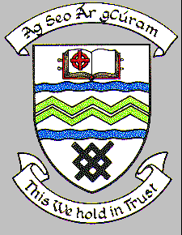

**MEETING OF SOUTH DUBLIN COUNTY COUNCIL**

**Monday 8th September 2018**

**Headed Item No 3 (d)**

**RESIGNATION OF COUNCILLOR B. BONNER AS CHAIR OF THE CLONDALKIN AREA COMMITTEE**

The following report went to the September Organisation, Procedure & Finance Committee Meeting 20th September 2018

**RESIGNATION OF COUNCILLOR B. BONNER FROM PARTICIPATORY BUDGETING STEERING GROUP**

**REPLY:**

A vacancy exists as Chair of the Clondalkin Area Committee following Councillor B. Bonner's resignation and it is a matter for the Council to nominate a replacement to fill the vacancy.

This is now before the Organisation, Procedure and Finance Committee for consideration.

It was proposed by Councillor B. Bonner and seconded by Councillor M. Duff and **AGREED** that Councillor F. Timmons be appointed to the Chair of the Clondalkin Area Committee.

This is now before full Council for approval