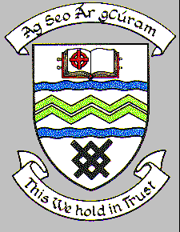

**MEETING OF SOUTH DUBLIN COUNTY COUNCIL**

**Monday 8th September 2018**

**Headed Item No 3 (e)**

**RESIGNATION OF COUNCILLOR D. RICHARDSON FROM THE TALLAGHT DRUG & ALCOHOL TASK FORCE**

The following report went to the September Organisation, Procedure & Finance Committee Meeting 20th September 2018

**THE RESIGNATION OF COUNCILLOR D. RICHARDSON FROM THE TALLAGHT DRUG & ALCOHOL TASK FORCE**

**REPLY:**

A vacancy exists on the Tallaght Drug & Alcohol Task Force following Councillor D. Richardson’s resignation from this Committee and it is a matter for the Council to nominate a replacement to fill the vacancy.

This is now before the Organisation, Procedure and Finance Committee for consideration.

It was proposed by Councillor D. Richardson and seconded by Councillor M. Duff and **AGREED** that Councillor C. King be appointed to the Tallaght Drug & Alcohol Task Force.

This is now before full Council for approval