**HEADED ITEM – Part VIII for the Energy Centre for the District heating Project**

**Background:**

Ireland has legal obligations and binding targets in terms of limiting Greenhouse Gas emissions and expanding the development of renewable energy as part of the EU’s energy and climate package to 2020 and then 2030. South Dublin County Council is fully committed to meeting its target of 30% reduction by 2020. The Council has a Sustainable Energy Action Plan, and Energy masterplans in position for Clonburris and Grange Castle Business Park. The County Development Plan has clear policies on renewable energy and use of waste heat.

Growing penetration of Wind-powered energy has meant that the majority of problematic emissions now arise from agriculture, transport and buildings. For large urban authorities like South Dublin, decarbonising transport and buildings has become the focus. For buildings, the vast majority of energy consumption and associated emissions comes from the provision of space heating and hot water. Near-Zero targets in upcoming Building Regulations will reduce energy-demand in new homes from early 2019. A recent report from Sustainable Energy Authority of Ireland has shown that Irish homes emit almost 60% more CO2 than the average EU home, which is the highest emissions per household in Europe. National level policies introduced to date have been partly successful, with 6.8% of Ireland’s heating demands now coming from renewable sources, but more than 93% still comes from fossil fuel sources, the majority of which are imported. (in 2016 imported fuels cost 5.7bn. euros).

District-heating is an important potential response to integrating renewable sources, lowering carbon and reducing heat costs. New-generation district-heating systems allow the integration of different sources of heat- co-generation, renewable and waste-heat into flexible smart-energy systems which link energy production and consumption creating resilience and value while reducing emissions. This enables urban areas to make better use of low-cost, low-carbon resources, increases security of supply, lowers heating costs transitions to a sustainable energy system. The SDCC Development Plan 2016-2022 in its Energy chapter promotes the use of waste industrial heat, local energy partnerships and prioritises the development of low-carbon District-heating.

**District Heating Pilot Project for Tallaght Update:**

In pursuing these objectives SDCC is a partner in the Inter-Reg NWE “Heatnet” project as one of 5 municipalities funded to develop a pilot 4G (fourth generation) district-heating network. Through a combination of grant-aid and matching funding just under 1.0m euros will be available to lay the first pipework and heat exchangers to be completed before the end of 2019 as the Tallaght pilot. A large scale source of waste-heat may be available from a new data-centre to be developed on Belgard Road (subject to Planning and all other statutory approvals).

This source can generate 4 Mw of waste heat sufficient to heat the County Hall complex – including theatre, arts centre, and library and circa. 1500 new dwellings planned for delivery in the adjacent Cookstown estate regeneration area as well as potential projects at the ITT campus and the Square shopping centre.

An economic-technical feasibility study was prepared by CODEMA confirming the financial viability of the overall project. This viability is dependent on the waste-heat component being made available at no charge by the Data-company, a critical mass of end users being signed up and sufficient grant aid being made available to mitigate the start-up costs. The data-company will be responsible for installing heat-recovery systems in the proposed building to provide the heat source for the heat-network.

Further to the approval by Elected Members the project delivery has taken a number of significant steps. As part of an independent Cost-benefit analysis, the CODEMA feasibility study has been peer-reviewed by specialist consultants with a proven track-record in developing and managing existing district-heating including the re-use of waste-heat. It confirms the dependencies as set out which are currently being worked on.

The Council is researching the establishment of a not-for-profit district-heating company whose central purpose is to deliver a low-cost, low-carbon heat-networks in South Dublin as part of its committed output on the Heatnet project. The company will be based on similar Local Authority models in Denmark and Scotland with local stakeholders on its board. This Company can act as a vehicle to facilitate the delivery of heat-networks in other locations in the county where waste-heat is available.

**Part VIII for the Energy Centre for the District heating Project:**

There is an ambitious programme for getting the pipes in the ground for the Heatnet NWE project and grant aid. This means that the Part VIII process needs to be finalised and set in motion as a next step.

The location of the proposed Energy Centre is on the junction of Belgard Road and Airton Road, on the site of the old Jacobs Social Centre. As part of the agreement with the Data Centre, the site for the Energy Centre will be leased to SDCC in perpetuity.

The proposed design is simple using backlit elevations of robust metal and concrete materials. The building is two storey in part. The elevation will be stepped to address the height of the Data centre next door and the busy junction. Two large water storage buffer tanks will be located beside the building. This design of the DH Energy-centre building and the first section of pipe network is presented here before the public consultation phase of the Part 8 planning-approval which is planned to start before the end of September.

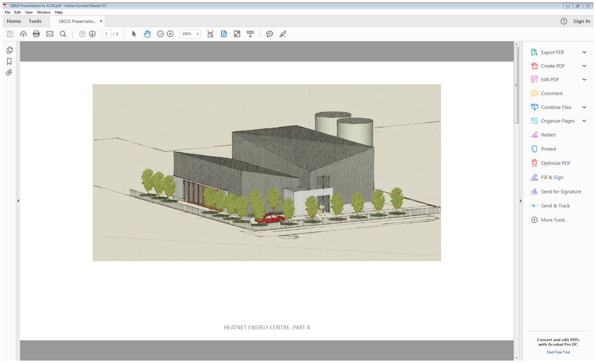

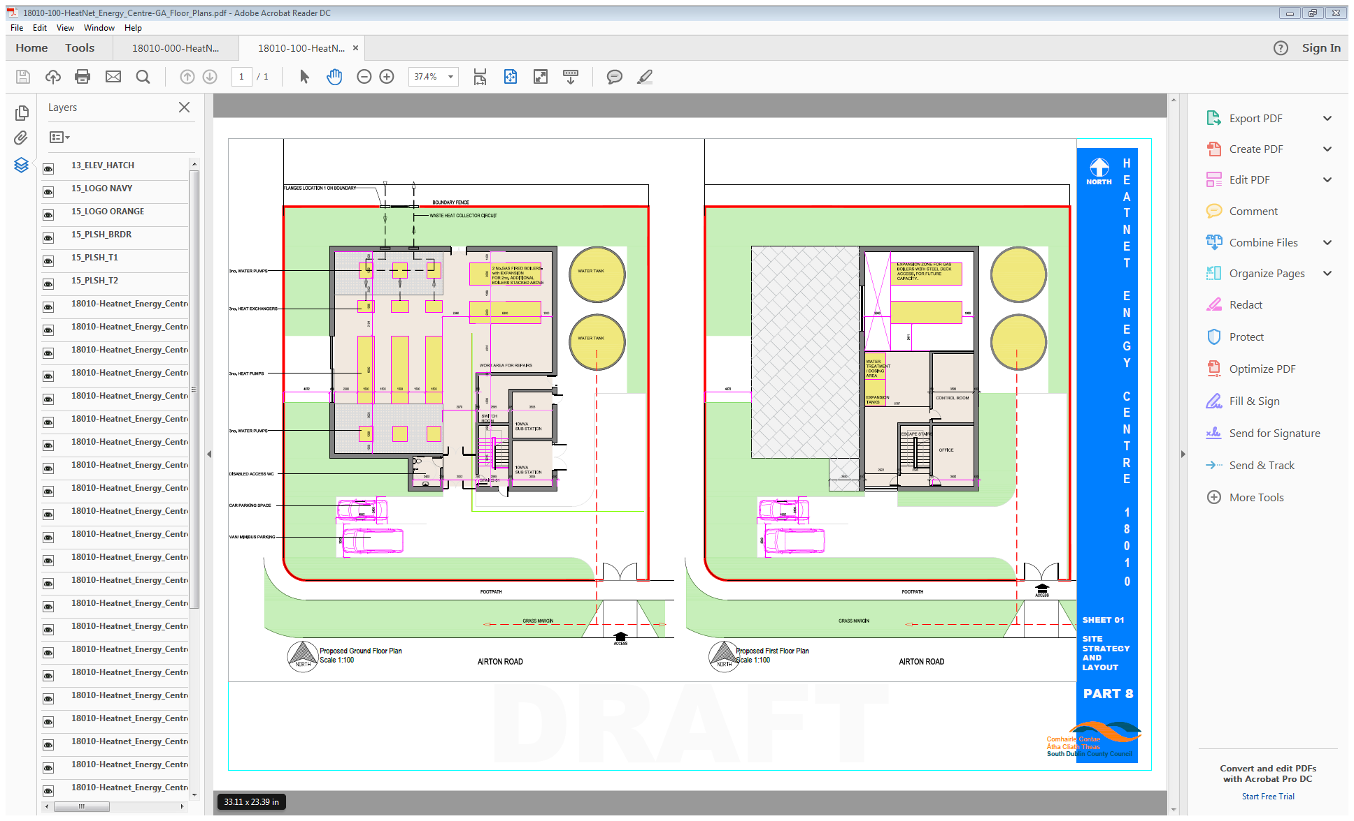

**Plans of Proposed Energy Centre**

The preferred distribution route for the district heating pipes is along Belgard road and the Marlet site and is subject to agreement.

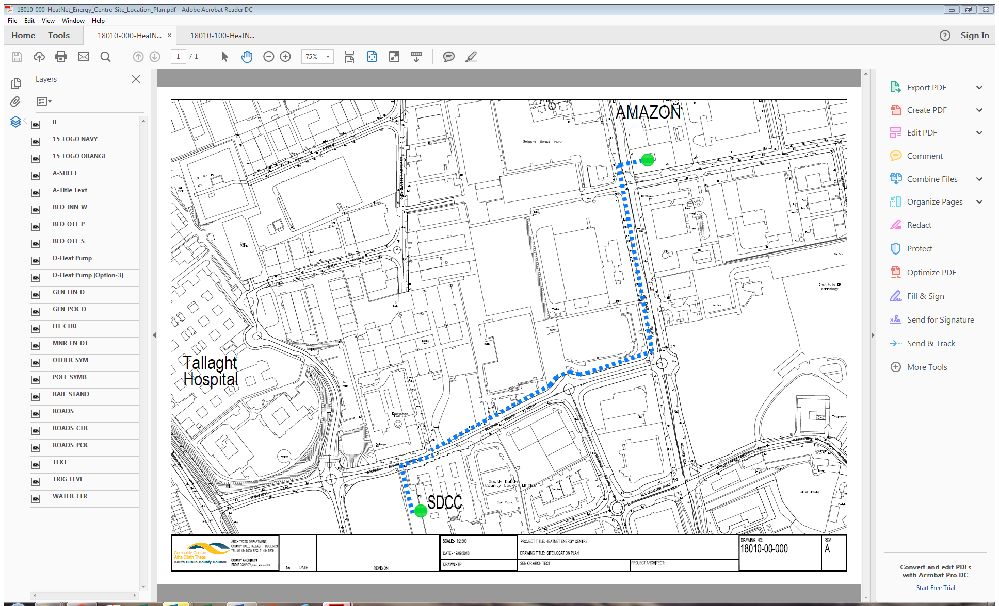

**Map showing preferred route of pipework from Proposed Energy Centre**

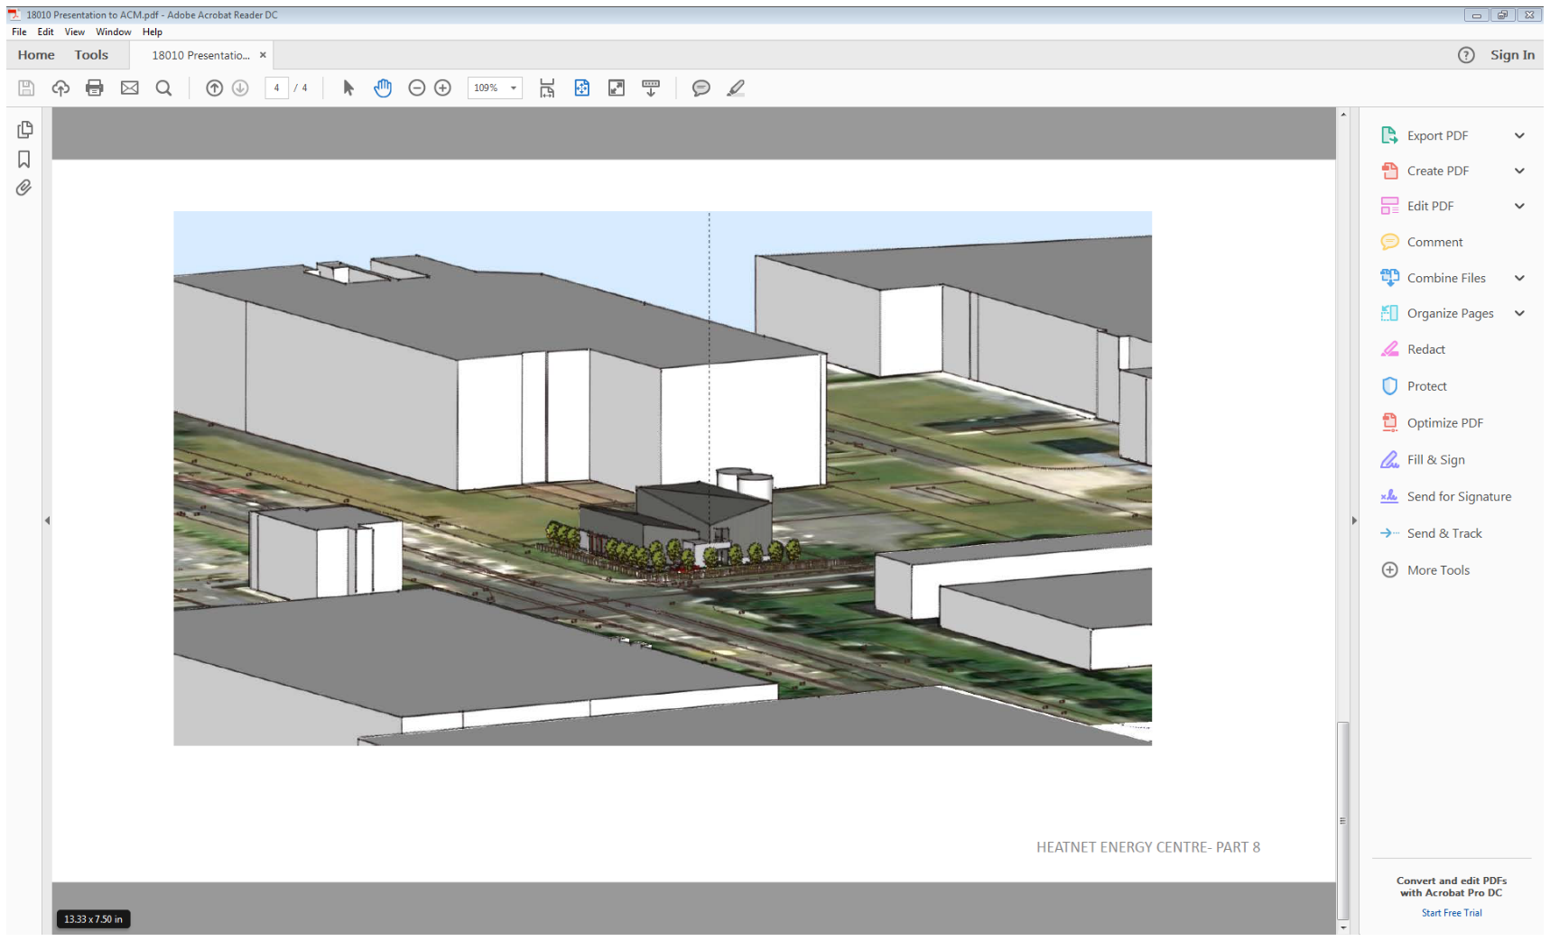

The preliminary process of environmental screening has been completed and will be included in the County Architects Report. The raising of the temperature of the waste-heat to levels suitable for distribution will be carried out using electric heat-pumps so no emissions will be involved. The use of the heat-pumps to raise the water-temperature defines the waste-heat as a renewable source for EU categorisation definitions and will attract Renewable-heat Incentives when the upcoming government RHI proposal is in place. Industrial Waste-heat treated in this way is categorised as a renewable energy source.

**Next Steps:**

When the District-heating company is formed it will tender for an energy-supply company (ESCO) to design, build, operate and maintain the technology of the Energy-centre, initial pipework connection and heat exchangers linking the County Hall to the data-centre. The Prequalification Questionnaire is being finalised requesting expressions of interest from suitable companies to engage in a competitive Dialogue Procedure. The ESCO will be subcontracted to the South Dublin District Heating Company for an initial contract period. This can be retendered over time to ensure continuing value for money. The roll-out of the heat network will commence with the County Hall complex as a guaranteed customer both to test the network and reduce commercial risk at the companys commencement. As the new housing is constructed it will connect to the system in phases as the data-centre is built out and the full amount of waste-heat becomes available.

SDCC are preparing an application for grant aid for the first call on the Climate Action Fund. SDCC are part of a Departmental policy team tasked with developing district-heat in Ireland as part of Project Ireland 2040. Heat-mapping already carried out by SDCC under the South Dublin Spatial Energy Demand Analysis has identified Tallaght as having heat-demand densities that will support the viable development of District-heating.

The benefits of the proposed investment in the SDDH system can be broken down into; energy policy, environmental policy, innovation and socio-economic, as shown in Table 1. Although the proposed project is an energy supply project, the benefits go far beyond the energy sector. Most of the benefits are direct and quantitative, like energy and GHG reductions, reduced energy costs and increased local employment, but many are in-direct and qualitative like increased comfort and knowledge. The socio-economic benefits far outweigh the benefits in any other area and shows the wide reach this project has outside of the strategic context already outlined.

|  |  |
| --- | --- |
| Category | Benefit |
| Energy Policy | * Reduced energy consumption * Reduced fossil fuel imports * Increased renewable energy * Increased security of supply * Increase data centre efficiency * Reduced national level fines for binding EU targets in renewable energy |
| Environmental Policy | * Reduced GHG emissions * Mitigates against climate change * Reduced local air pollution * Indigenous energy sources used |
| Innovation | * Increased knowledge of DH systems * Creation of new local market for waste heat * Based on leading best-practice in Europe * First of its kind in Ireland * Shared research and development * Proof of concept for other areas (i.e. Grangecastle) |
| Socio-economic | * Increased local employment * Decreased energy costs * Increased building safety – no carbon monoxide or gas leak risks * On-demand hot water * No on-site heating fuel storage * Reduced customer exposure to fuel price volatility * Increased local spending power * Increased competitiveness of Tallaght area * Landmark area for de-centralised sustainable energy * Reduced developer costs * Increased building energy ratings – increased property value |

In brief the keynote benefits will be-

* It will be the first 4G district heating network in Ireland contracting low-cost, low-carbon heat based on a renewable energy source.
* It will enable the first data-centre in Ireland to collect its waste-heat, improve its environmental efficiency and footprint and input to a DH network.
* It will be an important tool in helping SDCC achieve its 2020 and 2030 international targets. ( 55% reduction in carbon created in County Hall complex)
* It will create a publicly-owned energy company dedicated to increasing renewable energy sources, lowering carbon and delivering low-cost and sustainable heat to homes and institutions across the county
* It will consolidate the growing brand of South Dublin and Tallaght as centres of innovation in Smart-energy and sustainable community development attracting more business investment and job-creation.