[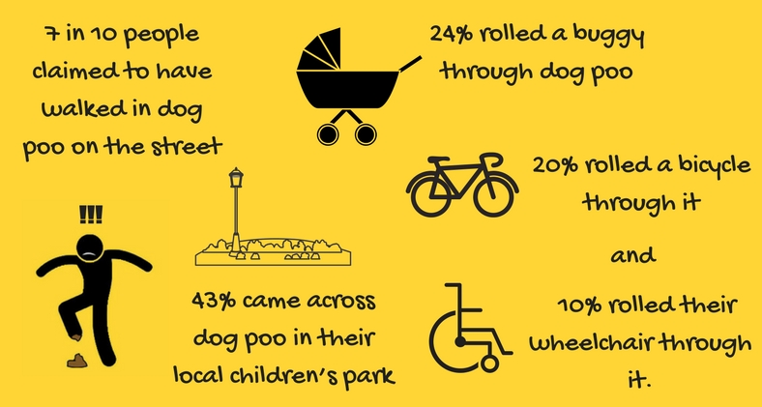](https://www.google.ie/url?sa=i&source=images&cd=&cad=rja&uact=8&ved=2ahUKEwjd6cHcs6jbAhUpI8AKHaERD20QjRx6BAgBEAU&url=https://www.dogstrust.ie/whats-happening/issues-campaigns/the-big-scoop/&psig=AOvVaw0fSQEJO-zh0-LWDAzXUXU-&ust=1527596629646637)