## COMHAIRLE CONTAE ATHA CLIATH THEAS

## SOUTH DUBLIN COUNTY COUNCIL

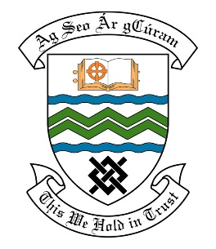

### MEETING OF THE TALLAGHT ACM

## 25th June, 2018

## HEADED ITEM NO. 9

**Deputations meeting – 23rd May, 2018 @ 2pm.**

**Fettercairn Estate Management**

**Deputation** **attendees** – Betty Caverley, Janice Nutley, John Kavanagh and Mary Keegan

**Elected Members** – Cllr. Mick Duff, Cllr. Martina Genockey, Cllr. Emma Hendrick, Cllr. Cathal King, Cllr. Brian Leech, Cllr. Mick Murphy, Cllr. Charlie O’Connor & Cllr. Dermot Richardson

**Council Officials** – Des English, Eamon Harnett, Mary Maguire, Caroline O’Reilly,

Brian Leonard, Pamela Hughes, Ann Ryan & Karen O’Neill.

Cllr. Cathal King presided.

**Items discussed**:

1. Landscaping of Green space at Kilmartin Park.
2. Development of waste ground behind Kilmartin Estate at the junction of Katherine Tynan Road & Cheeverstown Road.

**Commitments given**:

|  |
| --- |
| 1. Eamon Harnett to meet residents regarding landscaping and putting in two goalposts. |
| 1. Des English to go to Paddy de Roe to discuss services on the land. 2. Des English to find out about moving the wall. |