## COMHAIRLE CONTAE ATHA CLIATH THEAS

## SOUTH DUBLIN COUNTY COUNCIL

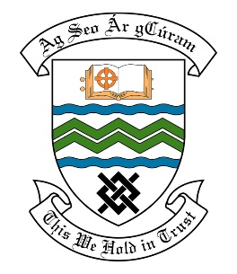

### MEETING OF THE TEMPLEOUGE TERENURE RATHFARNHAM ACM

## 12th June, 2018

## HEADED ITEM NO. 7

**Deputations meeting – 23rd May, 2018 @ 4pm.**

**Oldcourt Field Action Group**

**Deputation** **attendees** – Aishling Murphy, Roisin Kelly & Colin Conway.

**Elected Members** – Cllr. Deirdre O’Donovan, Cllr. Mick Duff, Cllr. Charlie O’Connor, Cllr. Paul Foley & Cllr. Emma Hendrick.

**Council Officials** – Chris Galvin, Laurence Colleran, Eamon Harnett, Mary Maguire, Caroline O’Reilly, Brian Leonard, Pamela Hughes, Ann Ryan & Karen O’Neill.

Cllr. Deirdre O’Donovan presided.

**Items discussed**:

1. Flood Plain
2. Anti-social behaviour, bonfires, litter/dumping, trespassing.
3. Overall maintenance, grass cutting, protected hedgerows upkeep of stream
4. Local community access & usage, dog walking, access from Oldcourt Road and Nature space.

**Commitments given**:

|  |
| --- |
| 1. Chris Galvin to follow with Public Realm and Gabrielle McGee regarding previous discussed issues. |
| 1. Eamon Harnett is to meet group on site to discuss all issues. |
| 1. Mary Maguire to establish ownership of the land. |
| 1. Groups details to be given to Una Maguire for the Social Credit Scheme. |