COMHAIRLE CONTAE ÁTHA CLIATH THEAS  
SOUTH DUBLIN COUNTY COUNCIL



MEETING OF ECONOMIC DEVELOPMENT, ENTERPRISE AND TOURISM SPC

Wednesday, May 09, 2018

HEADED ITEM NO. 3-Tourism update

**REPLY:**

 1. **Failte Ireland logo and tagline**

Fáilte Ireland launched a new tourism brand and accompanying tagline for Dublin in 2015, ‘Dublin. A Breath of Fresh Air’.  As is best practice, the brands performance was continuously monitored and as part of this process, Fáilte Ireland in 2017 undertook a series of research studies to evaluate the strength of the brand and ascertain how it is perceived by a broad range of stakeholders including international and domestic visitors, Dubliners, trade and business tourism interests.

The findings concluded that the brand name ‘Dublin’ is internationally and nationally recognised and further validated that the typography of the logo is exceptionally strong in terms of design and impact.  In addition, the research recommended that the colour of the logo be strengthened and made even more vibrant.

It also found that the current proposition of Dublin as a vibrant capital city bursting with a variety of surprising experiences where city living thrives side by side with the natural outdoors tested extremely well and scored very strongly against international benchmarks as a motivator for visitors to travel to Dublin.

As part of the research, five alternative taglines were developed and tested against the existing tagline “A Breath of Fresh Air” and also against a number of international competitor benchmarks.

Following this comprehensive research and validation process, the current brand will be boosted by a stronger and more vibrant colour palette and a new tagline, ‘Surprising by Nature’ has been developed for use.

Both tweaks to the existing brand will now be rolled out from July 2018.

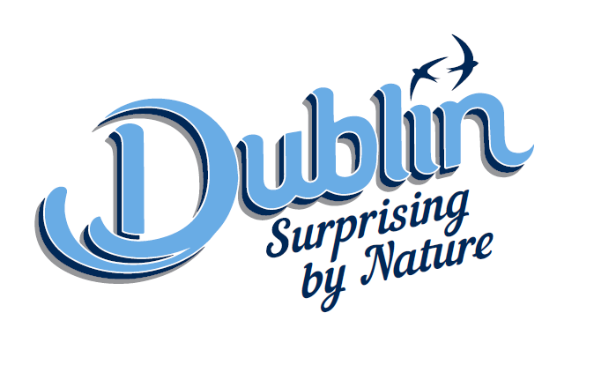

**2. Liffey Way/Canals**



The South Dublin Tourism Strategy pointed to the Tourism potential of a Liffey Valley Cluster. Accordingly, a feasibility study was commissioned and carried out in 2017. The Lucan Area Committee at its meeting on 24th April considered a report on the Liffey Valley Area Options study. The report can be viewed [**here**](http://intranet/cmas/documents/Lucan%20Area%20Committee/2018/April/LucanAreaCommitteeMeeting-24thApril2018/7e15dd91-1626-48e9-be78-c66ebf4f1e62.pdf). The report identifies opportunities for activities along the Liffey Valley notwithstanding the ongoing issues related to land ownership and access. Outline costings and development options were proposed and these will be further considered and proposals brought back to the Area Committee and full Council.

The Committee also considered a Waterways Ireland presentation on a linkage between the Royal and Grand Canals at Lucan. This will be an important Dublin loop between the canals on the longer greenways to the River Shannon. South Dublin County Council will lead a joint project between SDCC, Fingal County Council and Waterways Ireland to develop and deliver the loop proposal.

The Area Committee supported the following next steps:

1. **Continue to deliver other sections of Dublin Canal Greenway**

Waterways Ireland leading the overall co-ordination of the delivery of Dublin Canal Greenway.

1. **Tourism and Technical Study of Dublin Canal Greenway**

Failte Ireland have agreed to fund this study

1. **Capacity Building Workshops (Identify gaps and opportunities for development What is required;**

Service Providers -Cycle Hire, Canoe Trips, Paddling instructors, Walking Guides etc.

Visitor Services -Places to Stay, Eat and Go; Reasons to stay longer

**4. Canal Animation Program**

Canal Participation & Events Program, Canal Ambassadors Program, Canal Clean Up Program,

**5. Develop Marketing and Promotional Material**

Develop Brand Identity for Dublin Canals

Develop Brand Identity for Dublin Canals Greenway

Launch June 2019 at the Velo City – World Cycle Conference (3000 International Delegates)

**6. Feasability Study on the Lucan Route**

Partnership with South Dublin, Fingal , Waterways Ireland and NTA to deliver a feasibility study and preferred option on the route.

