***Dublin Canals Greenway***

Towpath development is at the centre of Waterways Ireland development plans where the asset is in public ownership and can be enhanced to increase accessibility and open up the canal network as a recreational and tourism resource. Where Greenways and Blueways have been constructed they have proven to be an economic success (The Great Western Greenway, The Waterford Greenway and the North Shannon Blueway) at a local, regional and national level. The development of such assets supports the increase, in the number of national and international visitors to an area which in turn can help revitalise local communities. Market research undertaken by Fáilte Ireland in 2013 indicated that recreational tourism had the potential to be 'Big Business' in Ireland with walking, cycling and water based activities to the fore of future potential. In order to convert the level of interest, especially from Germany, France and the UK it is vital to have high standard and connected routes to bring to market. Development of greenways will provide the critical mass of visitors needed for the stimulation of a recreation based industry, encouraging innovation and entrepreneurship in services such as accommodation, cafes, and restaurants, bike hire, and equipment sales. All such aspects of activity will increase both direct revenue, through taxes, and indirect revenue through ancillary service provision. The 290,000 visitors to the Great Western Greenway and the 100,000 visitors to the North Shannon Blueway easily make the case for investment and the benefits which can be derived from such investment through increased tourism numbers and increased visitor spend. The economic case alone in the ORP provides for a payback period of just 14 months after which time local, regional and the national economy will realise its dividend.

**The Dublin Canal Greenway (Outer Loop 40KM)**

Beginning your journey in Dublin's Water Quarter, Waterways Ireland has identified a remarkable 40km circular route that connects The Royal Canal and The Grand Canal from Grand Canal Dock, along the Grand Canal, through Lucan Village on to the Royal Canal and back to Dublin. As you meander along this route, it is hard to believe that you are close to Dublin City. The gentleness is awe inspiring, the potential boundless.

The development of the Dublin Canal Greenway – from 12th lock on the Royal Canal to 12th lock on the Grand Canal – linking in Leixlip, Lucan and Clondalkin is currently being developed and there has already been significant capital investment by the Dublin City Council, South Dublin County Council, Fingal County Council and The National Transport Authority. This circular route, beginning in Dublin's Water Quarter would be in excess of 40 km (note 42.2km is marathon distance) going through Dublin but experiencing the beauty and serenity of the canals network in the Dublin suburbs. It is a route that would be comparable to the Great Western Greenway – but would be a totally different experience – being so close to Dublin.

Current Update on Dublin Canals Greenway

1. Spencer Dock Linear Park – Waterways Ireland, DCC Parks, Failte Ireland (As part of Dublins Water Quarter)
2. Royal Canal Phase 1 – Spencer Dock – Greenway complete
3. Royal Canal Phase 2 / Phase 3 (This is the section from Spencer Dock to Cross Guns Bridge at the back of Sheriff Street) – Construction will begin Q3 2018 (Lead partner Dublin City Council). 18 months to completion.
4. Royal Canal Phase 4 – Upgrading of the Cycle Route from Cross Guns Bridge to Ashtown Gate Bridge – Q3 2018 - (Lead partner Dublin City Council) – 18 Months to completion.
5. Royal Canal Ashtown Gate to 12th Lock Hotel – Greenway Complete
6. 12th Lock Hotel to Kildare Border through The Deep Sinking – Consultants for the Feasibility Study have been appointed and are due to report by Q4 2018. (Lead Partner Fingal County Council and National Transport Authority)
7. The Royal Canal to The Grand Canal through St. Catherine's Park, Lucan, Griffeen Park which will require New Rail/Cycle Bridge over Royal Canal – Tender to appoint consultants for delivery of feasibility study to be complete by Q2 2018. (Lead Partners South Dublin County Council, Fingal County Council and National Transport Authority)
8. Grand Canal Greenway 12th Lock to Blackhorse Bridge – Greenway Complete
9. Blackhorse Bridge to Portobello - Delivery of this priority project for Dublin City Council commencing in 2018.
10. Portobello to Grand Canal Dock – Greenway Complete
11. Failte Ireland and Waterways Ireland to undertake a Product Development Study of Dublin Canals Greenway Outer Loop and Inner Loop (Q2 / Q3 2018)

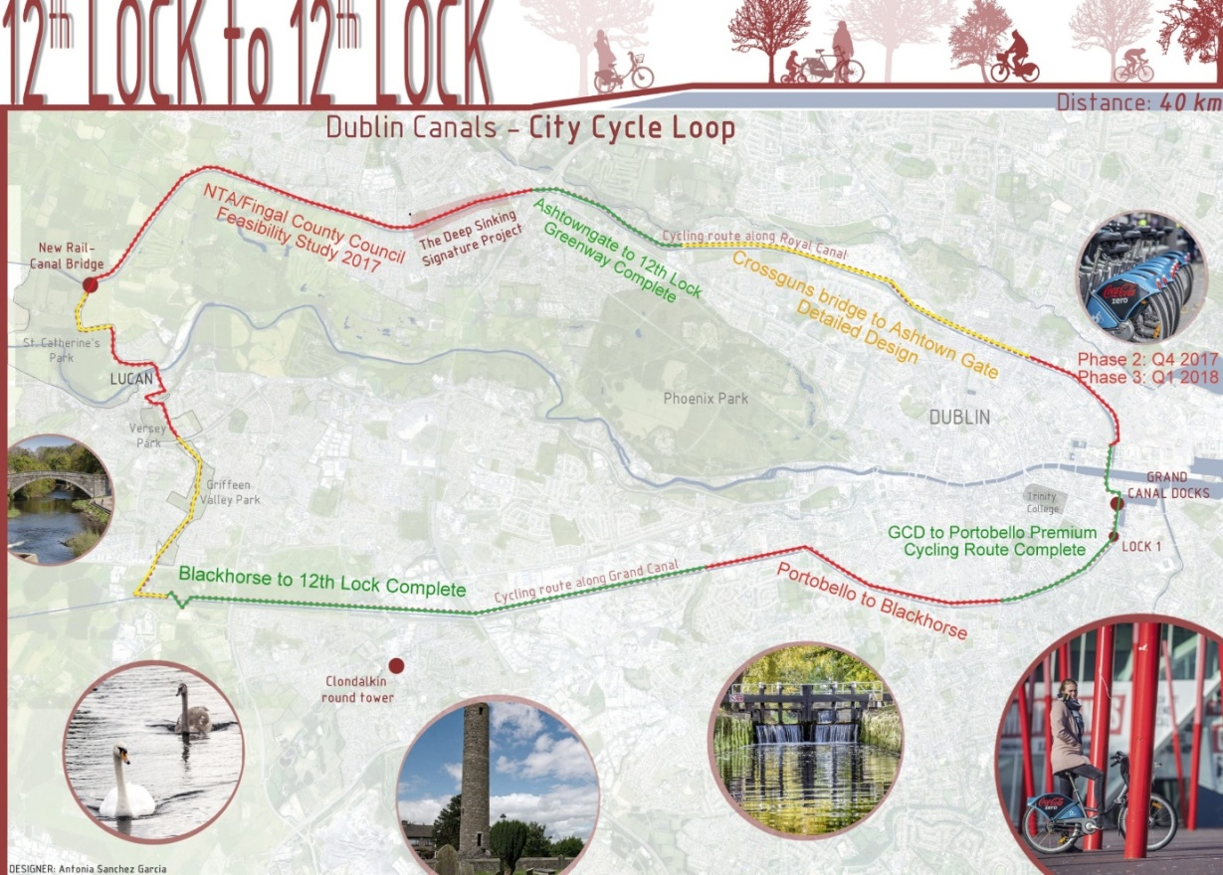

**Dublin Canals Greenway (Inner Loop 25KM through the Phoenix Park) – linking Dublin’s Water Quarter to The Phoenix Park off road – linking Dublin's Blue Lung with the Green Lung.**

A shorter 25km route linking the canals has also been identified and would and will attract users who may have small children and those who do not wish to undertake the 40km route. Again beginning in Dublin's Water Quarter the route goes out along The Royal Canal and into Phoenix Park at Ashtown Gate. (Dublin City Council are proposing to undertake a study on this difficult section of the proposed route). After The Phoenix Park, Chapelizod, The Liffey Cycle Route, The War Memorial Gardens, Kilmainham Gaol, The War Memorial Gardens and passing newly opened Richmond Barracks before joining The Grand Canal back to get back at Dublin's The Water Quarter.