**Q.7 North Clondalkin Library**

The tender for North Clondalkin Library is set to be released in April 2018, via e-tenders to the seven short-listed contractors. We anticipate a start date on site of mid-August 2018. The construction period has been set at 18 months for the purpose of the tender, but we would hope that given the quality of the short-listed contractors this timeframe may be shortened. Consultation will take place with local residents to confirm that issues previously raised have been addressed in the tender, and to explain the arrangements proposed while construction is underway. Images below are from a model of the new Clondalkin Library used for visualisation purposes. There may be small amendments in the final design.

Figure 1: Front Elevation of North Clondalkin Library

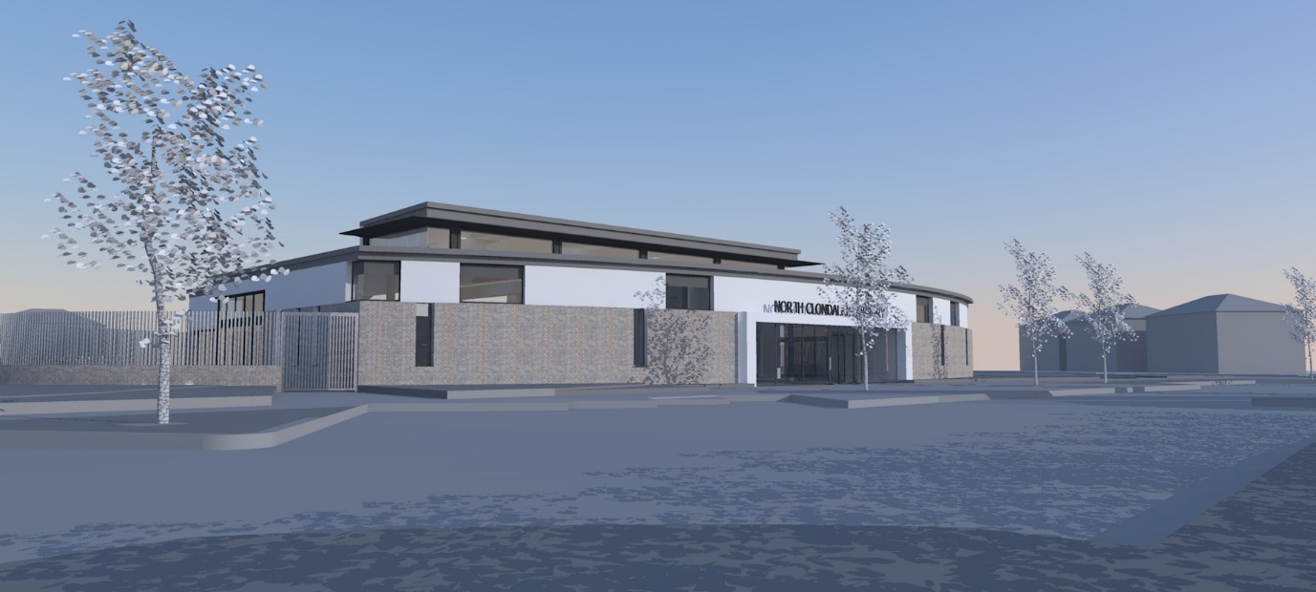

Figure 2: External overview of North Clondalkin Library

