## COMHAIRLE CONTAE ATHA CLIATH THEAS

## SOUTH DUBLIN COUNTY COUNCIL

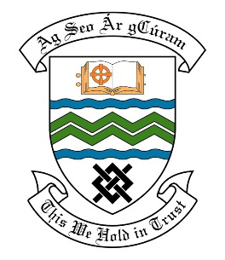

### MEETING OF THE RATHFARNHAM TEMPLEOGUE TERENURE

## 10th April, 2018

## HEADED ITEM NO. 17

**Deputations meeting – 28th March, 2018 @ 2pm.**

**Ferncourt Residents Association**

**Deputation** **attendees** – Rita Heavey, Lisa Kenny & Rosalyn Fay.

**Elected Members** – Cllr. Paul Foley, Cllr. Rob Russell & Cllr. Charlie O’Connor,

**Council Officials** – Leo Magee & Eamon Harnett.

Councillor Paul Foley presided.

**Items discussed**:

1. Upkeep & maintenance of Ballycragh Park.
2. Playground at Ballycragh Park.
3. Commitments given at Deputation meeting.

**Commitments given**:

1. Look at edging the paths in Ballycragh Park later this year by scraping with a mini-digger – Leo Magee.
2. Continue to monitor the rodent problem to ensure it doesn’t get any worse – Eamon Harnett.
3. Will propose replacement of gates and fencing around playground but it will have to be done as part of next year’s budget – Leo Magee.
4. Will examine an issue reported about the surfacing in the playground – Leo Magee.
5. Entrance & exit of the park to be looked at. Site meeting to be held with the group -Eamon Harnett.