

Severe Weather Response

Storm Emma

Interim Report

March 2018

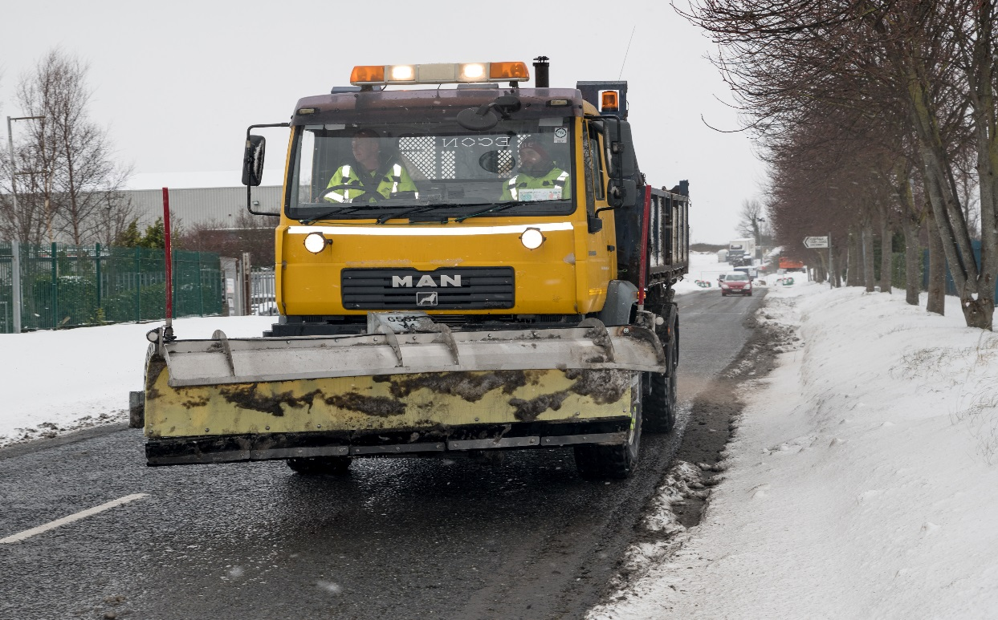

**Introduction.**

On Friday 23rd February Met Éireann issued a weather advisory indicating that the region was facing a very unusual, extremely cold period with precipitation, heavy snowfalls affecting the East and South East of the country from Tuesday night, 27 February 2018.

Sustained, very cold conditions, possibly only rising to 0⁰C in daytime was indicated. These conditions would persist until Friday 2nd March at least and may extend further.

The region was then in an Orange level Warning followed by a Red level Advisory Warning and blizzard conditions with a stay indoors advisory for Thursday afternoon 1st March until Friday evening.

**Severe Weather Assessment Team**

The severe Weather Assessment Team met on Monday 26th February for the first time and continued to meet or be in contact by conference calls and phone right through the weather event until the 8th March.

Members of SDCC staff from across the organisation met and ensured that there was a co-ordinated approach to the council’s response to the storm’s impact on the county.

All snow clearing equipment was made ready including equipment that had not been in use since the last heavy snowfalls of 2010. Health & Safety briefings and risk assessments took place following this meeting to ensure staff were prepared for the work ahead.

The Housing Department ensured that shelter was available for the homeless over the period ahead and outreach workers worked to ensure that no one was outside in the storm.

After the first meeting contact were also made with other agencies including, Dublin Fire Brigade, the Civil Defence, the Ambulance Service and other Eastern Region Local Authorities to ensure preparations were also in place.

**Local Authority Regional Working Group**

There were teleconferences twice daily between the four Dublin Local Authorities, Dublin Fire Brigade, Kildare and Wicklow LA’s and Fire Service.

**Eastern Regional Working Group and NECG**

There were also teleconferences twice daily between the LA’s, An Garda Siochana and the HSE. These followed the LARWG teleconferences and this was an opportunity for all to highlight issues or areas that needed attention from one agency or other or required to be escalated up to the National Emergency Coordination Group, which was attended by An Taoiseach, relevant Ministers and officials for Transport, Defence and Environment, Met Eireann, Representatives from the LA’s, Fire Services, Civil Defences, TII, HSE, Bus Eireann, Dublin Bus, LUAS, Irish Rail and the CCMA.  
An Extreme Weather Update for South Dublin was prepared and sent to the National Emergency Coordination Group daily.

**Work through the storm**

Throughout the severe weather period, South Dublin County Council road crews worked on a rolling shift basis of eight hours per shift, meaning that Council staff were continuously in operation or on emergency standby 24 hours a day. It is currently estimated that the Council covered over 7,000 kilometres of road but that figure is still rising as we deal with the end of the severe weather effects. Over the course of a 24-hour period, our crews dropped 80 tonnes of salt and grit per day. The total number of Local Authority staff deployed (excluding fire brigade staff which will be included in the final report, at peak response times was in the region of 240.

In rural areas of the County, the road crews encountered snowdrifts as high as six to eight feet whilst our crews were vital in clearing the way for emergency services through extremely treacherous conditions. Our staff helped transport an organ for donation from Tallaght Hospital to the M50 and on to Mater Hospital whilst we were also able to get the roads clear for a wedding to take place on Monday.

SDCC staff also assisted in ensuring that food was available in the Region, the road to some major food distribution centres was blocked and these were cleared to allow shops and supermarkets to be restocked.

As well as the Council’s Roads crews, South Dublin County Council Public Realm staff were deployed in urban centres and villages to focus on footpath clearance and gritting. The Council’s Drainage crews were on standby in case of local flooding and the Water and Drainage Crews repaired bursts and dealt with chokes as they occurred. The Council's Homeless section organised the availability of night and day shelters and the Council’s outreach team were active throughout in locating and bringing rough sleepers inside.

The Council handled almost three thousand requests and queries from the public through our customer care team and out of hour’s service.

The Council contracted a number of pieces of equipment from seven suppliers to aid the clean-up operation. These included JCBs, loading shovels, grab trucks, rubber ducks, teleporters, bobcats and track machines. For the clearing of footpaths, the Council deployed mounted snow-ploughs on tractors and snow shovels. The recovery process is ongoing so we do not have a total figure at this time.

We saw numerous cases of community spirit throughout the county as citizens rallied to clear streets, dig out ambulances and fire engines, check on their neighbours and work together.

**Communication and Social Media:**

South Dublin County Council’s updates and information on the adverse weather conditions and water supply restrictions were placed on the front page of the website [www.sdcc.ie](http://www.sdcc.ie) on an ongoing basis during the weather alerts.

The Council endeavoured to keep the public up to date at all times. There were 38 Facebook posts relating to Storm Emma and 135 Twitter posts. People saw the Council Storm Emma Facebook posts a total of 704,058 times and 17,065 times on Twitter.

Staff also received calls and correspondence from the public. A total of 2,635 phone calls were taken between Wednesday the 28th February and Wednesday the 7th March. Customer Care also received 91 emails, 113 Fix Your Street and 39 Web queries, these were passed on to the relevant department for action.

The Mayor and elected members were updated by email on a daily basis or as relevant information was available.

The media was also updated and the council responded to all national and local media enquiries In addition the national and local media were also following SDCC on Twitter and Facebook and relaying this information to the public through their media channels.

**Ongoing Impacts**

Due to unprecedented demand owing to the severe weather that has affected the Greater Dublin Region in the past week, it is necessary to conserve water in an effort to restore levels in treated water reservoirs to normal.

Nightly restrictions, which are likely to lead to a loss of supply, will be put in place from tonight, Monday, March 5th at 8:00 pm to last until 6.00 am the following morning and will continue on a rolling basis until further notice. Restrictions will be reviewed on a daily basis and the public is asked to check for regular updates through national and local media, Irish Water’s @IWCare Twitter feed or by ringing 1850 278 278.

This will assist Irish Water and local authorities in replenishing treated drinking water levels to a normal level. During the restricted supply periods, the provision of water to essential services, such as hospitals, will take priority.

A General clean-up of roads and footpaths is ongoing. Cycle lanes and roads will receive additional road sweeping to clear grit and dirt which was deposited after the snow melted. A full survey of the council roads, paths, street furniture, traffic lights/poles, community buildings and parks spaces etc will be carried out to ascertain damages and a repair/replacement programme will be implemented.

**Debrief**.

Senior staff from across SDCC and the various agencies will meet next week to review all aspects of the storm and the council’s response to it. A formal Debrief meeting will be held, at this meeting all thing that went well and that could have been better will be reviewed.

We will also assess the cost of responding to the storm and also the longer term impact including the repair that will now be required to infrastructure and to vehicles.

Following this debrief meeting and review we will issue a full report to Council.

