**COMHAIRLE CONTAE ÁTHA CLIATH THEAS**

**SOUTH DUBLIN COUNTY COUNCIL**



**MEETING OF SOUTH DUBLIN COUNTY COUNCIL**

**Monday 12th March 2018**

**Planning and Development Acts 2000 (Part XI) (AS AMENDED)**

**Planning & Development Regulations 2001(AS AMENDED) Part 8**

**CELBRIDGE LINK ROAD**

**Report on Part 8 consultation process for the above proposal.**

**Project Description**

The proposed Celbridge Link Road is a new two-way single carriageway road alignment linking the northwest corner of the Adamstown Strategic Development Zone (SDZ) lands to the Celbridge Road (R403).

The SDCC County Development Plan 2016-2022 Six-Year Roads Programme incorporates the Celbridge Link Road and complies with the provisions of the SDCC County Development Plan. The construction of the proposed scheme is considered necessary to provide access to the Adamstown SDZ lands and the scheme aims to facilitate and support the development of the Adamstown SDZ by providing access and permeability to the SDZ.

The scheme has been designed in accordance with the Design Manual for Urban Roads and Streets (DMURS), the Design Manual for Roads and Bridges (DMRB) and the National Cycle Manual.

**Part 8 of the Planning & Development Regulations 2001**

Development carried out by a Local Authority is often referred to as 'Part 8” development. This is reference to Part 8 of the [Planning and Development Regulations 2001](http://www.environ.ie/sites/default/files/migrated-files/en/Legislation/DevelopmentandHousing/Planning/planning_and_development_regulations_2001_-_2015_unofficial_consolidation_annotated_17_12_2015.pdf) (as amended) which sets out the procedure for carrying out such developments. Such works would include developments such as the construction of houses, roads, swimming pools, public toilets etc.

Public consultation is a compulsory element of the 'Part 8' planning application process. This consultation procedure requires that notice of the proposed development be given in the public press and that a Site Notice be erected. If any submissions or observations are received, a report is presented to [the Elected Members](http://www.sdcc.ie/council/councillors) of the Council. Following consideration of this report by the Council, the proposed development may be ‘carried out as recommended, unless the local authority, by resolution, decides to vary or modify the development, otherwise than as recommended in the report, or decides not to proceed with the development’ – Section 179(4)(b) of the Planning and Development Act 2000 – 2007. The making of a decision on a Part 8 application is a reserved function of the elected members, while for a normal planning application this is an executive function of the local authority.

**Project Funding**

The proposed Celbridge Link Road is part funded by the Local Infrastructure Housing Activation Fund (LIHAF) which is a Governement of Ireland initiative under ‘Rebuilding Ireland, Action Plan for Housing and Homelessness’. Project costs for LIHAF projects are shared on a 75%/25% basis between the Exchequer and local authorities.

€20 million has been designated to the Adamstown SDZ for public infrastructure projects including the Celbridge Link Road, Airlie Park and Tandy’s Lane Park. Adamstown is seen as a priority location, providing for a total of approximately 8,900 residential units in an area that is a designated SDZ, has significant infrastructural investment to date, and is in a prime location in terms of accessibility to public transportation. The Celbridge Link Road proposal is identified as being a key form of infrastructure within the Adamstown SDZ Planning Scheme, the delivery of which, will directly contribute to the provision of 750 residential units. Two parks are proposed and over the course of 4 phases, the phased delivery of those parks is linked to the provision of up to 2500 residential units. Projected delivery of 1,000 units by 2021.

**Legislative Background**

Section 179 (3) of the Planning and Development Act 2000 (as amended), requires that the Chief Executive of a local authority shall, after the expiration of the period during which submissions or observations with respect to the proposed development may be made, in accordance with regulations under subsection (2), prepare a written report in relation to the proposed development and submit the report to the members of the authority.

Section 179(b) outlines that a report prepared in accordance with paragraph (a) shall—

1. describe the nature and extent of the proposed development and the principal features thereof, and shall include an appropriate plan of the development and appropriate map of the relevant area,
2. Evaluate whether or not the proposed development would be consistent with the proper planning and sustainable development of the area to which the development relates, having regard to the provisions of the development plan and giving the reasons and the considerations for the evaluation.
3. list the persons or bodies who made submissions or observations with respect to the proposed development in accordance with the regulations under subsection (2),
4. summarise the issues, with respect to the proper planning and sustainable development of the area in which the proposed development would be situated, raised in any such submissions or observations, and give the response of the Chief Executive thereto, and
5. Recommend whether or not the proposed development should be proceeded with as proposed, or as varied or modified as recommended in the report, or should not be proceeded with, as the case may be.

Under Section 179(4) of the Planning and Development Act, members of a local authority shall, as soon as may be, consider the proposed development and the report of the Chief Executive. Following the consideration of the Chief Executive's report, the proposed development may be carried out as recommended in the Chief Executive's report, unless the local authority, by resolution, decides to vary or modify the development, otherwise than as recommended in the Chief Executive's report, or decides not to proceed with the development. A resolution must be passed not later than 6 weeks after receipt of the Chief Executive's report.

The application is also required to comply with the provisions of the Habitats Directive (92/43/EEC) and the EIA Directive (2014/52/EU).

# 1. Introduction

**1.1 Purpose of the Report**

The purpose of this Chief Executive’s Report is to present the outcome of the Part 8 consultation, to respond to submissions made during the consultation period and to make recommendations in relation to the proposed development where appropriate.

**1.2 Structure of the Report**

This report provides the following which complies with Section 179(b) of the Planning and Development Act 2000 (as amended):

* An introduction including details on the purpose of the report and an outline of the public consultation programme that was carried out.
* Description of Proposed Development.
* List of Submissions received.
* A summary of the issues raised in the submissions made during the consultation period together with the Chief Executive’s Responses and Recommendations.
* Assessment as to whether or not the proposed development would be consistent with the proper planning and sustainable development of the area.
* Recommendation as to whether or not the proposed development should be proceeded with as proposed, or as varied or modified as recommended in the report, or should not be proceeded with, as the case may be.

**1.3 Outline of Public Consultation Programme**

*1.3.1 Statutory Consultation*

The proposed development and accompanying **Appropriate Assessment, Ecological Survey and Environmental Report** were placed on public display for the statutory period from Thursday 21st December 2017 to Wednesday 7th February 2018.

The closing date for receipt of written submissions was up to 5.00pm on Wednesday the 21st February 2018 and were to be addressed in writing to: Senior Executive Officer, Roads Department, Land Use, Planning and Transportation, County Hall, Tallaght, Dublin 24 and 23:59pm on Wednesday the 21st February 2018 if submitted via South Dublin’s on-line consultation portal: http://consult.sdublincoco.ie

Copies of the plans and particulars of the proposed scheme were available for inspection or purchase at a fee not exceeding the reasonable cost of making a copy from **21st December 2017 up to and including 07th February 2018 at the following locations:**

* **South Dublin County Council, County Hall, Tallaght, Dublin 24** between the hours of 9am to 5pm Monday to Thursday and 9am to 4.30pm Friday (Inspection only) between the hours of 9am to 4:30pm Monday to Thursday and 9am to 3.30pm Friday **(Inspection and Purchase)**.
* **Tallaght Library, Library Square, Tallaght, Dublin 24** (between the hours of 9.45am to 8 pm Monday to Thursday and 9.45am to 4.30pm Friday and Saturday) **(Inspection only)**.
* **Lucan Library, Supervalu Shopping Centre, Adamstown Road, Lucan, Co. Dublin** (between the hours of 9.45am to 8 pm Monday to Thursday and 9.45am to 4.30pm Friday and Saturday) **(Inspection only)**.

# Submissions

Submissions and observations on the Part 8 Celbridge Link Road could be made online and in writing to the addresses below, between Thursday 21st December 2017 up to and including Wednesday 7th February 2018 (excluding Public Holidays) as follows;

## • Online: at https://consult.sdublincoco.ie

• By Post: In writing to the Senior Executive Officer, Roads Department, Land Use, Planning and Transportation, County Hall, Tallaght, Dublin 24.

A total of 5 submissions were received by the closing date for public consultation.

### **2. Proposed Development**

**2.1 Description of the Proposed Development**

The proposed Celbridge Link Road is a new two-way single carriageway road alignment linking the Adamstown SDZ lands to the Celbridge Road (R403), a distance of approximately 810m in length.

The Proposed Scheme includes the following works:

1. Construction of a new two-way single carriageway road alignment linking the Adamstown SDZ lands to the Celbridge Road (R403) approx. 810m in length.
2. Construction of 810m of new footpaths and cycle tracks in both directions.
3. New signalised junction where the proposed Celbridge Link Road meets the Celbridge Road (R403).
4. New uncontrolled T-junction where the proposed Celbridge Link Road meets Tubber Lane. This junction will be constructed to allow for future potential upgrade to a signal controlled junction.
5. New vehicular cul-de-sac with turning facilities on Tubber Lane on the eastern side of the proposed Celbridge Link Road. Pedestrian and Cycle access will be maintained along Tubber Lane.
6. Construction of boundary treatments and appropriate landscaping works and Public Lighting.
7. Drainage, public lighting and ancillary service works.

**2.2 Plans and Details**

Plans and details are available at the following link:

<https://consult.sdublincoco.ie/en/consultation/celbridge-link-road>

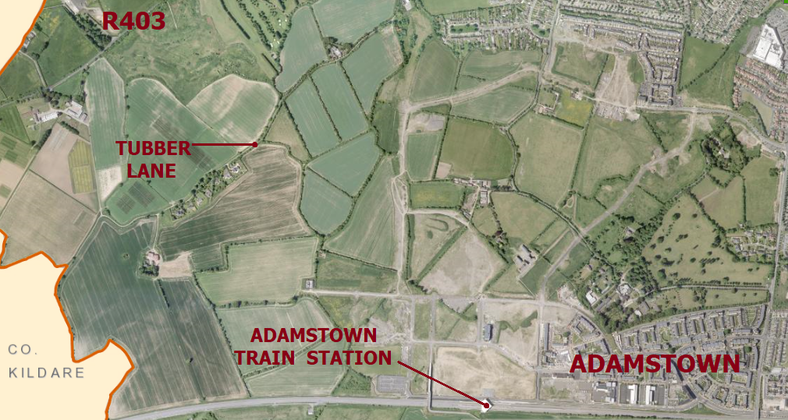

**Figure 1: Site Location Map**

**2.3 Environmental Considerations**

The proposed Scheme has undergone **Appropriate Assessment Screening** under the Habitats Directive (92/43/EEC) and a determination has been made that a Stage 2 Appropriate Assessment will not be required.

The proposed Scheme has undergone **Environmental Impact Assessment Screening** under the EIA Directive (2014/52/EU) and a determination has been made that an Environmental Impact Assessment will not be required. However it was decided by South Dublin County Council to prepare an **Environmental Report** for this scheme to the standard of a full Environmental Impact Statement.

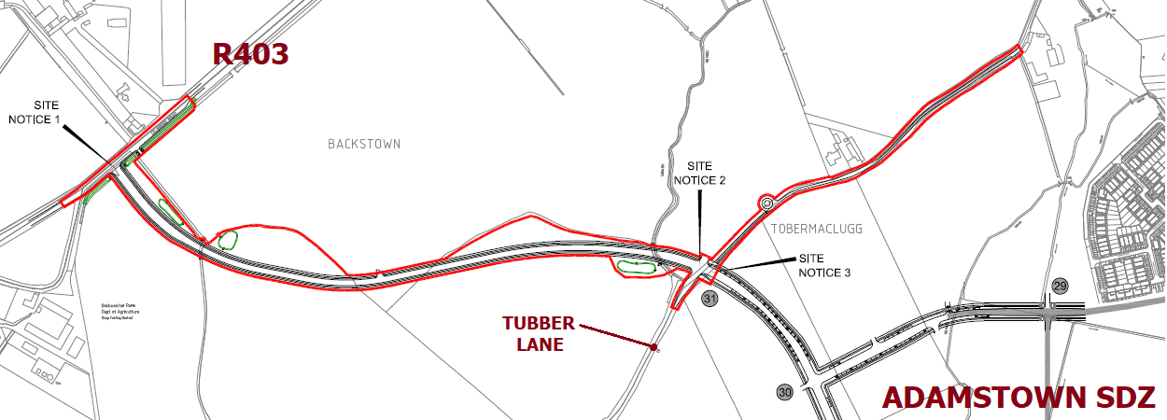

**Figure 2: Outline of the Part 8 application boundary**

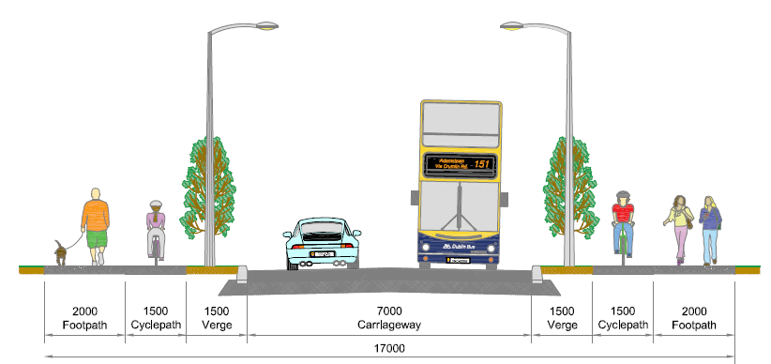

**Figure 3: Proposed cross section of the Celbridge Link Road**

### **3. List of Submissions**

Submissions were received during the specified period of the public consultation in respect of the proposed development from the following:

|  |  |
| --- | --- |
| SD-C50-1 | Tom Moriarty |
| By Post | David Trost (On behalf of Celbridge Community Council) |
| By Post | Gretta Hannigan (On behalf of Inland Fisheries Ireland) |
| SD-C50-2 | Brendan Kearney |
| SD-C50-3 | Michael MacAree (On behalf of National Transport Authority) |

### **4. Summary and Categorisation of Issues Raised and Chief Executive’s Responses**

**4.1 Introduction**

This section presents an analysis of the submissions and includes a summary of each of the issues raised and the responses and recommendations of the Chief Executive.

The responses of the Chief Executive have been framed taking account of the statutory obligations of the local authority, relevant Government and Ministerial guidelines and the proper planning and sustainable development of the area.

**4.2 Summary of Issues Raised, Responses and Recommendations**

|  |
| --- |
| **Submission No.1 – Tom Moriarty**  This submission relates to the following issues:   1. The proposed Celbridge Link Road will allow traffic, particularly Heavy Goods Vehicles (HGVs) to divert through the Adamstown SDZ to avoid the permanent restriction on HGVs travelling along the Outer Ring Road through to the N4 and to avoid high traffic volumes on other roads. The traffic impacts and increase in traffic through the Adamstown Development Area have not been assessed. 2. The Planning and Environmental Report states that construction traffic will not be allowed to use Tubber lane during the construction phase of the project. The implications on safety and welfare of residents in Adamstown due to construction traffic has not been adequately explored. 3. Adamstown Educate Together National School (ETNS) promotes sustainable forms of transport to and from school and raises concerns that increased traffic volumes through Adamstown via the Celbridge Link Road will have a negative impact on the promotion of sustainable forms of transport by the school. 4. Suggests that during the Construction stage of the Celbridge Link Road that construction traffic would be prohibited from using Station Road during school time and other roads should be also restricted to enable the safe movement of children around Adamstown. 5. Requests that the Planning Department consult with the stakeholders regarding the continuing construction in the Adamstown SDZ and its implications for the safety of children and other road users. Suggests HGV restrictions on all roads within Adamstown and a complete ban on HGVs be placed on Station Road from Londis to the next junction after the Community Centre. |

**Chief Executives Response and Recommendation:**

1. SDCC will undertake to ensure that HGV do not divert through the Adamstown development, including implementing measures up to and including weight restrictions on roads within the area.
2. A detailed Construction Traffic Management Plan (CTMP) will form part of the construction tender for the project. Appropriate restrictions will be placed on roads around school areas during the construction phase of the Celbridge Link Road in order to protect existing amenities within Adamstown.
3. SDCC have every intention of protecting all forms of sustainable transport. Traffic within the Adamstown development will be monitored and measures such as weight restrictions on roads in the area will be considered if deemed appropriate.
4. SDCC agree that this measure should be implemented during the construction phase of the project.
5. This matter will be reviewed on an ongoing basis with Construction Traffic Management Plans in the Adamstown SDZ.

|  |
| --- |
| **Submission No.2 – David Trost** (On behalf of Celbridge Community Council)  This submission relates to the following issues:   1. Congestion levels will increase with proposed developments in Adamstown and Celbridge. Residents of Celbridge face a problematic commute daily which will be exacerbated by the proposed signalised junction between the proposed Celbridge Link Road and the R403 at Backweston. This junction should be properly designed to alleviate congestion as much as possible on the current road network. The junction design should not rely on future traffic projections for schemes which may reduce local traffic on the R403 such as the Western Dublin Orbital Route. 2. Public transport has not been considered in the design of the junction on the R403. Bus movements at the signalised junction between the proposed road and the R403 at Backweston should be prioritised and junction throughput should not be hindered by stopping buses. The drawings do not show any accommodation for bus prioritisation measures or alterations to the existing bus stops as a result of the proposed layout. Suggests bus lay-bys at the bus stops at Backweston. 3. The safety of vulnerable road users on the R403 has not been considered. 4. The assessment of traffic impact in the Planning and Environmental Report is based on badly timed Automatic Traffic Count (ATC) data and flawed trip generation assumptions. The ATC was carried out on 31st August 2017 when not all schools may have been open. The Celbridge Road (R403) will become more attractive for commuters as the BusConnects programme proposes park & ride facilities at the N4 Junction 5. The Transport Infrastructure Ireland (TII) growth factors were applied to the traffic count data but do not take account of additional trips to the proposed park and ride. 5. The Planning and Environmental Report does not take into account of drivers that may divert along the proposed road through Adamstown to avoid traffic bottlenecks on the N4, the R120 and in Lucan generally. The report has not taken into account residents of Adamstown who may travel west along the proposed road to access the N4 eastbound via the R403 in order to avoid congestion at the R120 rather than travelling east from Adamstown. 6. The Celbridge Local Area Plan proposes 3,250 new residential units to the south of the town and residents accessing the N4/M4 are more likely to use the R403 rather than Junction 6 on the M4 as this is not a viable route for them, therefore increasing traffic from Celbridge on the R403. |

**Chief Executives Response and Recommendation:**

1. The junction between the R403 and the proposed Celbridge Link Road is designed to accommodate the current and future needs of the area independently of any other road schemes.
2. Bus stop locations on the R403 will be altered as necessary in conjunction with Dublin Bus. Within the Adamstown SDZ a roads hierarchy has been developed to accommodate bus movements. Bus prioritisation will be implemented at the junction as part of the detailed design phase and the introduction of lay-bys for stopping buses will be considered.
3. This item is out of scope for the proposed project.
4. Traffic counts will be reassessed in conjunction with traffic consultants and traffic counts will be amended if necessary to reflect peak flow conditions on the R403 throughout the year. The Transport Infrastructure Ireland (TII) growth factors take account of all traffic growth on the road network.
5. Until the proposed Celbridge Link Road is complete and all development within the Adamstown SDZ which will use the proposed Celbridge Link Road for accessing the R403 is complete, only estimates of likely traffic flow can take place. On completion of all foregoing development, SDCC will undertake further traffic counts and implement measures to optimise traffic flow in the area as necessary.
6. SDCC note the Celbridge Local Area Plan 2017-2023 and agree that the volume of traffic on the R403 is likely to increase with future development. We express disappointment at the lack of provision of a roads objective for an eastern bypass of Celbridge in the Celbridge Local Area Plan 2017-2023. SDCC will continue to monitor traffic volumes and flow on the R403 throughout the expansion of Celbridge and the Adamstown SDZ. SDCC will take necessary actions where necessary in conjunction with Kildare County Council to optimise traffic flow in the area.

|  |
| --- |
| **Submission no. 3 –** **Gretta Hannigan** (On behalf of Inland Fisheries Ireland (IFI))  This submission relates to the following issues:   1. It is Inland Fisheries Ireland (IFI) policy to maintain watercourses in their open natural state to prevent habitat loss, preserve biological diversity and aid in pollution detection. All stream or river manipulation works must be submitted to IFI for consultation and approval. 2. The proposed road will result in a number of watercourse crossings and detailed design is to be agreed in advance with IFI. 3. The Appropriate Assessment Screening refers to a diversion and realignment of the Tubbermaclugg. If permitted the new channel must fulfil the requirements of fisheries habitats, 4. All construction works to be in line with a Construction Environmental Management Plan. |

**Chief Executives Response and Recommendation:**

1. Submission noted.
2. Submission noted.
3. Submission noted.
4. Submission noted.

|  |
| --- |
| **Submission No.4 – Brendan Kearney**  This submission relates to the following issues:   1. Tubber Lane is presently a quiet road with very limited use by motorised traffic and is an important exercise route for walkers, runners and cyclists. The proposed T-junction between Tubber Lane and the proposed Celbridge Link Road will result in an increase in the volume of traffic using Tubber Lane. Suggests that Tubber Lane should be made into a cul-de-sac to allow walkers, runners and cyclists to continue to use the route in a safe manner. |

**Chief Executives Response and Recommendation:**

1. Since the inception of the Adamstown SDZ in the early 2000’s, the arrangement has always been to close Tubber Lane in an easterly direction and to provide a T-junction onto Tubber Lane in a westerly direction. There is no proposal to alter these plans which have been in place since the inception of the Adamstown SDZ.

|  |
| --- |
| **Submission No.5 – Michael MacAree** (On behalf of National Transport Authority (NTA))  This submission relates to the following issues:   1. The NTA is of the view that the proposed Celbridge Link Road does not cater for cyclists in a manner consistent with the National Cycle Manual, in relation to the width of the proposed cycle track as well as the lack of safe crossing facilities at side roads and junctions. 2. It is recommended that the local authority consult with the NTA with a view to expediting the delivery of a revised scheme which caters more appropriately for cyclists. |

**Chief Executives Response and Recommendation:**

1. The width of cycle lanes provided along the proposed Celbridge Link Road will be consistent with requirements of the ‘Width Calculator’ which can be found in the NTA National Cycle Manual 2011. The provision of suitable safe crossing facilities at side roads will be addressed at the detailed design phase of the proposed road.
2. SDCC are satisfied with the design of the proposed Celbridge Link Road and specific details will be determined at the detailed design phase of the project.

**5.0 DEVELOPMENT PLAN POLICIES**

**South Dublin Co Co Development Plan 2016-2022 Land Use Zoning Objectives**

|  |  |  |
| --- | --- | --- |
| Zone | Abbreviation | Objective |
| **Rural and Agriculture** | RU | To protect and improve rural amenity and to provide for the development of agriculture. |
| **Open Space** | OS | To preserve and provide for open space and recreational amenities. |

**Zoning Objective ‘RU: ‘To protect and improve rural amenity and to provide for the development of agriculture’**

|  |  |
| --- | --- |
| **USE CLASSES RELATED TO ZONING OBJECTIVE** | |
| **Permitted in Principle** | Aerodrome/Airfield, Agriculture, Allotments, Cemetery, Concrete/Asphalt Plant in or adjacent to a Quarry, Home Based Economic Activitiesa, Industry-Extractive, Open Space, Public Services, Rural Industry-Food. |
| **Open for Consideration** | Abattoir, Bed & Breakfasta, Boarding Kennels, Camp Siteh, Car Parkh, Childcare Facilitiesb, Community Centre, Crematorium, Cultural Usea, Doctor/Dentistb, Education, Embassya, Enterprise Centreb, Fuel Depotb, Funeral Homeb, Garden Centre, Guest Housea, Health Centreb, Heavy Vehicle Park, Hotel/Hostel, Offices less than 100 sq.mb, Petrol Stationb, Place of Worshipb, Primary Health Care Centreb, Public Houseb, Recreational-Facility, Recycling Facilityb, Refuse Landfill/ Tip, Residentialc, Restaurant/Café, Service Garageb, Shop-Localb, Social Club, Sports Club/Facility, Stadium, Traveller Accommodation, Veterinary Surgery. |
| **Not Permitted** | Advertisements and Advertising Structures, Betting Office, Caravan Park- Residential, Conference Centre, Hospital, Housing for Older People, Industry- General, Industry-Light, Industry-Special, Live-Work Units, Motor Sales Outlet, Nightclub, Nursing Home, Office-Based Industry, Offices 100sq.m-1,000 sq.m, Offices over 1,000 sq.m, Off-Licence, Outdoor Entertainment Park, Refuse Transfer Station, Residential Institution, Retail Warehouse, Retirement Home, Science and Technology Based Enterprise, Scrap Yard, Shop-Major Sales Outlet, Shop- Neighbourhood, Transport Depot, Warehousing, Wholesale Outlet, Wind Farm. |

*a In existing premises*

*b In Villages to serve local needs*

*c In accordance with Council policy for residential development in rural areas*

*f In accordance with a Local Area Plan*

*h For small-scale amenity or recreational purposes only*

**Zoning Objective ‘OS: ‘To preserve and provide for open space and recreational amenities’**

|  |  |
| --- | --- |
| **USE CLASSES RELATED TO ZONING OBJECTIVE** | |
| **Permitted in Principle** | Allotments, Community Centre, Cultural Use, Open Space, Recreational Facility, Sports Club/Facility. |
| **Open for Consideration** | Agriculture, Bed & Breakfasta, Camp Site, Carparkh, Cemeterye, Childcare Facilities, Crematorium, Education, Garden Centre, Guest Housea, Home Based Economic Activitiesa, Hotel/Hostel, Housing for Older People, Outdoor Entertainment Park, Place of Worshipa, Public Services, Recycling Facility, Residential, Restaurant/Café, Shop-Local, Stadium, Traveller Accommodation. |
| **Not Permitted** | Abattoir, Advertisements and Advertising Structures, Aerodrome/ Airfield, Betting Office, Boarding Kennels, Caravan Park-Residential, Concrete/Asphalt Plant in or adjacent to a Quarry, Conference Centre, Doctor/Dentist, Embassy, Enterprise Centre, Fuel Depot, Funeral Home, Health Centre, Heavy Vehicle Park, Hospital, Industry-Extractive, Industry-General, Industry- Light, Industry-Special, Live-Work Units, Motor Sales Outlet, Nightclub, Nursing Home, Office-Based Industry, Offices less than 100 sq.m, Offices 100 sq.m -1,000 sq.m, Offices over 1,000 sq.m, Off-Licence, Petrol Station, Primary Health Care Centre, Public House, Refuse Landfill/Tip, Refuse Transfer Station, Residential Institution, Retail Warehouse, Retirement Home, Rural Industry-Food, Science and Technology Based Enterprise, Scrap Yard, Service Garage, Shop-Major Sales Outlet, Shop Neighbourhood, Social Club, Transport Depot, Veterinary Surgery, Warehousing, Wholesale Outlet, Wind Farm. |

*a In existing premises*

*h For small-scale amenity or recreational purposes only*

*e If provided in the form of a lawn cemetery*

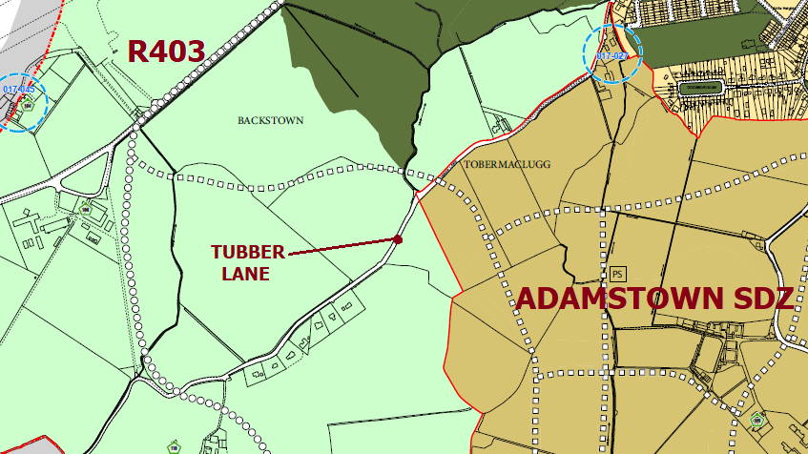

**Figure 4: Extract from the SDCC County Development Plan 2016-2022 Land Zoning Maps**

Given the proposed road and the zoning of surrounding lands under the South Dublin County Council Development Plan 2016 – 2022 there are no development opportunities arising in the adjoining lands as a direct result of the development of this road. The road will allow access and permeability to the Adamstown SDZ and will aid in providing future development opportunities and sustainable transport practices in the Adamstown SDZ area.

**6.0 Recommendation**

Following consideration of the submissions the Chief Executive is of the view that the issues raised by way of the submissions can be satisfactorily addressed as outlined in the foregoing report.

SDCC Roads Forward Planning section recommend that detailed design now commence on this scheme.

**The report recommends that;**

1. This road proposal has been in existence in the current form since the inception of the Adamstown SDZ in the early 2000’s. No changes are proposed to alter the road alignment or layout of junctions on the road.
2. The following changes are to be made to the drawings at the detailed design stage:
   1. The width of the cycle tracks along the proposed Celbridge Link Road be increased to 2.0 metres wide along the full length of the road.
   2. Suitable safe crossing facilities for pedestrians and cyclists will be incorporated into the design at the detailed design stage.
3. A Construction Traffic Management Plan to be developed for the construction phase of the project. This will include defining routes for construction traffic and implementing appropriate weight restrictions on specific roads within the Adamstown SDZ including a restriction on vehicles over 7.5 tonnes using Station Road in the vicinity of the schools.
4. The location of bus stops on the R403 to be agreed and adjusted in conjunction with Dublin Bus.
5. Appropriate measures to comply with Inland Fisheries Ireland (IFI) requirements to be implemented as part of the project.