Review of South Dublin County Council (Control of Parking) Bye-Laws 2010

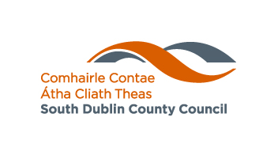

Land Use Planning and Transportation SPC
15th February 2018

Land Use Planning and Transportation Department - Parking Section

Background

A Countywide Pay and Display Parking system supported by Parking Bye Laws was introduced to the village centres of Rathfarnham, Tallaght, Templeogue, Palmerstown, Rathcoole, Lucan and Clondalkin since 2006. Saggart and Newcastle were originally listed, however, have not been operational. The power of the Council to make such Bye Laws is contained in Section 36 of the Road Traffic Act, 1994 and section 101 of the Road Traffic Act, 1961.

The purpose of this was to manage parking and achieve turnover of parking spaces to address the needs of the business community and the shoppers. It also assists in preventing traffic congestion in our villages.

Following presentations to each of the Area Committees of the Council, it was agreed that the public consultation phase leading to the adoption of revised Control of Parking Bye Laws would commence, public notices were placed on 11th November, 2009 in both the Tallaght Echo and the Irish Independent. A total of 92 individual submissions were received before the closing date 6th January, 2010 and a further 3 submissions received after the closing date were also included for completeness. In addition a series of questions and motions were tabled by Members at Area Committee Meetings seeking clarification of certain aspects of the proposal.

The latest Control of Parking Bye Laws 2010 underpinning the pay parking system were adopted by the elected Council at its meeting of 23rd July, 2010. Notice advising the public that the Bye Laws came into effect from Monday 2nd August, 2010 was advertised on July 30th, 2010. At the request of the Members a review of the first six months operation of revised Bye Laws was carried out and a report tabled by Headed Item at the Council Meeting held on April 11th, 2011.

Significant Changes since the introduction of Pay and Display Parking

There are 800 public Pay and Display spaces Countywide. Enforcement of the Bye Laws is by way of contract and parking wardens are appointed by way of Chief Executive Order who implement the Bye Laws on behalf of the Council.

- Operational Hours & Days - 8 am to 6 pm and tariffs

Mon – Sat  €1.50 / Hr | Mon – Fri  €1.00 / Hr
Rathfarnham,  Tallaght,  Templeogue,  Palmerstown | Rathcoole,  Lucan,  Clondalkin

A reduced tariff of 75c per hour applies in car parks and selected peripheral spaces in some villages. In off street car parks the tariff includes VAT.

In 2011 a review was carried out after six months of operation leading to the following changes; see Appendix 1: Headed Item No. 16 Amendments to Control of Parking Bye Laws County Council Meeting 11th April, 2011

Cashless Parking agreement through Parking Tag was introduced in June 2013 and the transactions growth has increased year on year.

The Transportation SPC undertook a review of the Parking Bye Laws which led to the recommendation to introduce 30 Minutes Free Parking option. It was agreed and introduced on 7th April, 2014. A review of Pay and Display Parking and the application of 30 minutes free parking was discussed at Transportation SPC on February 13th, 2014; see Appendix 2: Headed Item No. 3 Report on Paid Parking Review.

To encourage Cashless Parking, a number of signs outlining the relevant Payzone Zone was installed in all area in 2015. As part of this initiative, a number of meters were wrapped with advertising for Parking Tag to outline how to sign up to use cashless parking.

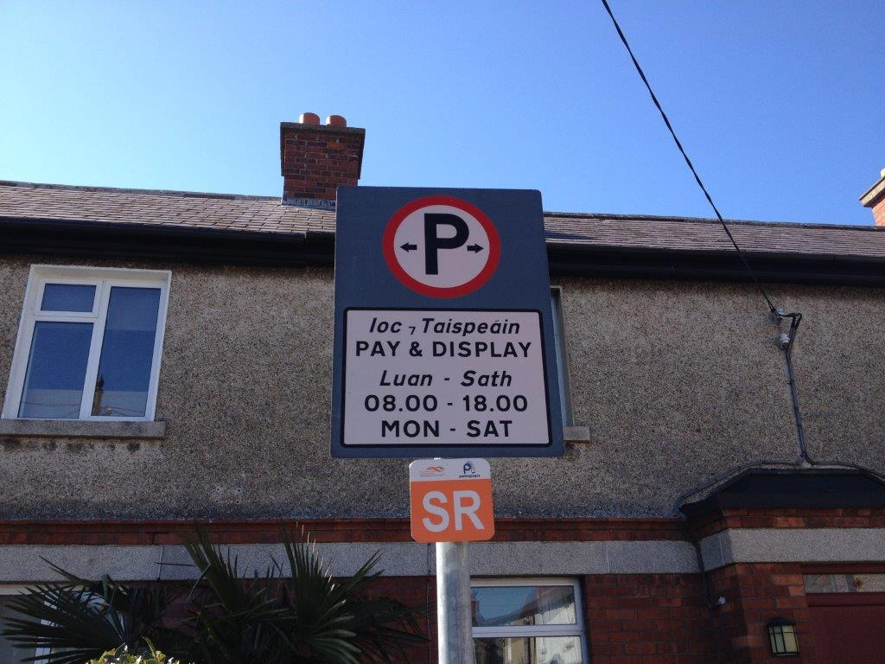

In 2015 by means of a competitive procurement process, Park Rite trading as South Dublin Parking Services were awarded in October 2015, a two year contract for Parking Enforcement within the administrative area of South Dublin County Council. This contract contains a further two one year extensions.

On 6th September, 2016 changes were made to the operation of the 30 Minutes Free Parking option that every motorist should display a ticket, free tickets were available from the parking meter and should be displayed.

On 26th July, 2016 the Parking Section began to process Parking Permit applications in-house, issued previous by our former Parking Enforcement Contractor, APCOA.

The Parking Section had its first Court Prosecutions sitting in Tallaght Courthouse on 24th March, 2017.

It should be noted that the Parking Section avails of a number of Collaborative Regional Tenders with the other Dublin Local Authorities for shared parking services such as Machine Parts Supply, Purchasing of Machines, Cashless Parking and Cash Collection to ensure value for money.

A collaborative working relationship to discuss all parking related matters has been fostered between the Parking Section and its colleagues in the Parking Sections in the other Dublin Local Authorities.

Financials and Compliance Details

Parking Income: 2007 - 2017

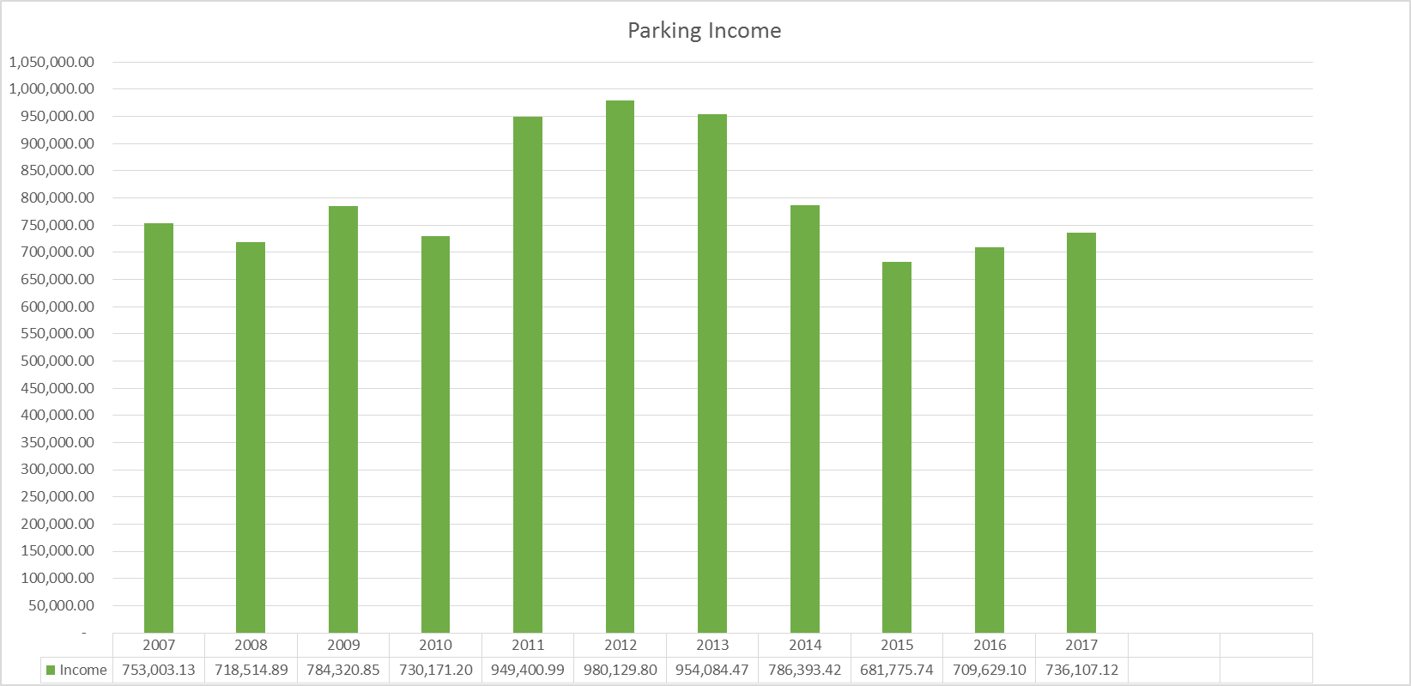

Year | Income
2007 | 753,003.13
2008 | 718,514.89
2009 | 784,320.85
2010 | 730,171.20
2011 | 949,400.99
2012 | 980,129.80
2013 | 954,084.47
2014 | 786,393.42
2015 | 681,775.74
2016 | 709,629.10
2017 | 736,107.12

2016/2017 Parking Meter Income

Village | 2016 | 2017
Lucan | €161775.88 | €142330.14
Palmerstown | €13319.60 | €16075.40
Clondalkin | €38980.90 | €37538.80
Rathfarnham | €130734.90 | €108466.12
Rathcoole | €24251.50 | €28842.70
Tallaght | €26119.40 | €25084.40
Templeogue | €18218.00 | €15929.00

Ticket Issuing History: 2016 v 2017

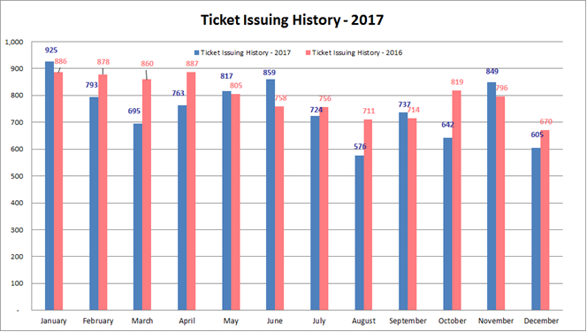

Ticket Issuing History: 2017

Total Fines Paid Per Year %

Year | Percentage
2017 | 63% *This percentage will continue to increase until the end of March 2018
2016 | 68%
2015 ** | 63%
2014 | 65%
2013 | 64%
2012 | 70%
2011 | 61%
** New service provider from October 2015

Parking Tag Cashless Parking – Transactions Growth Year on Year

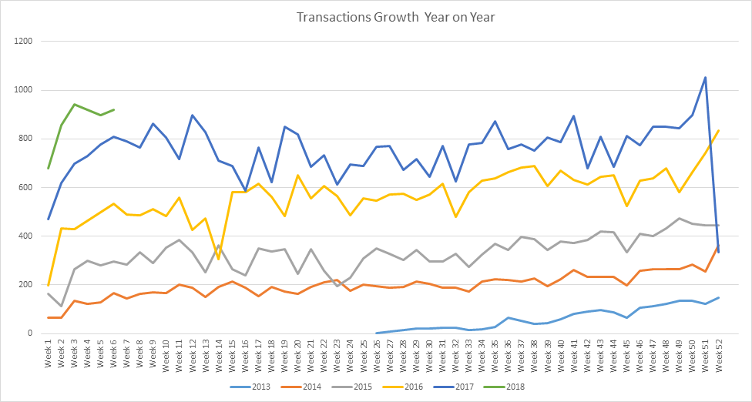

Enforcement of Bye Laws

Breakdown of Parking Offences – Categorised December 2017

Breakdown of Parking Offences | Total | Percentage
Footpath/Grass Margin/Median Strip | 93 | 15.37%
Prohibited Place (Loading bay/SYL/DYL) | 82 | 13.55%
P&D/Permit Parking Area | 329 | 54.38%
Disabled Parking Bay | 23 | 3.80%
Other (Bus stop, Bus Lane, Cycle Track, School Entrance, Traffic signals and Clearway) | 78 | 12.89%
Total | 605 | 100%

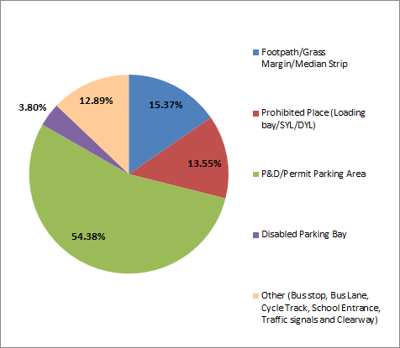

Park Rite trading as South Dublin Parking Services enforces the Parking Bye Laws on behalf of South Dublin County Council. The On-Street Enforcement Team consists of a Parking Supervisor and 3 Parking Wardens assisted by a back office customer care telephony team. The contract is managed by a Contract Manager and an On Street Contract Supervisor.

The Supervisor and Wardens operate a 6 day beat rota enforcing the Parking Bye-laws and Road Traffic Act parking offences such as parking on footpaths, in loading bays, in disabled parking bays in seven of our villages.

Since the engagement of the services of Park Rite, a number of new locations not previously enforced have been highlighted by the on-street wardens for regular parking offences, including school time collection and drop off times in the vicinity of schools. Our School Wardens have praised the Parking Wardens for their assistance in ensuring their crossing points are being kept free of parked cars and cars dangerously parked are being ticketed.

There has been a notable increase in motor garages parking their cars, not visibly for sale, on public property, this was highlighted by the Wardens and is being actively enforced in various locations throughout the county.

The Wardens note along with photographs on Park Rite’s CIT System, which staff in the Parking Section has access to, any street defects, such as faded double yellow lines, issues with signage etc. which are then referred by staff on to the relevant section for consideration and action.

The Wardens also inform the Council of any abandoned cars throughout their beat which they may observe and these observations are referred to the Gardaí or internally to the Environment Services Department.

The Wardens take a zero tolerance approach by issuing instant fines to motorists not displaying a disabled parking permit while parked in a disabled parking bay, these bays are provided to assist those who have the permit to use them. On occasion, contact has been made with the Irish Wheelchair Association regarding suspected fraudulent disabled permits, upon information received from wardens.

Contract Management Monthly meetings are held between the Parking Section and the relevant Park Rite staff assigned to this contract.

Park Rite was instrumental in assisting the Parking Section to secure our first Parking Prosecutions sitting in Tallaght Court House on 24th March, 2017.

Engineering [requests for additional locations] Willie Purcell
Road Traffic and Planning are continuously reviewing pay and no-pay parking provisions throughout the county. This includes:
- Use of bus lanes during non- busy periods for casual parking
- Provision of park and ride facilities near Luas and QBC routes
- Provision of indent spaces in POS where a justifiable demand and community acceptance exists
- Provision of adequate set-down spaces in the vicinity of schools
- Assessment of parking provision on planning applications in line with the provisions of the CDP.

Recommendations

Review and updating of Bye Laws

Additional Loading Bays

Additional Taxi Ranks

- Potential to increase the number of Wardens for enforcement work at schools

- As the ethos of parking enforcement that we wish to deliver is of a fair, impartial and professional service standard we have now agreed that all wardens will use a Body Worn Video device which will be used in certain circumstances that are compliant with Data Protection requirements.

Appendix 1:
COMHAIRLE CONTAE ÁTHA CLIATH THEAS
SOUTH DUBLIN COUNTY COUNCIL

MEETING OF SOUTH DUBLIN COUNTY COUNCIL
Monday, April 11, 2011
HEADED ITEM NO. 16
AMENDMENTS TO CONTROL OF PARKING BYE-LAWS
Following the introduction of the South Dublin County Council (Control of Parking) Bye Laws 2010 and at the request of the Members of the Council, a review of the first six months operation of the revised Bye Laws has been carried out.
Among the principal changes made by the adoption of the the South Dublin County Council (Control of Parking) Bye Laws 2010 was the introduction of controlled parking into the commercial centres of Tallaght and Templeogue and surrounding areas. Also, in response to demands from the business and residential communities in certain areas, paid parking was introduced on a Monday to Saturday basis. All the changes have been monitored and their operation has been analysed to ensure that the most tailored system for each area in terms of managed parking could be achieved. Following further consultation it is proposed to make a number of minor modifications to the parking arrangements as set out below:
Rathfarnham:
In Rathfarnham Village paid parking was introduced as requested on a Monday to Saturday basis and now includes the areas of Owendore Crescent, The Lakelands and The Woodlands.
Following consultation with traders regarding the introduction of Saturday paid parking and in order to free up valuable parking spaces in the village area and to improve usage of the Village Court parking area, it is proposed to introduce free parking on Saturdays in the Village Court car park. This proposal will have a number of beneficial effects and will assist businesses in the promotion of the village on Saturdays for the benefit of the overall business community in the village. Additional traffic measures are also being provided which will assist traffic flows in the village and these arrangements will be put in place (signs to the car park, for one way traffic flow, loading areas and some traffic assistance during village fairs) at the earliest opportunity.
In Owendore Crescent, and following extensive consultation with residents, The Members of the Rathfarnham Area Committee have recommended that the pay and display parking controls should remain without a limit on the number of permits issued to residents in regard to specific needs of that road. Permits will also be charged at first permit lower rate. The benefit to residents of the general removal of unwanted parking is thus maintained.
Templeogue:
Pay and display parking was introduced in Templeogue, it operates on a Monday to Saturday basis. The area also includes Fortfield Park shopping area.
In order maximise use it is proposed to reduce the tariff in the Riverside Cottages car park to tariff ‘B’
Tallaght:
Pay and display parking was introduced in Tallaght, it operates on a Monday to Saturday basis. The area also includes Westpark and the Oldbawn car park.
The introduction of controlled parking in the residential area of Westpark has been well received since been made operational. Residents are delighted that the unwanted parking in their estate is now being controlled.
The areas of Old Greenhills Road and Oldbawn Car Park are under utilised and it is proposed to reduce the tariff to tariff ‘B’ on Old Greenhills Road and to propose in the interests of the business community to introduce free parking on Saturday for Old Greenhills Road and Oldbawn Car Park. Some additional and appropriate loading bays are also to be provided to assist with commercial requirements. In the immediate past a request has been received from residents on the roads surrounding Oldbawn Road Car Park that consideration be given to the introduction of parking control measures in these areas. It is proposed to carry out a study of the locations and to make further recommendations to the Members as part of the next Review of the Bye Laws.
Cashless Parking Service:
The Council is at present in discussions with its sister authorities in Dublin Region, on the introduction of a cashless pay parking system. It will be based on the mobile phone payment ‘Parking Tag’ system which has been successfully piloted and introduced in Dublin City centre. The new system will be interoperable across each local authority in the region and should be of considerable benefit to those who conduct business throughout the region.. In order to introduce this cashless payment system it will be necessary to make a number of changes and modifications to the Control of Parking Bye Laws. These changes will require that Draft Bye Laws be prepared and presented to the Members later this year and a full consultative process undertaken prior to their adoption. This process will also offer a further opportunity to Members to raise any further concerns which may have arisen since the last review.
Accordingly it is necessary for the Members of the Council to approve of the changes proposed in the foregoing report and the following motion will be required:
"We, the Members of South Dublin County Council hereby approve and adopt the changes, as set out in the foregoing report of the County Manager, to the South Dublin County Council (Control of Parking) Bye Laws 2010".

Appendix 2:

COMHAIRLE CONTAE ÁTHA CLIATH THEAS
SOUTH DUBLIN COUNTY COUNCIL
MEETING OF TRANSPORTATION SPC
Thursday, February 13, 2014
HEADED ITEM NO. 3
Report on Paid Parking Review

Following the Transportation SPC in November 2013 at which a review of pay and display parking arrangements in the County were discussed and noted. It was agreed that the a number of matters required further examination and analysis with particular reference to providing a more favourable car parking pricing regime and as a support to businesses within the County.
A number of matters were raised by elected members at Council Area Committee meetings during the course of this parking review.
The matters raised by elected members are summarised below together with associated responses.

1.0 Tariffs should not be such as to introduce competition between local shopping areas in villages but sufficiently low to attract customers from large shopping centres with a level of consistency across the county
Response: the rates are consistent across the county in public parking areas. A reduction in tariff can be effected by a modification of the bye - law by the members which is reserved function.

2.0 Expenditure of any surplus monies after operational and maintenance costs.

Response: If a surplus is generated it can be ring fenced and used for additional parking schemes, village improvement works as part of the village initiative in an equitable manner across the county.

3.0 Adjustment of parking areas in outlying underused village areas and the need for park and ride facilities.
Response: It is possible to adjust the parking areas with a defined length of road. It is possible to truncate but not add additional areas without a new bye law with full public consultation.

4.0 Grace period. A discussion took place around the length of grace period and a request to examine same for this meeting particularly in regard to commercial benefits, parking control and safety in remote parking areas.

Response: In this regard it was decided to examine parking durations in two areas in the first instance and Lucan and Rathfarnham were chosen as the two largest utilised parking areas and examine possible options in this regard. This is the subject of a slide presentation below.

The majority of suggested changes are operational adjustments and can be incorporated into the Paid Parking Services contract without recourse to the development of a new parking Bye law and it is proposed to effect such changes as are possible within a short time frame and in any event by the 7th April following adoption by the full council of any recommendations of this committee.

