## COMHAIRLE CONTAE ATHA CLIATH THEAS

## SOUTH DUBLIN COUNTY COUNCIL

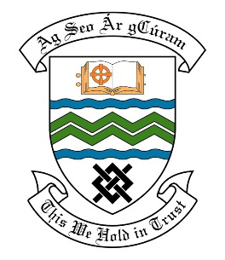

### MEETING OF THE TALLAGHT ACM

## 26th February, 2018

## HEADED ITEM NO. 7

**Deputations meeting – 24th January, 2018 @ 3pm.**

**Tallaght Community Council**

**Deputation** **attendees** – Gerry Stockil, Tara De Buitlear, John Kiberd, Walter Butler

& Donie Anderson.

**Elected Members** – Cllr. Charlie O’Connor, Cllr. Brian Lawlor, Cllr. Kieran Mahon Cllr. Ronan Mahon, Cllr. Emma Murphy, Cllr. Mick Murphy & Cllr. Dermot Richardson.

**Council Officials** – Elaine Leech, Suzanne Furlong, Michael Glynn, Brian Carroll & Carol McDonnell.

Councillor Charlie O’Connor presided.

**Items discussed**:

1. Signage for Dublin Mountain Way.
2. Public Realm Upgrade of Dublin Mountain Way.
3. Cattle grids & associated signage in rural Tallaght.
4. Commitments given at Deputation meeting.

**Commitments given**:

1. Specific signage request to be discussed with the Council’s Land Use, Planning and Transportation Department and will refer back to Tallaght Community Council - Elaine Leech.
2. Kiltipper Park at Design and Planning Stage – will refer back to Elected Members and Tallaght Community Council when completed – Suzanne Furlong.
3. Site meeting offered as part of the agenda of working groups report to be brought to Management – Michael Glynn.