COMHAIRLE CHONTAE ÁTHA CLIATH THEAS

SOUTH DUBLIN COUNTY COUNCIL



MEETING OF TERENURE/RATHFARNHAM AREA COMMITTEE (2)

TUESDAY 14TH FEBRUARY 2006

Question No. 4

Tree planting and pruning

QUESTION: Councillor J. Lahart

“To ask the Manager for an update on the tree planting and pruning programme in Rathfarnham/Terenure including details of what streets have been dealt with so far?”

REPLY:

An update of the 2005 – 2006 Arboricultural Programme is attached. It should be noted that the work completed to date is outlined in green. It should also be noted that there are additional works included in the list, which were not included in the original programme, and were carried out due to requests from the public, emergency situations, as the need arose during the season.

It is also obvious from the update that the large volume of work set out in the programme is being attended to in a prompt and professional manner by the staff of the Tymon and Rathfarnham Depots.

Terenure Rathfarnham Electoral Area
Arboricultural Works Programme 2005-2006

Programme Update – February 2006

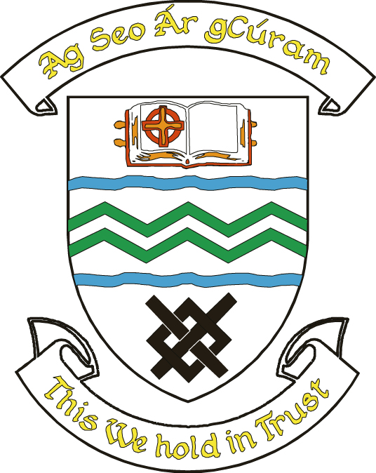

Parks & Landscape Services

Rannóg Seirbhísí Páirceanna agus Tírdhreacha

Terenure Rathfarnham Street Tree Planting
Street Species Quanties
Ashfield Sorbus aucuparia 2
Ballyroan Park Sorbus "Joseph Rock" 1
Ballytore Road Tilia cordata "Greenspire" 1
Barton Drive Carpinus "Frans Fontaine" 1
College Crescent Prunus cerasifera "Nigra" 1
College Park Crataegus monogyna 25
Coolamber Court Malus 'Whitestar' 2
Cypress Grove Rd Prunus "Accolade" 15
Dangan Park Betula papyrifera 1
Fortfield Drive Malus 'Whitestar' 1

Fortfield Drive Sorbus "Joseph Rock" 1

Fortfield Drive Sorbus aria 8
Fortfield Park Sorbus aria 10
Glendale Park Carpinus "Frans Fontaine" 1
Glendoher Drive Acer campestre "Elsrijk" 1

Glendoher Drive Acer campestre "Elsrijk" 1
Glendoher Estate Malus "Whitestar" 20
Glendoo Close Sorbus commixta "Embley" 5
Glendown Avenue Acer campestre "Elsrijk" 1
Glendown Court Acer campestre "Elsrijk" 1
Glendown Lawn Betula pendula 3

Glendown Lawn Sorbus aria 3
Glendown Road Betula pendula 15
Glenlyon Grove Sorbus commixta "Embley" 1
Glenlyon Park Sorbus commixta "Embley" 1
Glenlyon Crescent Sorbus 5
Glenvara Park Tilia cordata "Greenspire" 1
Greentrees Drive Acer campestre "Elsrijk" 2
Hillside Park Corylus colurna 1
Idrone Drive Sorbus "Joseph Rock" 1
Keadeen Avenue Sorbus aria 2
Kennington Crescent Sorbus aucuparia 1
Kilamshogue Grove Sorbus aria 4
Kilmashogue Drive Sorbus aria 4
Kilmashogue Grove Carpinus "Frans Fontaine" 5
Kimmage Road West Corylus colurna 4

Kimmage Road West Corylus colurna 5

Kippure Avenue Sorbus aria 3
Knockaire Carpinus "Frans Fontaine" 1
Knocklyon Road Prunus "Accolade" 5
Knocklyon Heights Tilia cordata "Greenspire" 1
Lansdowne Park Acer campestre "Elsrijk" 1
Limekiln Green Acer platanoides 8
Marian Road Carpinus "Frans Fontaine" 15
Mountdown Road Prunus cerasifera "Nigra" 1
Orwell Park Sorbus aria 1
Orwell Park Grove Sorbus intermedia 1
Priory Walk Tilia cordata "Greenspire" 1
Rossmore Lawns Malus 'Whitestar' 1
Saint Enda’s Park Malus 'Whtestar' 5
Shelton Drive Acer campestre "Elsrijk" 1
Shelton Drive Betula pendula 2
St Columbas Road Sorbus commixta "Embley" 1
St Finbarrs Close Tilia cordata "Greenspire" 1
St James Road Malus "Profusion" 5
Temple Manor Prunus "Accolade" 1
Templeogue Road Prunus "Accolade" 1
Templeogue Wood Sorbus "Joseph Rock" 5
Templeogue Woods Sorbus aria 1
Templeroan Downs Carpinus "Frans Fontaine" 1
The Court Cypress Downs Acer campestre "Elsrijk" 1
The Dale Prunus "Accolade" 5
Tibradden Close Sorbus commixta "Embley" 5
Wainsfort Crescent Prunus cerasifera "Nigra" 4
Wainsfort Manor Quercus Ilex 10
Wainsfort Road Aesculus x carnea "Briottii" 1

Wainsfort Road Aesculus x carnea "Briottii" 10
Wellington Lane Ulmus "Dodoens" 40
Whitechurch Way Prunus "Accolade" 10
Whitehall Road West Corylus colurna 10
Terenure Rathfarnham Open Space Planting

Beverly Downs
Beverly Rise
Boden Park
Cherryfield
Glendoher
Grangebrook
Greenhills Park
Kimmage Manor
Knockfield Manor
Priory Walk
Temple Manor
Temple Manor Grove
Tymon Park
Whitechurch Crescent
Terenure Rathfarnham Open Space Pruning
Aranleigh Open space
Boden Wood
Riversdale View
Castlefield Park
Coolamber Park
Dargle Wood
Dodder Lawn
Elkwood
Glenbrook Park
Glendown
Hillsbrook Avenue
Idrone Park
Kilvere
Knocklyon Avenue
Knocklyon Close
Moyville
Muckcross Crescent
Orchardstown Park
Osprey Park
Rathfarnham Castle
Rathfarnham Wood
Rossmore Lawns
Rushbrook View
The Orchard
Tymon Park
Woodstock Park

Terenure Rathfarnham Street Tree Pruning

Ashfield Avenue
Ashfield Close
Ashton
Ballycullen Avenue
Ballycullen Drive
Ballycullen Road
Ballyroan Road
Barton Road
Barton Drive
Springfield Bridge, Templeogue
Boden Park
Boden Wood
Brookvale Downs
Brookwood
Butterfield Park
Carrigwood
Castlefield Manor Court
College Drive
Coolamber Court
Coolamber Park
Corrig Close
Crannagh Grove
Crannagh/ Ballytore
Cypress Avenue
Cypress Downs, The Avenue
Cypress Grove North
Cypress Grove Road
Cypress Lawn
Dangan Park
Dargle Wood
Delaford Park

Delaford Grove

Delaford Lawn
Dodder Park Road
Edenbrook Court
Fonthill
Forest Park
Forest Drive
Forest Green
Fortfield Park
Glendown Park
Glenvara Park
Hermitage Court
Hillsbrook Avenue
Hillsbrook Grove
Hillside Park
Idrone Close
Kilakee Drive
Kilakee View
Kilvere
Knockcullen
Knocklyon Avenue
Knocklyon Park
Knocklyon Road
Lansdowne Park
Limekiln Green
Limekiln Road
Longwood Park
Lugnaquilla Avenue
Marian Road
Monalea Park
Mount Alton
Muckcross Park
Orwell Park
Orwell Park Crescent
Orwell Park Drive
Orwell Park Glen
Orwell Park Green
Orwell Park Grove
Orwell Park Rise
Pinewood Park
Quarry Drive
Rockfield Avenue
Rossmore Avenue
Rossmore Close
Rossmore Crescent
Rossmore Lawns
Rushbrook Grove
Rushbrook Park, Templeogue
Shelton Drive
Springvale
St Conleths Road
St. James Road
St Patricks Road
St Peters Crescent
St. Brendans Crescent
Temple Manor Close
Templeroan Downs, Meadows
Templeville Drive
Templeville Road
Wainsfort Park
Wainsfort Road
Washington Lane
Wellington Park
Whitechurch
Whitechurch Close
Whitechurch Court
Whitecliff
Whitehall Road East
Willbrook Lawn
Willington Avenue
Willington Drive
Woodfield Estate

Terenure Rathfarnham Street Tree Removals

Ashfield
Ballyroan Park
Barton Drive
Barton Road
Barton Drive
Barton Road West
Beechfield Close
Beechfield Road
Brookvale
Cherryfield Avenue
Coolamber Court
Coolamber Park
Crannagh Road
Cremorne
Dargle Wood
Delaford Drive
Fonthill Park
Fortfield Road
Glendale Estate
Glendale Park
Glendoher Drive
Glendoo Close, Green Park
Glendown Park
Grange Manor Grove
Greentrees Drive
Hillsbrook Avenue
Hillsbrook Grove
Idrone Drive
Kimmage Road West
Knockaire
Knocklyon Heights
Lansdowne Park
Limekiln Green
Limekiln Road
Lugnaquille Ave
Monalea Wood
Mountdown Road
Orwell Park Crescent
Osprey Park
Rathfarnham Wood
Rockfield Avenue
Rossmore Avenue
Rossmore Crescent
Rossmore Lawns
Rushbrook Avenue
Rushbrook Grove
Rushbrook Park, Templeogue
St Annes Estate
St Brendans Crescent
St Endas Park
St James Road
St Patricks Road
St. Brendans Crescent
Temple Manor Close
Templeogue wood
Templeroan Park
Templeville Drive
Templeville Park
Wainsfort Park
Wainsfort Road
Wellington Park
Whitecliff
Whitehall Road East
Willington Grove
Woodfield

