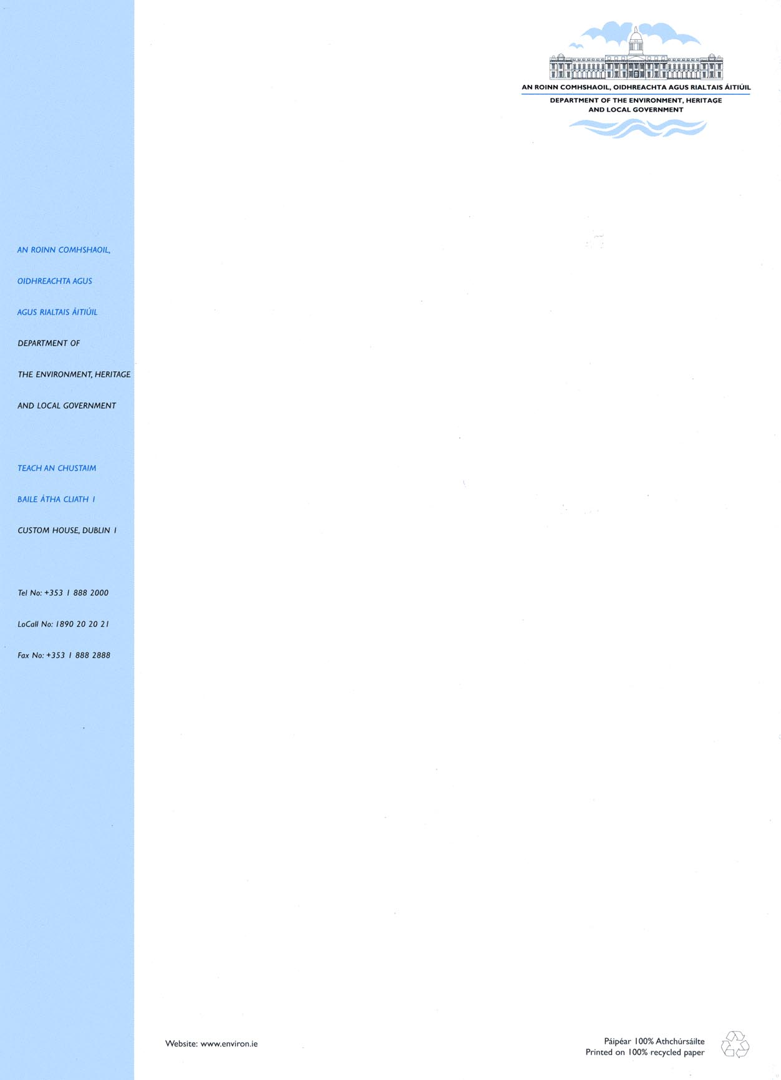
- General enquiries about this circular should be made to Mr Gerry McNamee or Ms. Joan Ryan, Housing Policy & Finance Section (telephone 888 2176 or 2122).

Specific enquiries regarding the various schemes should be directed to the numbers shown below.

L. A. House Purchase Loans | 01 - 888 2176 | Gerry McNamee
Shared Ownership Scheme | 01 - 888 2735 | Niall Hayden
Affordable Housing Scheme | 01 - 888 2735 | Niall Hayden

Michael Murphy
Assistant Principal
Housing Policy and Finance Section.

To each Housing Authority issuing loans
Appendix

- Rent Subsidy
An additional income band (€25,501 to €28,000) has been added: this increases the cut off point for eligibility from €25,501 to €28,001. A revised schedule is set out in the table below: -

Household Income  € | Annual Subsidy Payable  €
13,000 and under | 2,550
13,001 to 15,500 | 2,300
15,501 to 18,000 | 2,050
18,001 to 20,500 | 1,800
20,501 to 23,000 | 1,550
23,001 to 25,500 | 1,300
25,501 to 28,000 | 1,050

The revised schedule applies from 1 January 2006.

- Mortgage Subsidy
An additional income band (€25,501 to €28,000) has been added: this increases the cut off point for eligibility from €25,501 to €28,801. A revised schedule is set out in the table below: -

Household Income  € | Annual Subsidy Payable  €
13,000 and under | 2,550
13,001 to 15,500 | 2,300
15,501 to 18,000 | 2,050
18,001 to 20,500 | 1,800
20,501 to 23,000 | 1,550
23,001 to 25,500 | 1,300
25,501 to 28,000 | 1,050

The revised schedule applies from 1 January 2006.

3. Income Eligibility Limits for Shared Ownership, Affordable Housing and Local Authority House Purchase Loans
Eligibility will continue to be determined in accordance with the existing formula approach. However, with effect from 1 January 2006, the product of the formula (2½ A + B) must not exceed €100,000, where, in the income tax year immediately preceding the date of the application: -

  - A is the larger of the incomes of the borrower and, if any, that of the borrower’s spouse or any person cohabiting as husband or wife with the borrower or any joint borrower(s); and

  - B is the income, if any, of such spouse, person cohabiting or joint borrower(s), as the case may be.

In the case of a single income household, this has the effect of increasing the income eligibility limit from €36,800 to €40,000 per annum.

Maximum House Purchase Loans
The maximum loan which may be advanced for the acquisition or construction of a house has been increased to €185,000 with effect from 1 January 2006. The maximum mortgage loan in each case is to be determined by the local authority subject to the €185,000 limit and also subject to the purchaser’s ability to repay i.e. mortgage repayments should not exceed 35% of a household’s net income (after tax, PRSI etc.).

In order to ensure the optimal use of resources, the prioritisation of funding for lower income groups and to avoid any significant impact on house prices in their respective areas, local authorities may apply lower loan limits to reflect local market conditions.

The limits will be reviewed on an annual basis. However, in the period between approval for a loan and the allocation of the loan/house, an individual, once approved shall continue to be deemed eligible where the increase in income does not exceed the maximum income limit by more than the normal pay and incremental increase due to that individual over a twelve month period from the date of approval.

4. Site Subsidy
This provision allows for site subsidies for housing provided by local authorities under the affordable housing scheme, new houses provided under the shared ownership scheme and low cost sites. The site subsidy payable for the Dublin Metropolitan Area (including the city of Dublin and the counties of Dun Laoghaire-Rathdown, Fingal, South Dublin and certain District Electoral Divisions* in Kildare, Meath and Wicklow) and the cities of Cork, Limerick, Waterford and Galway has been increased from €38,100 to €50,000 with effect from 1 January 2006.

The site subsidy for areas other than those set out above remains at €31,800.

* District Electoral Divisions, as set out in Regional Planning Guidelines for the Greater Dublin Area 2004-2016, are attached (relevant local authorities only).

