## COMHAIRLE CONTAE ATHA CLIATH THEAS

## SOUTH DUBLIN COUNTY COUNCIL

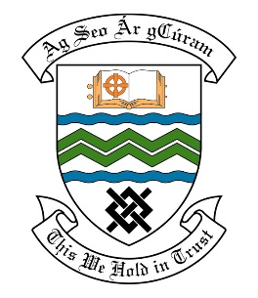

### MEETING OF THE TALLAGHT ACM

**18th December, 2017**

## HEADED ITEM NO. 14

**Deputations meeting 22nd November 2017 @ 4pm**

**Kingswood Heights Residents Association**

**Deputation** **attendees** – Breda Brennan, Nicola Brennan, Peter Fitzpatrick & Anna Quinn.

**Elected Members** – Cllr. Mick Duff, Cllr. Charlie O’Connor, Cllr. Cora McCann & Cllr. Kieran Mahon.

**Council Officials** – Vincent Heywood, Shelia Kelly, Leo Magee & Paul Allen.

Councillor Mick Duff presided.

**Items discussed**:

1. Parking problems in Kingswood.
2. Tennis Courts.
3. Ballymount Park.
4. The Black Path.
5. Commitments given at the Deputation meeting.

**Commitments given**:

1. Mr. Vincent Heywood to arrange an evening inspection in April/May 2018 ascertain depth of parking issues around Ballymount Park.
2. Mr. Vincent Heywood to liaise with Gardaí about parking on double yellow lines and discuss repainting of double yellow lines at St. Killian’s School & Kingswood Community College at Traffic Management meeting.
3. Mr. Vincent Heywood to consider different parking layout/layby/alternative parking on the other side of the road at Luas Park & Ride.
4. Mr. Leo Magee to liaise with group regarding resurfacing of Tennis Courts.
5. Mr. Paul Allen to meet with residents to examine cutting the shrubbery at the lake, remove graffiti from benches and the nature signs, upgrade the green areas and also explore what options may be available regarding the installation of a platform at the lake. Heritage Officer to be invited on site also as per Mr. Leo Magee.
6. Mr. Leo Magee to look at this Black Path area with a view to removing the encroaching grass and costing works for resurfacing and new lights to be included in next year’s proposed works programme, also to arrange a clean-up of green materials in the area.
7. Mr. Leo Magee to see if monies were previously allocated to works lighting up Kingswood Castle or will money become available in the future.