## COMHAIRLE CONTAE ATHA CLIATH THEAS

## SOUTH DUBLIN COUNTY COUNCIL

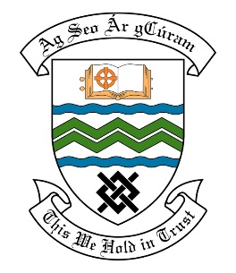

### MEETING OF THE TALLAGHT ACM

**18th December, 2017**

## HEADED ITEM NO. 14

**Deputations meeting 22nd November 2017 @ 2pm**

**Springbank Residents Association**

**Deputation** **attendees** – Jennifer O’Toole, Seamus Delaney, Padraic Nolan & Luke Brady.

**Elected Members** – Cllr. Martina Genockey & Cllr. Emma Hendrick.

**Council Officials** – Leo Magee.

Councillor Martina Genockey presided.

**Items discussed**:

1. Retention of the fence in Springbank.

**Commitments given**:

1. Consultation to be carried out by the Council to see if residents want the access opened up or not.