## COMHAIRLE CONTAE ATHA CLIATH THEAS

## SOUTH DUBLIN COUNTY COUNCIL

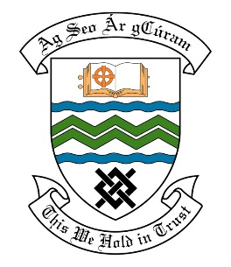

### MEETING OF THE LUCAN ACM

**19TH December 2017**

## HEADED ITEM NO. 14

**Deputations meeting - 22nd November 2017 @ 3pm.**

**Airlie Heights Residents against Car Park & All Weather Pitch**

**Deputation** **attendees** – Orla Rankin, Elaine Redmond, Andrew Flanagan, Garrett Fitzpatrick & Tony Blount.

**Elected Members** – Cllr. Paul Gogarty, Cllr. Ed O’Brien, Cllr. Madeline Johnson & Cllr. Liona O’Toole.

**Council Officials** – Siobhan Duff, Suzanne Furlong & Mary Maguire.

Councillor Ed O’Brien presided.

**Items discussed**:

1. **Requirement of a revised planning application for access road to serve units at rear of 17-23 Dodsboro Cottages.**
2. **Details of planning permission relating to the construction of the access road at rear of 17-23 Dodsboro Cottages.**
3. **Part 8 planning for Car Park.**
4. **Original Part 8 report and site notice for access road to serve units at rear of 17-23 Dodsboro Cottages.**
5. **Meetings with Residents Association on proposed development.**
6. **Commitments given at the Deputation meeting.**

**Commitments given**:

No commitments given.