**Japanese Knotweed at the Dodder/Old Bawn bridge**

Before

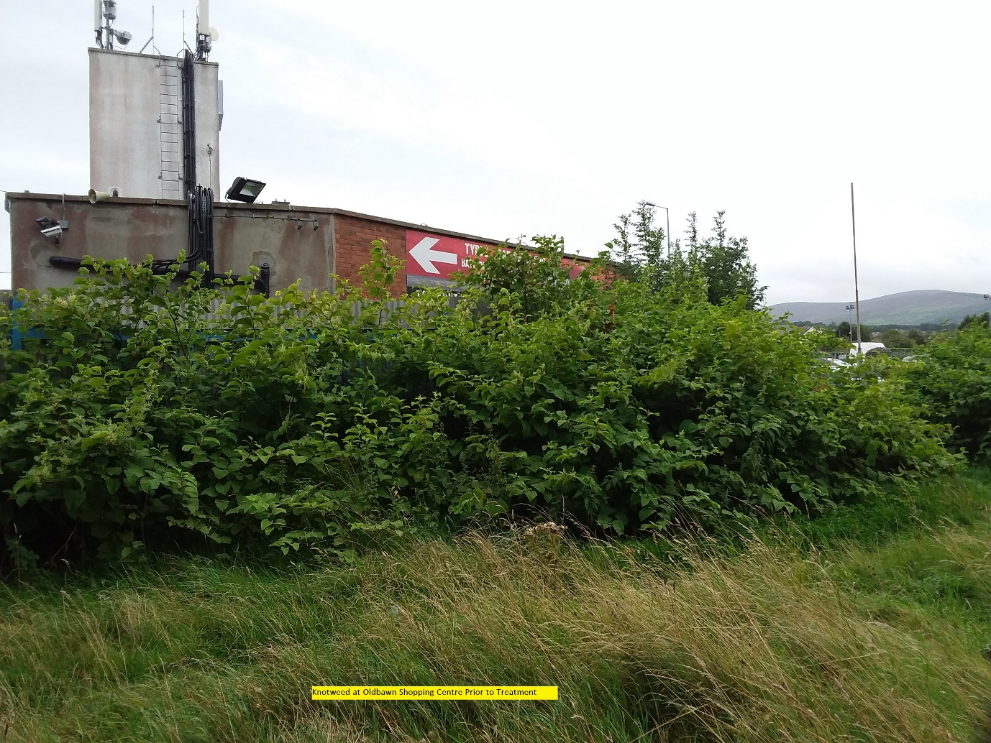

After

