**From:** Andrew Shinnick <[ashinnick@gmail.com](mailto:ashinnick@gmail.com)>  
**Sent:** Friday, November 10, 2017 12:25:23 PM  
**To:** Liona O'Toole  
**Subject:** Re: FAO - Mr. David Fennell - Senior Executive Park SuperIntendant

Liona,

Attached are some photos for visual reference.

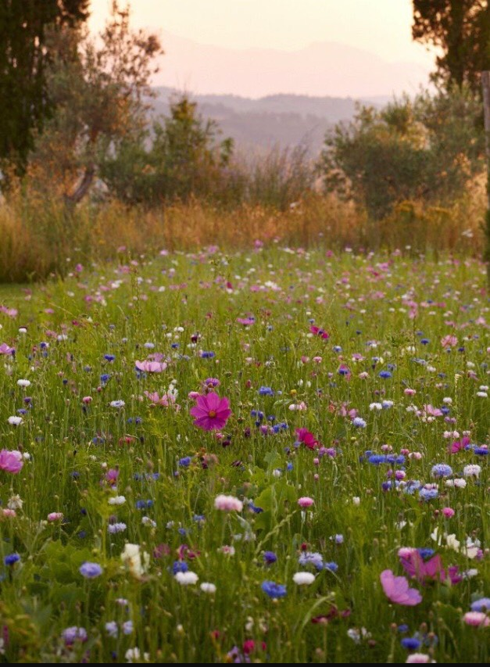

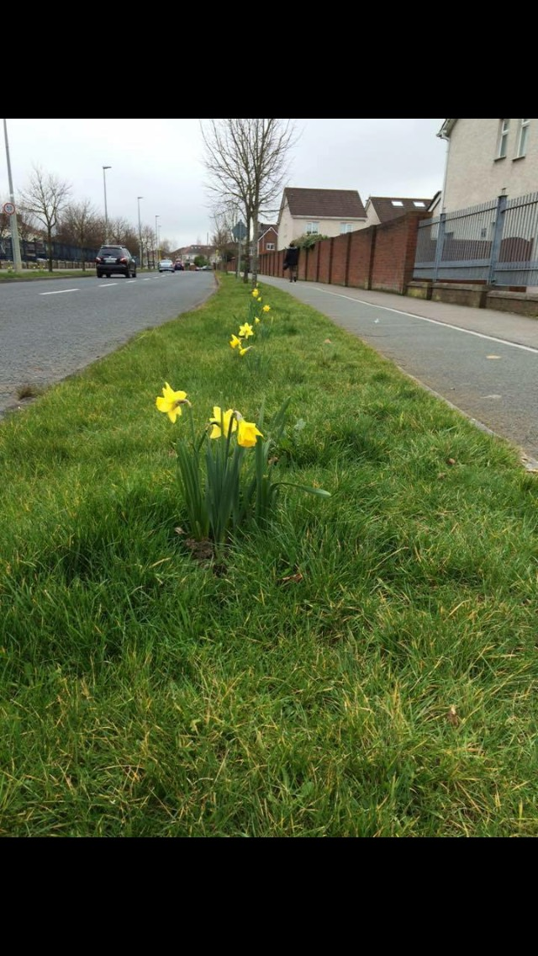

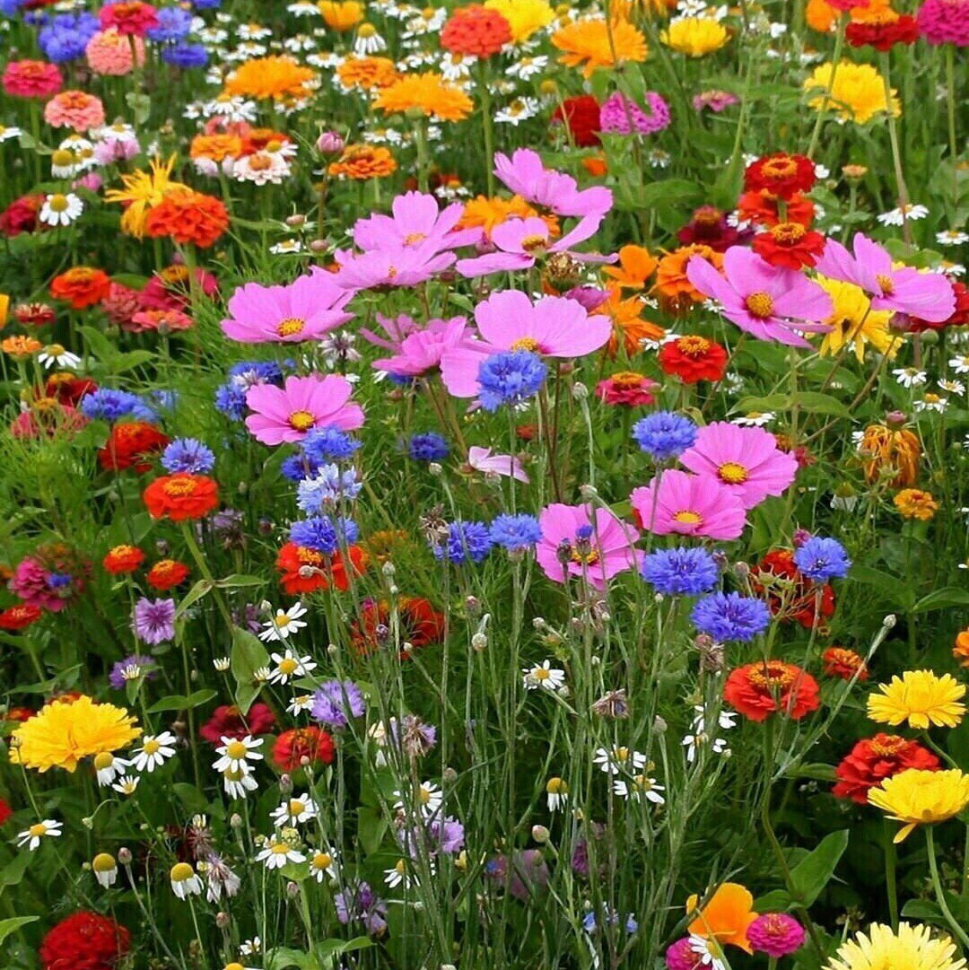

On Fri 10 Nov 2017 at 12:20, Andrew Shinnick <[ashinnick@gmail.com](mailto:ashinnick@gmail.com)> wrote:

Hi Liona,

As discussed last night at the LPF meeting.

I’m looking for the SDCC to donate 1000s of Daffodil bulbs to the communities of Lucan/Admanstown and Ronanstown so that we can plant them along the main roads in lucan in order to brighten up the place and help offset antisocial behavior and to get community estates out to take pride in the local area.

The place is littered with rubbish due to lack of bins at locations like bus stops and particularly along long stretches of footpaths where you can never find a bin so people just throw it on the ground or over the wall in to many of the estates.

On a separate matter, SDCC has thousands of acres of grassland that could be planted with Wildflowers to help the environment, help improve bee and insect numbers and allow for more bee keeping. It would also help to offset any spraying SDCC does and to help the heritage and wildlife in SDCC areas. I’d like to see some of grass in the Fforster Estate among the Ballyowen Road planted with Wildflowers to create a wild meadow effect. This would look amazing from the road. By doing the above also would save SDCC thousands of Euro in grass cutting expenses each month and year.

By not cutting the grass and planting wildflower you also create a better place to live within.

Finally, planting bulbs along each road is needed to lift peoples spirits. Additionally, a number of the roundabouts (Willsbrook Road and Castleroad along with Griffeen way towards the park) could be planted with Wildflowers again to create a wonderful visual effect all summer long.

Can I just say also that a lot of the footpaths in Lucan have vegetation growing outwards causing people to be forced out in to the cycle paths. All streets need maintenance in this regard. If the above can’t be done then I’ll do it and let the vegetation in piles to be collected by SDCC.

Thanks for your help and I will meet with anyone in SDCC to get them a tour of the areas I’ve in mind to help improve.

---------- Forwarded message ---------  
From: Andrew Shinnick <[ashinnick@gmail.com](mailto:ashinnick@gmail.com)>  
Date: Wed 8 Nov 2017 at 16:36  
Subject: FAO - Mr. David Fennell - Senior Executive Park SuperIntendant

To: <[info@sdublincoco.ie](mailto:info@sdublincoco.ie)>

Dear David,

I’m looking to improve the neighborhood of Lucan and to tie in with the Lucan Tidy Towns on a number of projects I’d like to see happen in Lucan.

Firstly, is there a possibility that I could get a several hundred or thousand Daffodil bulbs to plant in groups of along Castleroad, Ballyowen Road and Willsbrook Road, Griffeen way, Esker Manor and Ash Park Manor is that the flowers come up in the spring and add a bit of colour and beauty to all Lucan.

Secondly, I note that there’s a lot of the roundabouts in the area which are awful looking and have no plants or plant scheme on them.

Ideally, I’d like someone in SDCC or us the locals & Tidy Towns to plant them with perhaps wildflower seeds on them as then they’d look amazing during the Spring/summer&autumn and they would help the bee and insect population.

Thirdly, I’d also like to float the idea of creating meadow areas again of wildflowers and grasses in each of the estates or parks. Doing this would substantially reduce the grass cutting bill of SDCC each year and also create again a lovely landscape and help to promote the environment and local wildlife.

I’ve attached a number of photos of what the roundabouts could look like using either Tulips&Daffodils or Wildflowers.

Additionally, I’d attached a photo of a natural wildflower area which is like to see done in our estate.

Finally, would it be possible to meet you at the Roundabout at Castleroad and Willsbrook Road and have a discussion as to what could be achieved in our area.  Please note that time is of the essence here as any Daffodil bulbs would want to be planted soon before it’s too late and the frosts set fully in.

My phone number is 0872453607.







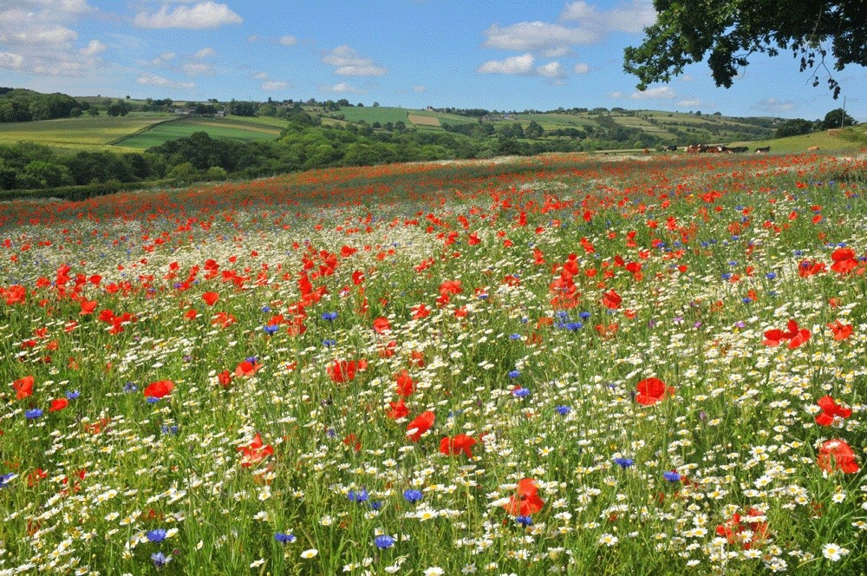

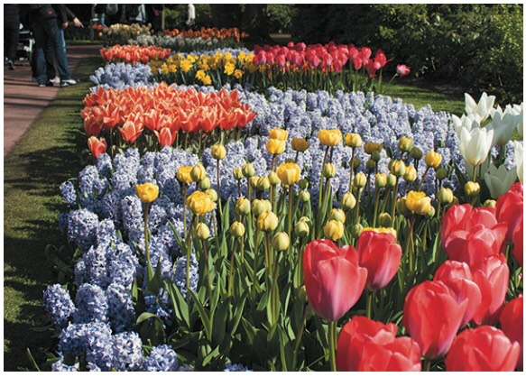

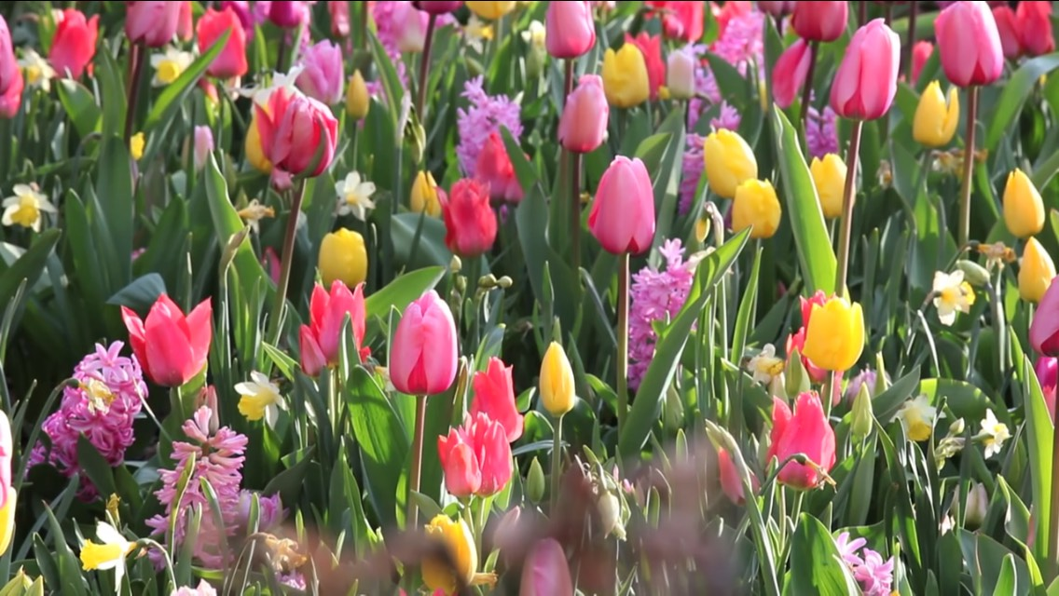

--

Sent from my iPhone. Regards, Andrew Shinnick

--

Sent from my iPhone. Regards, Andrew Shinnick

--

Sent from my iPhone. Regards, Andrew Shinnick