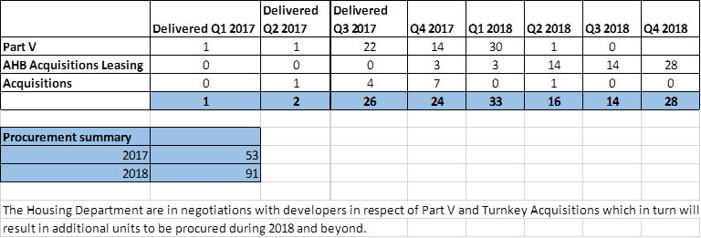

**Construction Update for the Tallaght Area November 2017**

|  |  |  |  |  |  |  |  |  |
| --- | --- | --- | --- | --- | --- | --- | --- | --- |
| Schemes | No. of Units | Status | **Est. Completion Q4 2017** | **Est. Completion  Q1 2018** | **Est. Completion  Q2 2018** | **Est. Completion  Q3 2018** | **Est. Completion  Q4 2018** | **Est. Completion  Q1 2019** |
| Mac Uilliam (Fortunestown) | 28 | On Site May 2017 |  |  |  | **28** |  |  |
| Dromcarra, Tallaght | 14 | On Site May 2017 |  |  |  | **14** |  |  |
| St. Aidans, Tallaght | 85 | On Site August 2017 |  |  | **66** | **19** |  |  |
| Killinarden, Tallaght | 27 | On Site October 2017 |  |  |  |  |  | **27** |
|  |  |  | **0** | **0** | **66** | **61** | **0** | **27** |