## COMHAIRLE CONTAE ATHA CLIATH THEAS

## SOUTH DUBLIN COUNTY COUNCIL

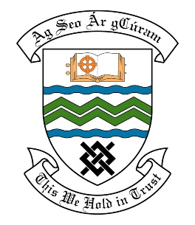

### MEETING OF THE RATHFARNHAM TEMPLEOGUE TERENURE ACM

**14th November 2017**

## HEADED ITEM NO. 19

**Deputations meeting 25th October 2017 @ 4pm**

**Stocking Wood Residence Association**

**Deputation** **attendees** – Mark Lynch, Karen Gleason & Theresa Mc Cormack.

**Elected Members** – Cllr. Deirdre O’Donovan & Cllr. Paul Foley.

**Council Officials** – Gerry Fitzgibbon, Sonia Lavelle & Eamon Harnett.

Councillor Deirdre O’Donovan presided.

**Items discussed**:

1. Issues at halting site on Stocking Avenue.
2. Dumping of rubbish on Stocking Avenue.
3. Maintenance of green area on Stocking Avenue.
4. Commitments given at Deputation meeting.

**Commitments given**:

1. **Mr. Gerry Fitzgibbon to check with Land Use Planning & Transportation department about the taking in charge of Stocking Wood and then contact residents.**
2. **Mr. Gerry Fitzgibbon to liaise with Cllr. O’Donovan about possible development of the green space beside the halting site.**
3. **Mr. Eamon Harnett to arrange a site meeting with residents to discuss loose horses & ownership of the field, the broken wall beside the halting site, vermin problem.**
4. **Mr. Eamon Harnett to contact litter enforcement about use of the mobile CCTV unit in the area and installing signage to deter dumping.**
5. **Cllr. O’Donovan to check through Members Rep if there is a bond on Stocking Wood in place.**