Dublin Fire Brigade
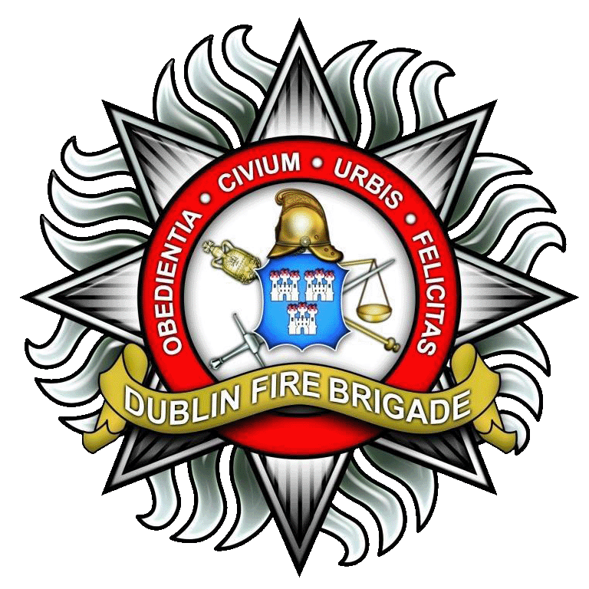
Service Provision Data For
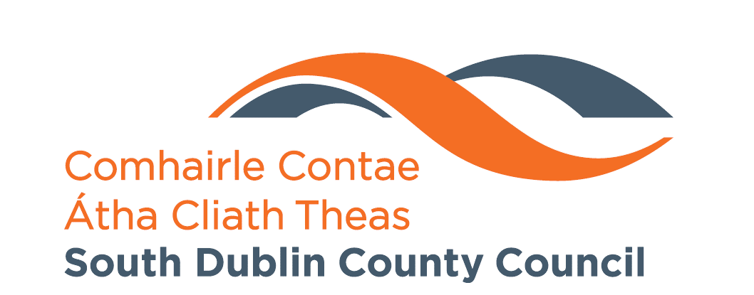
South Dublin County Council
2016/2017

South Dublin County covers an area of 223 square kilometres and has a total population of 278,767. The total housing stock is 98,387, of which vacant households (excluding holiday homes) number 3,495. It is bounded by Dublin City, The Dublin Mountains and County Wicklow to the south, the River Liffey to the north separating it from Fingal and County Kildare to the west. It covers the areas of Lucan, Palmerstown, Clondalkin, Newcastle, Rathfarnham, Rathcoole, Saggart, Tallaght and Templeogue.
Dublin Fire Brigade provided integrated Fire, Rescue and Emergency Medical Services to the citizens of South Dublin County (as part of its provision to all citizens of Dublin City & County), of which the particular details relating to 2016 & 2017 are displayed below.

SDCC ACTIVITY 01/01/2016 – 31/10/2017. BY INCIDENT TYPE, FIRE AND S/S
INCIDENT TYPE | 2016 | 2017 | Total
FIRE/SMALL/BIN/SKIP | 708 | 756 | 1464
FIRE/VEHICLE | 457 | 343 | 800
FIRE/ALARM ACTIVATION | 309 | 261 | 570
FIRE/DOMESTIC | 132 | 102 | 234
FIRE/VARIOUS | 75 | 64 | 139
S/S VARIOUS | 53 | 51 | 104
S/S TRAFFIC ACCIDENT | 52 | 36 | 88
FIRE/CHIMNEY | 52 | 32 | 84
S/S AMBULANCE ASSIST | 41 | 40 | 81
FIRE/DOMESTIC PERSONS REPORTED | 42 | 39 | 81
FIRE/FOREST/GORSE/HAY | 34 | 33 | 67
FIRE/INDUSTRIAL | 31 | 33 | 64
S/S LOCKOUT | 26 | 21 | 47
S/S ALARM/CARBON MONOXIDE | 17 | 11 | 28
S/S GARDA ASSIST | 9 | 17 | 26
S/S MAKE SCENE SAFE/SPILLAGE | 12 | 12 | 24
S/S TREES DOWN/FLOODING | 6 | 18 | 24
FIRE/INSTITUTIONAL | 15 | 4 | 19
S/S GAS LEAK | 8 | 9 | 17
S/S RIVER RESCUE | 3 | 4 | 7
Total | 2082 | 1883 | 3965

Table 1: Incident types in South Dublin County from 2016 to date

The number of vehicles mobilised to the South Dublin County area since 2016 can be seen from the data below.

VEHICLES MOBILISED INTO SDCC AREA
MONTH | 2016 | 2017 | Total
JANUARY | 2026 | 2007 | 4033
FEBRUARY | 1952 | 1726 | 3678
MARCH | 1987 | 1915 | 3902
APRIL | 1939 | 1923 | 3862
MAY | 1943 | 1943 | 3886
JUNE | 1874 | 1873 | 3747
JULY | 2001 | 1918 | 3919
AUGUST | 1963 | 1991 | 3954
SEPTEMBER | 2050 | 1859 | 3909
OCTOBER | 2206 | 1964 | 4170
NOVEMBER | 1993 |  | 1993
DECEMBER | 2157 |  | 2157
Total | 24091 | 19119 | 43210
Table 2: Emergency Vehicles mobilised to the South Dublin County area from 2016 to date
Dublin Fire Brigade also responded to Medical Emergencies within the South Dublin County area, mobilising DFB Ambulances to various grades of medical criticality, as seen in the table below.
SDCC ACTIVITY 01/01/2016 – 31/10/2017. AMBULANCE ACTIVITY BY MEDICAL CRITICALITY
CRITICALITY | 2016 | 2017 | Total
ALPHA | 2712 | 1734 | 4446
BRAVO | 1522 | 1751 | 3273
CHARLIE | 2241 | 1718 | 3959
DELTA | 6374 | 4708 | 11082
ECHO | 292 | 280 | 572
OMEGA | 544 | 383 | 927
Total | 13685 | 10574 | 24259
Table 3: Dublin Fire Brigade Emergency Ambulance activity within the South Dublin County area
Clinical Status | Clinical Description | Code
1 | Immediately Life Threatening – Cardiac or respiratory arrest | Echo
1 | Life Threatening – other than cardiac or respiratory arrest | Delta
2 | Serious not Life Threatening - Immediate | Charlie
2 | Serious not Life Threatening - Urgent | Bravo
3 | Not Serious and not Life Threatening | Alpha
3 | Minor illness or injury | Omega
Table 4: Clinical description of Critical Codes
The South Dublin County area is generally provided with Fire, Rescue & Emergency Medical Services cover from the three Fire Stations within its area – Dolphin’s Barn, Tallaght and Rathfarnham. As can be seen from the following table, there are occasions where Dublin Fire Brigade mobilise their resources from Fire Stations outside South Dublin County’s area due to periods of extreme demand for the service.
DFB STATIONS FROM WHERE VEHICLES WERE MOBILISED INTO SDCC AREA
STATION | 2016 | 2017 | Total
TALLAGHT | 10692 | 8452 | 19144
DOLPHINS BARN | 4666 | 3801 | 8467
RATHFARNHAM | 3695 | 3014 | 6709
BLANCHARDSTOWN | 1575 | 1178 | 2753
DONNYBROOK | 1490 | 1134 | 2624
TARA STREET | 1160 | 893 | 2053
BLANK | 330 | 272 | 602
PHIBSBOROUGH | 314 | 229 | 543
FINGLAS | 79 | 72 | 151
NORTH STRAND | 40 | 35 | 75
DUN LAOGHAIRE | 29 | 16 | 45
SWORDS | 13 | 16 | 29
KIBARRACK | 8 | 7 | 15
Total | 24091 | 19119 | 43210
Table 5: DFB Stations that provided Emergency Vehicles to South Dublin County as required

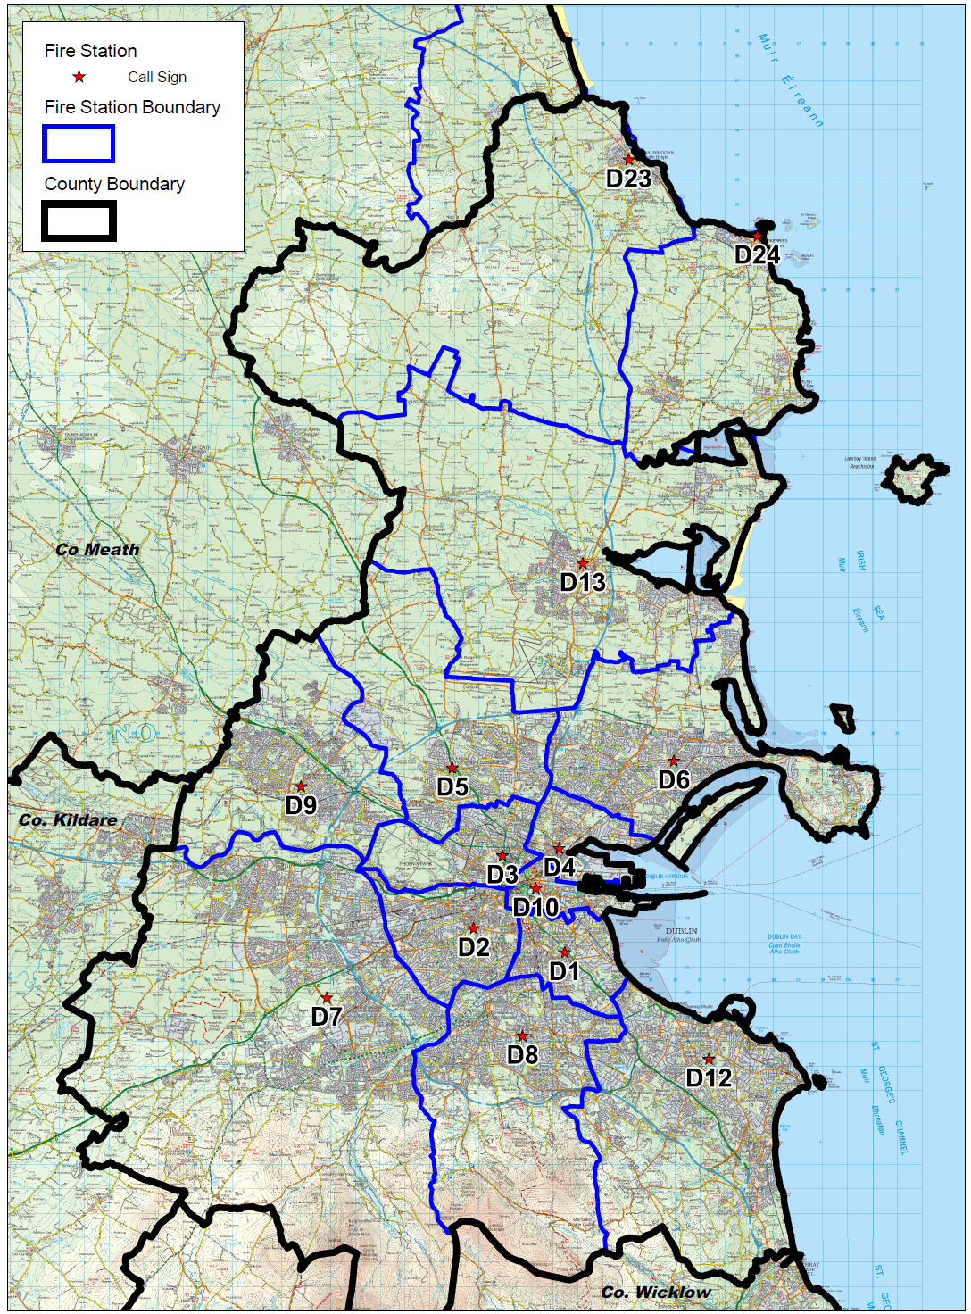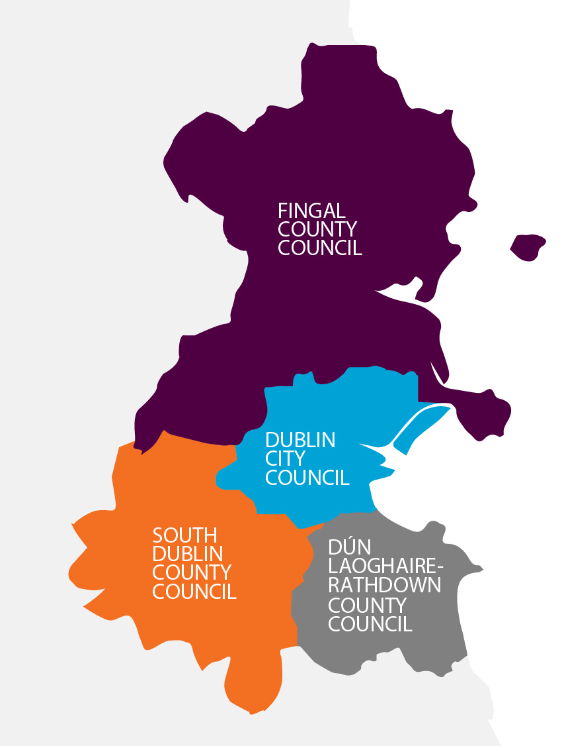
Figure 1: Fire Station boundaries in relation to Council boundaries

