## COMHAIRLE CONTAE ATHA CLIATH THEAS

## SOUTH DUBLIN COUNTY COUNCIL

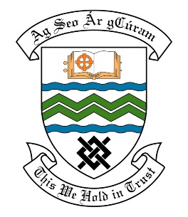

### MEETING OF THE RATHFARNHAM TEMPLEOGUE TERENURE ACM

**10th October 2017**

## HEADED ITEM NO. 2

**Deputations meeting 27th September 2017**

**Orwell Park Residents Association**

**Deputation** **attendees** – Ciaran Boylan, Joe Kieran, Declan Devlin & Donacha Lehane.

**Elected Members** – Cllr. Enda Fanning & Cllr. Paul Foley

**Council Officials** – Michael Glynn, Oisin Egan, Eamon Harnett,

Councillor Enda Fanning presided.

**Items discussed**:

1. **Road signage and road marking.**
2. **Condition road ramps- Orwell Estate.**
3. **Grass cutting and scheduling of same.**
4. **Development plan – Orwell Park Green.**
5. **Spawell Complex.**

**Commitments given**:

1. Michael Glynn to ask Traffic Section to look at issue of road signage.
2. Michael Glynn to add road marking to works list.
3. Michael Glynn to bring issues to next Area Committee Meeting as a headed item.
4. Residents group to send list of ramps to Michael Glynn.
5. Oisin Egan to monitor grass cutting rota on Orwell Park Green in the spring.
6. Michael Hannon to organise site meeting with residents group to discuss development plan for Orwell Park Green.
7. Residents group to make complaint to Building Control about planning issue.