## COMHAIRLE CONTAE ATHA CLIATH THEAS

## SOUTH DUBLIN COUNTY COUNCIL

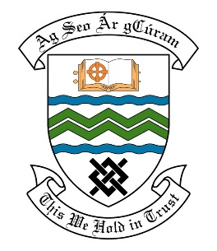

### MEETING OF THE LUCAN ACM

**Tuesday 26th September 2017**

## HEADED ITEM NO. 8

**Deputations Meeting June 2017**

**St. Andrews National School Parent Teachers Association**

**Deputation** **attendees** – Rev. Scott Peoples, Ms. Avril Rankin & Ms. Aileen Blackwell Kelly.

**Elected Members** – Cllr. Liona O’Toole, Cllr. Paul Gogarty, Cllr. Gus O’Connell & Cllr. Ed O’Brien.

**Council Officials** –Willie Purcell, Helena Fallon, Brian Carroll & Carol McDonnell.

Councillor Liona O’Toole presided.

**Items discussed**:

1. **Pedestrian Crossing improvements at Lucan Road/R136 (Woodies Junction).**
2. **Footpath & Cycle path improvements along Lucan Road.**
3. **Proposals to redesign junction of Lucan Road/Chapel Hill.**
4. **Commitments given at meeting.**

**Commitments given**:

Item 1 - Mr. Purcell to mention the request for a Traffic Warden at the Woodies Junction to the Senior Staff Officer in charge of assigning Traffic Wardens to locations.