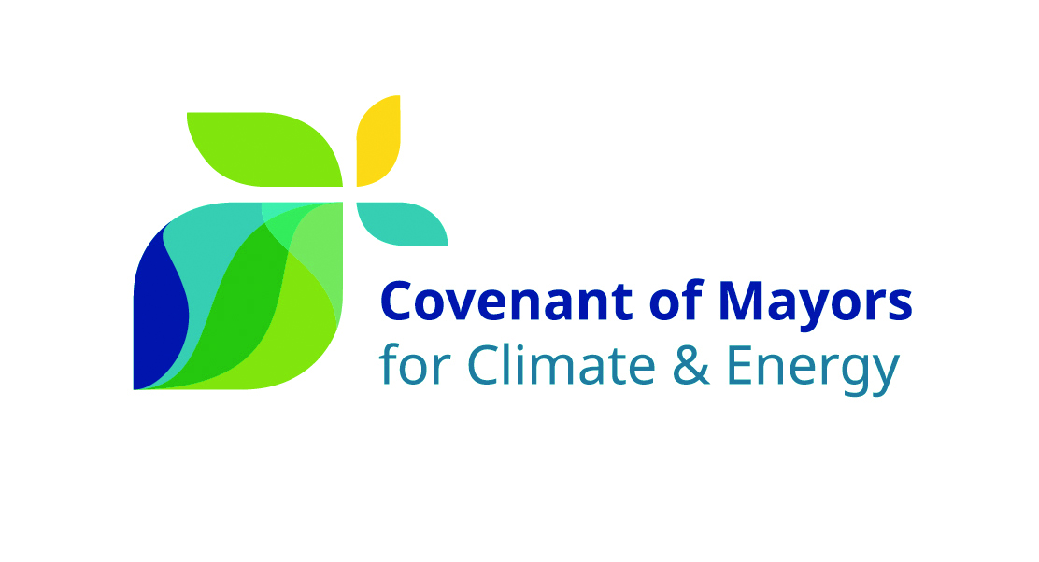
2030


I, Cllr. Paul Gogarty, Mayor of South Dublin County Council have been mandated by South Dublin County Council on September 25th 2017 to sign up to the Covenant of Mayors for Climate and Energy, in full knowledge of the commitments set out in the official Commitment Document and summarised below.

Therefore, my local authority principally commits to:

- Reducing CO₂ (and possibly other greenhouse gas) emissions on its territory by at least 40% by 2030, namely through improved energy efficiency and greater use of renewable energy sources;
- Increasing its resilience by adapting to the impacts of climate change.

In order to translate these commitments into action, my local authority undertakes to fulfil the following step-by-step approach:

- Carry out a Baseline Emissions Inventory and a Climate Change Risk and Vulnerability Assessment;
- Submit a Sustainable Energy and Climate Action Plan within two years following the above date of the municipal council decision;
- Report progress at least every second year following the submission of the Sustainable Energy and Climate Action Plan for evaluation, monitoring and verification purposes.

I accept that my local authority shall be suspended from the initiative – subject to prior notice in writing by the Covenant of Mayors Office – in case of non-submission of the above-mentioned documents (i.e. Sustainable Energy and Climate Action Plan and Progress Reports) within the established deadlines.


South Dublin County Council,
County Hall, Tallaght,
Dublin 24, D24 YNN5.
Director of Environment Water and Climate Change 01 414 9000

________________________

