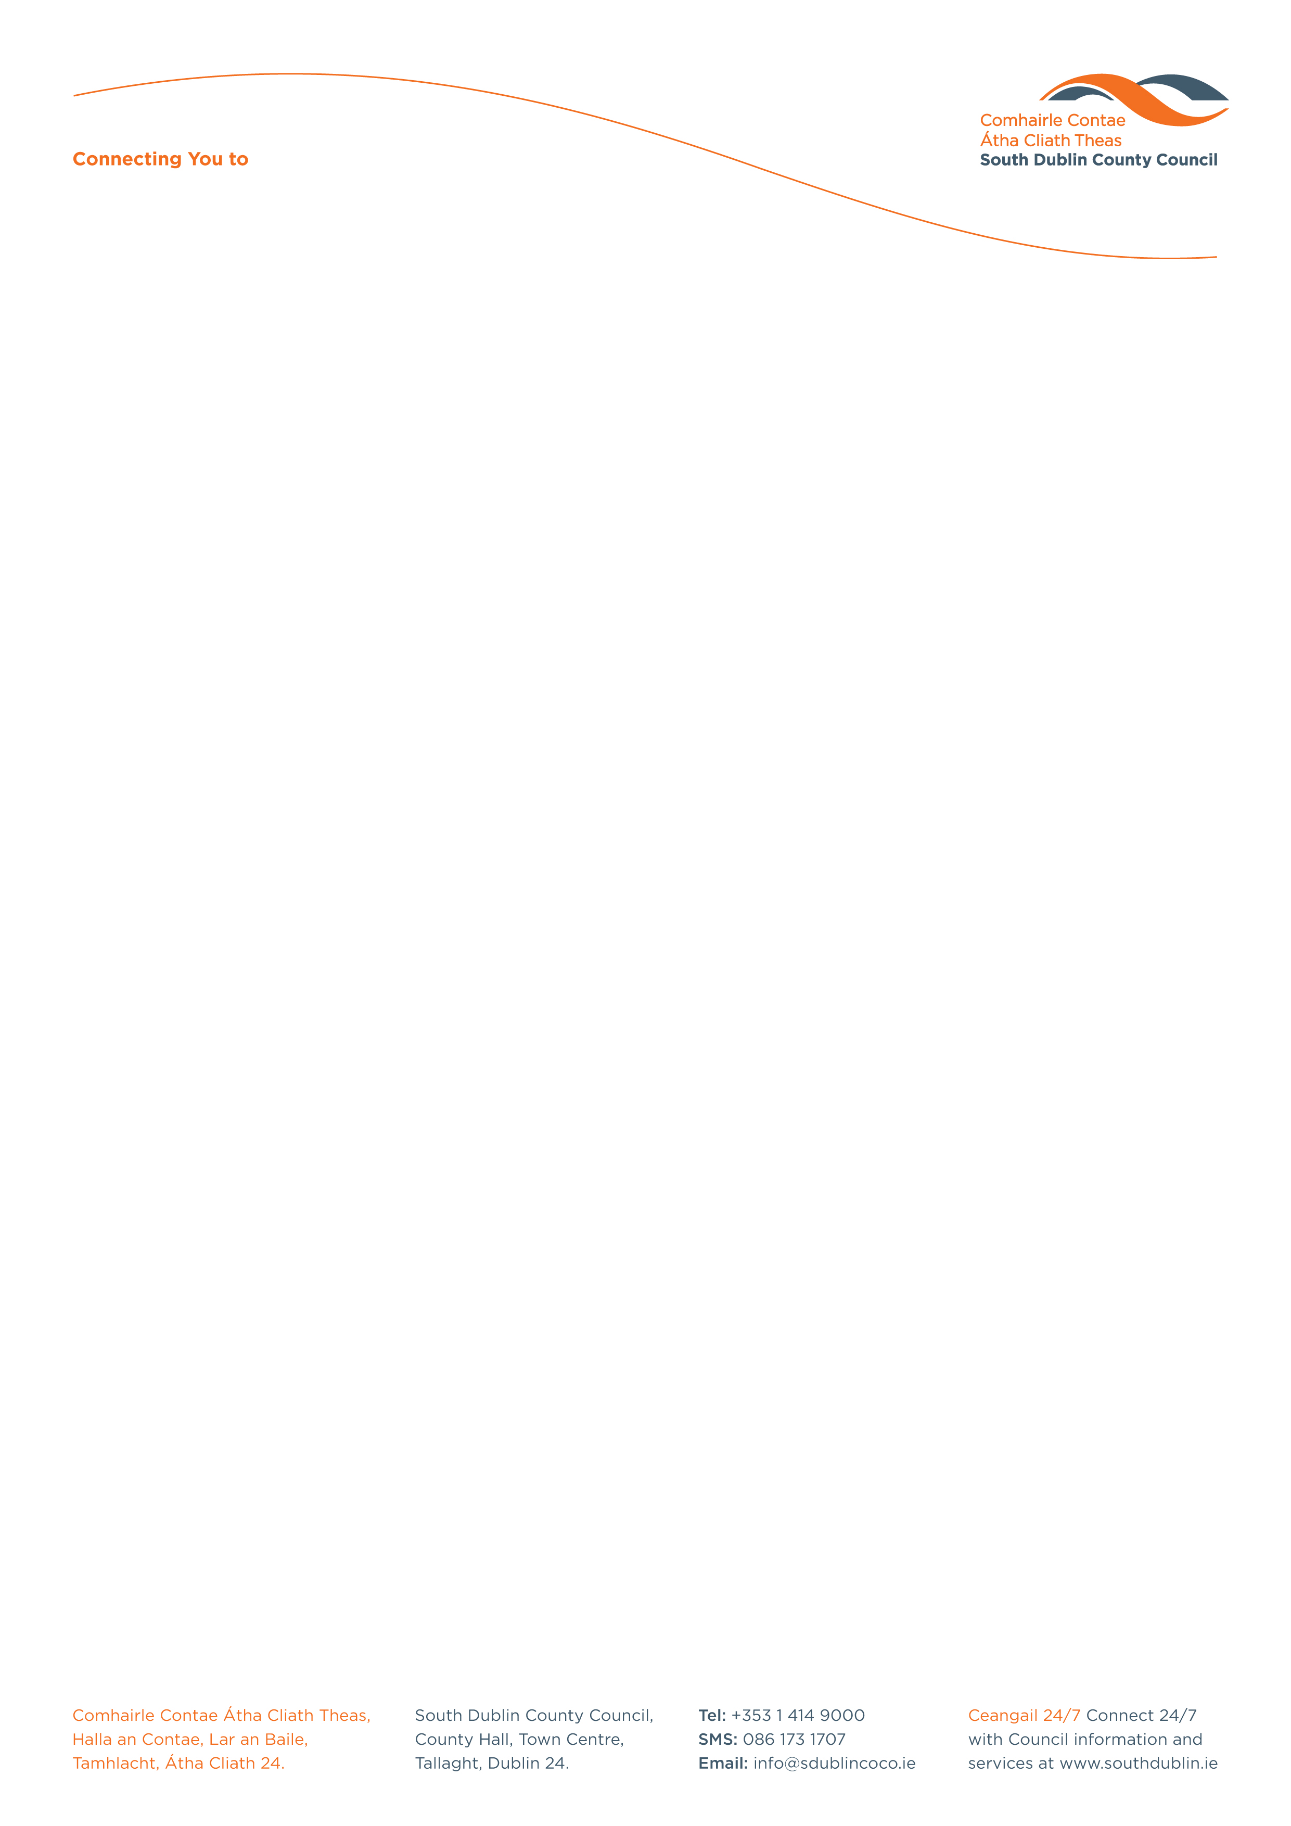

Halla an Chontae, Lár an Bhaile County Hall, Town Centre
Tamhlacht, Baile Átha Cliath 24 Tallaght, Dublin 24
Telefon: 01-4149052 Telephone: 01-4149052

Facs: 01-4149332 Fax: 01-4149042
www.southdublin.ie

Greyhound Household Head Office,
Crag Avenue,
Clondalkin Industrial Estate,
Dublin 22.
25th July 2017

RE: Tallaght Area Committee Meeting – 26th June 2017

Dear Sir/Madam,

At South Dublin County Council’s Tallaght Area Committee Meeting, held on 26th June 2017, the following Motion was passed:

"That the Chief Executive writes to Greyhound Household asking why the waste company is sending correspondence to households in the Tallaght area claiming Green Bin contamination and requesting a detailed explanation of their policy in that regard and also noting that this correspondence is creating much concern and confusion particularly among elderly residents?"

I should be obliged if you would let me have a reply on this matter at your earliest convenience.

Thanking you in anticipation,

Yours faithfully,

__________________
Edwina Leonard,
Staff Officer,
Housing Administration.

Housing Administration

