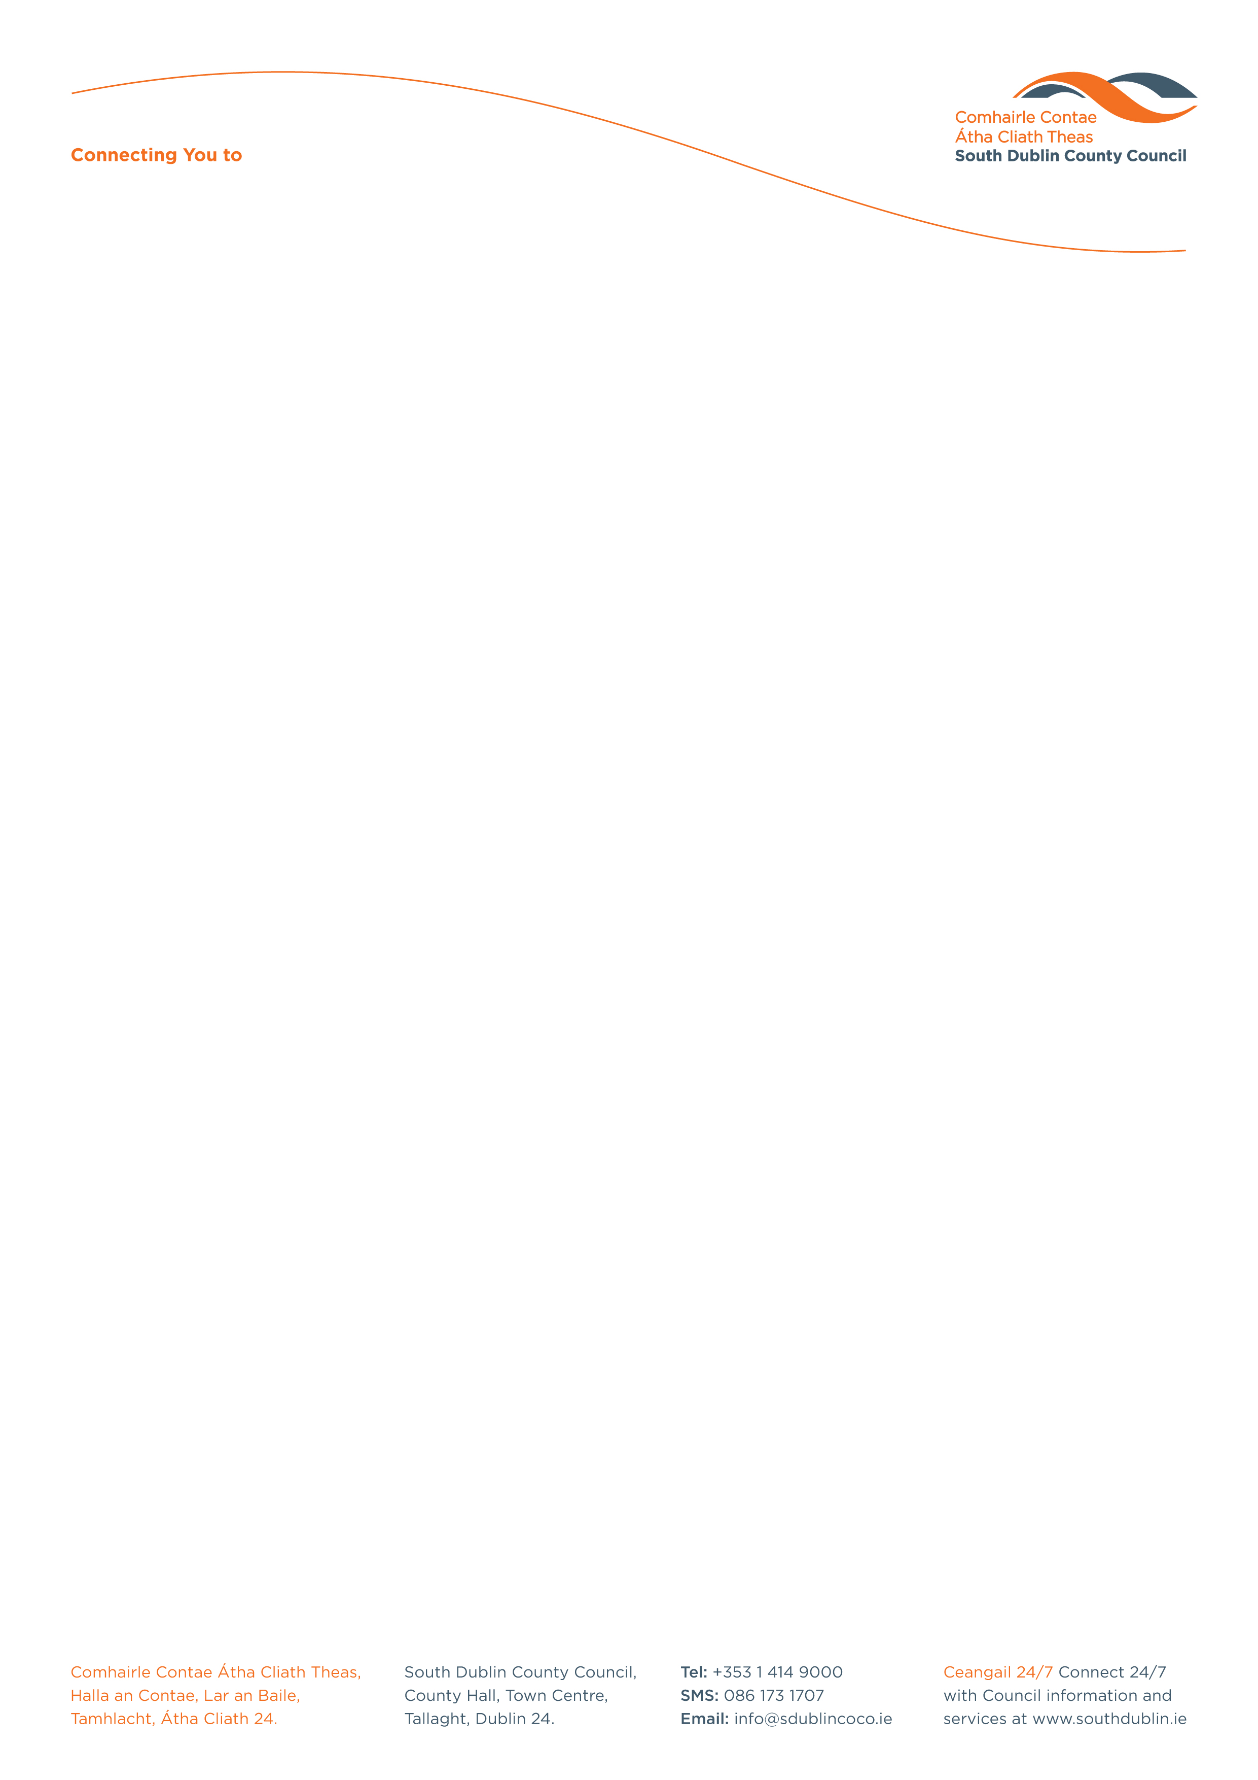

Halla an Chontae, Lár an Bhaile County Hall, Town Centre
Tamhlacht, Baile Átha Cliath 24 Tallaght, Dublin 24
Telefon: 01-4149052 Telephone: 01-4149052

Facs: 01-4149332 Fax: 01-4149042
www.southdublin.ie

Dublin Bus,
59 O’Connell Street,
Dublin 1.

RE: Tallaght Area Committee Meeting – 26th June, 2017

Dear Sir/Madam,

At South Dublin County Council’s Tallaght Area Committee Meeting, held on 26th June, 2017, the following Motion was passed:

"That this Committee writes to Dublin Bus asking if the company has any plans to alter bus routes in the Tallaght area and seeking assurances that the company will continue to endeavor to provide an excellent bus service to the Tallaght region?"

I should be obliged if you would let me have a reply on this matter at your earliest convenience.

Thanking you in anticipation,

Yours faithfully,

__________________
Edwina Leonard,
Staff Officer,
Housing Administration.

Housing Administration

