## COMHAIRLE CONTAE ATHA CLIATH THEAS

## SOUTH DUBLIN COUNTY COUNCIL

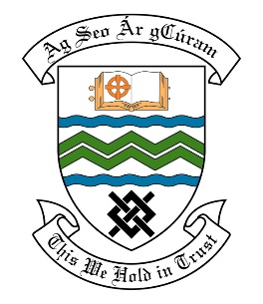

### MEETING OF THE LUCAN ACM

**Tuesday 23rd May 2017**

## HEADED ITEM NO.

**Deputations Meeting April 2017**

**Concerned Residents of the Grange, Lucan**

**Deputation** **attendees** – John Power, Mary Byrne, Adrian Byrne & Hugh Rooney.

**Elected Members** – Cllr. Liona O’Toole, Cllr. Paul Gogarty, Cllr. Trevor Gilligan Cllr. Ed O’Brien, Cllr. Paul Foley, Cllr. Charlie O’Connor & Cllr. Deirdre O’Donovan

**Council Officials** –Helena Fallon, James Phelan, Nicola Lawler, Michael McAdam, Brian Carroll & Carol McDonnell.

Councillor Liona O’Toole presided.

**Items discussed**:

1. **Update on progress with the 12th Lock Masterplan.**
2. **Traffic Safety on the 12th Lock Bridge.**
3. **Cases of Fly Tipping & security of pedestrians on Green Route.**
4. **Drainage for back drain from Grand Canal.**

**Commitments given**:

Item 1 - Commitment that the Contractor will be on site in July 2017.